Collisions
Please remember to photocopy 4 pages onto one sheet by going A3→A4 and using back to back on the photocopier

This booklet contains every higher level (and most ordinary level) questions that have appeared on exam papers from 1971 – 2023
Note that this topic was usually Question 5 on the old syllabus (up to 2022)
Fully worked solutions from the legend that is Dominick Donnelly here appliedmathematics.ie/index.php/students/exam-solutions
Solutions to HL 2023 and Sample Paper (plus lots more) from Joe Kennedy here: https://www.jkmaths.net/exam-paper-solutions
Screencasts of worked solutions to HL 2023 and Sample Paper (plus lots more) from Shane Molloy here: https://www.molloymaths.com/applied-maths

Exam Papers (in pdf and Word format) plus Marking Schemes (and lots more) from: thephysicsteacher.ie/exammaterialappliedmaths.html
A good idea is to look at as many sources as you can for solutions as there is often more than one approach and some can be much easier to understand and/or remember than others.
Screencasts of worked solutions to various older past paper question plus comprehensive resources for all topics

Questions from 2023 and Sample Paper (Ordinary level and Higher level) are left until the very end – page 43

You can find this document plus all other Applied Maths booklets on the homepage of thephysicsteacher.ie

Last updated: 04/11/2023
Noel Cunningham
Contents
Introduction 3
Collision between ball and floor 3
Collisions between two spheres: 2 rules 5
Impulse and kinetic energy 6
Higher Level - Direct collisions 10
Direct Collisions involving inequalities 12
Direct Collisions involving inequalities and three spheres 12
Direct Collisions involving inequalities and two spheres 14
Kinetic energy 16
Conservation of energy questions 18
“Sphere B collides with a wall and next collision takes place a distance ‘d’ from the wall.” 19
And this one is just a complete oddball 20
Oblique Collisions 21
Introduction 21
Direction of spheres after collision 23
“The spheres move at right angles after the collision” 27
Angle of deflection 28
Exam questions involving angle of deflection 29
Deflected through an angle of 90° 33
Kinetic energy 34
General questions 36
Guide to answering exam questions 37
Answers to ordinary level exam questions 41
Collisions questions from 2023 and Sample Paper: Ordinary level and Higher level 43

Introduction

If you drop a ball, its speed just after impact will be less than its speed before impact.
In general, the ratio of the speed afterwards (V) to the speed before (U) will be the same regardless of the initial speed (once you keep don’t change the ball or the surface).
So we can say that V/U is a constant.
This constant is known as the coefficient of restitution and is given the symbol ‘e’ (‘restitution’ is like a fancy word for ‘bounciness’).
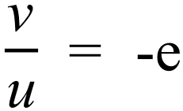
The negative sign indicates the object will be moving in the opposite direction afterwards.
Alternatively we could re-write it as V = -e U

Collision between ball and floor

Here we need to divide the motion into three stages
- The ball travelling downwards
- The collision (‘bounce’) at the bottom. This is where the ball compresses and then expands while in contact with the floor.
- The ball travelling back upwards

Note that in each case the final velocity for the previous stage becomes the initial velocity for the following stage.

The following questions are all Ordinary Level

2004 (b)
A ball is dropped from rest from a height of 1.25 m onto a smooth horizontal table.
The ball hits the table with a speed of v m/s and then rebounds to a height of h metres above the table.
The coefficient of restitution between the ball and the table is 0.8.
- Find the value of v.
- Find the value of h.

2015 (b)
A ball is dropped from rest from a height of 3.2 m onto a smooth horizontal floor.
The ball hits the floor and rebounds to a height of h metres above the floor.
The coefficient of restitution between the ball and the floor is $\frac{3}{5}$.
Find
- the speed of the ball when it hits the floor
- the value of h.

2016 (b)
A ball is fired vertically down with a speed of 2 m s^{–1} from a height of 3 metres onto a smooth horizontal floor. The ball hits the floor and rebounds to a height of 1·8 metres.
The coefficient of restitution between the ball and the floor is e.
- Find the speed of the ball when it hits the floor
- Find the value of e.

2017 (b)
A ball is fired vertically upward in a room with a smooth horizontal floor and a smooth horizontal ceiling.
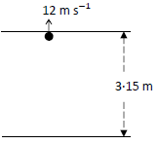
The height of the room is 3.15 metres.
The ball strikes the ceiling with a vertical speed of 12 m s⁻¹.
The coefficient of restitution for all collisions between the ball and the ceiling and between the ball and the floor is $\frac{3}{4}$.
- Find the speed of the ball immediately after striking the ceiling.
- Investigate whether the ball strikes the ceiling again after rebounding from the floor.

Collisions between two spheres: 2 rules

Anybody happen to remember how we defined ‘e’ (the coefficient of restitution)?
Didn’t think so.

Here it is again. Pay attention this time:

Now if we have two objects moving then what counts is their relative velocities - the difference between the their two velocities beforehand compared to the difference between them afterwards.

So we have . $\frac{V_{2}- V_{1}}{U_{2}- U_{1}}=-e$
V₂ – V₁ = -e (U ₂– U₁)

This is known as Newton’s Law of Restitution (N.L.R.):

We will also need to use
The Principle of Conservation of Momentum (P.C.M.):
M₁ U₁ + M₂ U₂ = M₁ V₁ + M ₂V₂

Tackling the question
Always begin by putting the information in the question into a table as follows

A | U₁ | M₁ | V₁
B | U₂ | M₂ | V₂

Now substitute this information into the two formulae above and solve the two resulting simultaneous equations to calculate the velocity for each sphere after the collision.

Let’s look again at the formula: V₂ – V₁ = -e (U ₂– U₁).
It is just as valid to write this is V₁ – V₂ = -e (U₁– U₂) Can you see why?

Impulse and kinetic energy
All exam questions will require you to use the two formulae above to calculate the velocity of the spheres after the collision.
You will then most likely get asked something about either impulse or kinetic energy (or both).

Impulse

Impulse = Change in momentum of one of the spheres = (mu – mv)

Due to conservation of momentum, what one particle loses the second particle must gain, i.e. the changes are equal in magnitude but opposite in direction.

Quite often the question will ask for the magnitude of the impulse. This just means find the size of the impulse, so ignore the sign.

This also explains why it doesn’t matter if you go with (mv – mu) or (mu – mv); you will get the same same answer either way, but one answer will just be opposite in sign to the other.

Kinetic Energy

K.E. = ½ mv²

Note that if we are looking for the initial kinetic energy then v will be the initial speed.

Change in Kinetic Energy = (Initial K.E. minus final K.E.)

Fractional change in Kinetic Energy = change in kinetic energy divided by the original (total) K.E.

Percentage change in K.E = fractional change in kinetic energy multiplied by 100.

*********************************************************************
It’s probably best to leave all Higher Level questions on Kinetic Energy until either the end of 5th year or even 6th year, when students are more proficient at algebra and arithmetic.
**********************************************************************
Exam questions - Ordinary Level

The following questions are all very similar and therefore quite repetitive.
I have included them for completeness – don’t feel that you need to do every single question

2010
A smooth sphere A, of mass 2 kg, collides directly with another smooth sphere B, of mass 3 kg, on a smooth horizontal table.
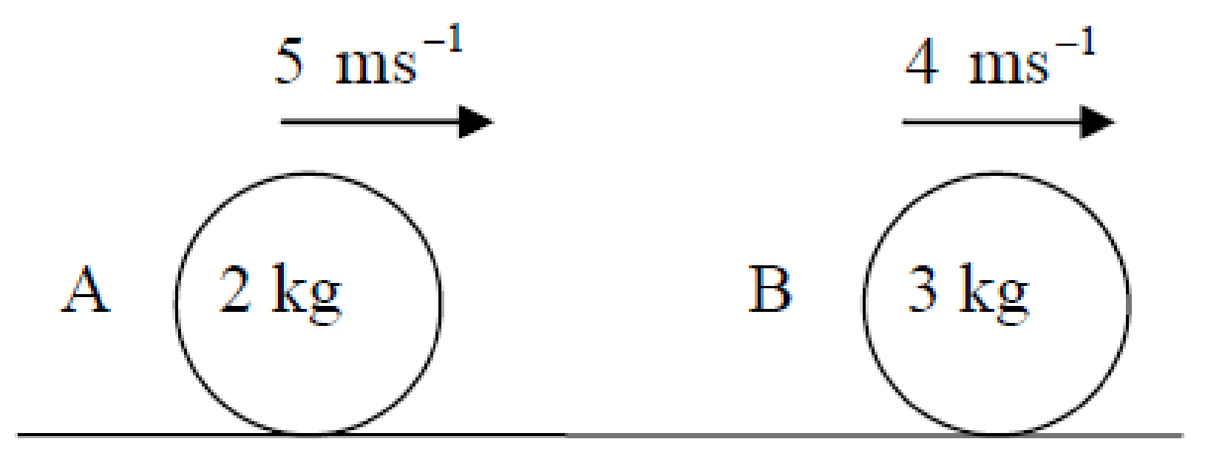
A and B are moving in the same direction with speeds of 5 m s⁻¹ and 4 m s⁻¹ respectively.
The coefficient of restitution for the collision is $\frac{2}{3}$
Find
- the speed of A and the speed of B after the collision
- the change in the kinetic energy of A due to the collision
- the magnitude of the impulse imparted to A due to the collision.

2015 (a)
A smooth sphere A, of mass 5 kg, collides directly with another smooth sphere B, of mass 6 kg, on a smooth horizontal table.
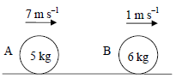
A and B are moving in the same direction with speeds of 7 m s^{‒1} and 1 m s^{‒1}, respectively.
The coefficient of restitution for the collision is $\frac{5}{6}$.
Find
- the speed of A and the speed of B after the collision
- the loss in kinetic energy due to the collision
- the magnitude of the impulse imparted to A due to the collision.

2009
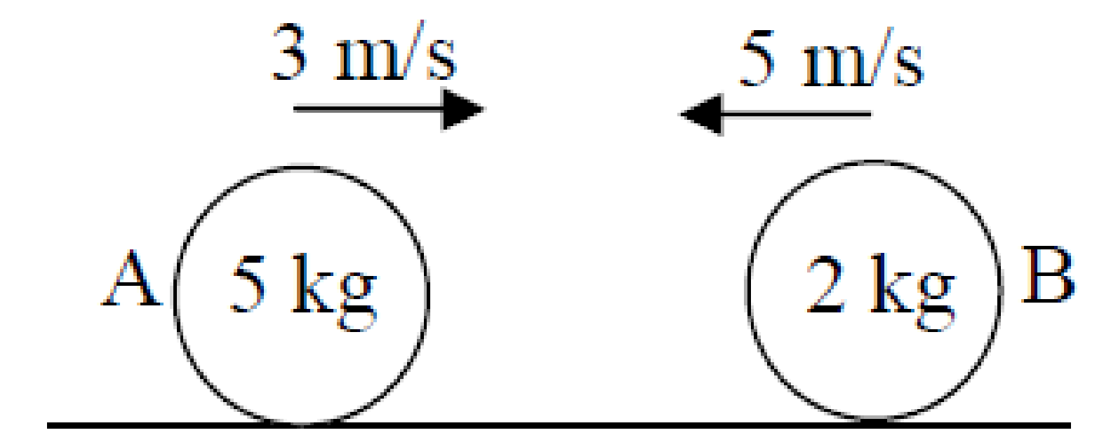
A smooth sphere A, of mass 5 kg, collides directly with another smooth sphere B, of mass 2 kg, on a smooth horizontal table.
Before impact A and B are moving in opposite directions with speeds 3 m/s and 5 m/s, respectively.
The coefficient of restitution for the collision is 3/4.
Find
- the speed of A and the speed of B after the collision
- the loss in kinetic energy due to the collision
- the magnitude of the impulse imparted to B due to the collision.

2008
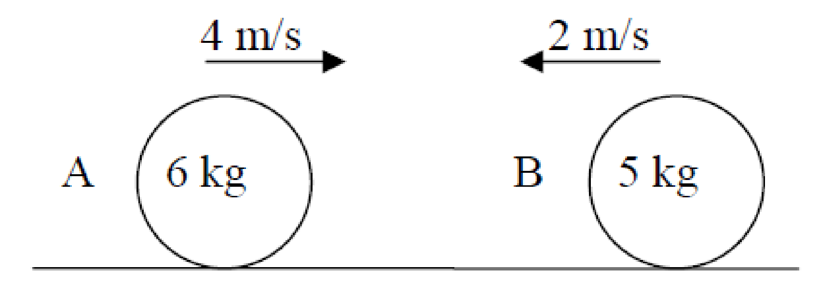
A smooth sphere A, of mass 6 kg, collides directly with another smooth sphere B, of mass 5 kg, on a smooth horizontal table.
A and B are moving in opposite directions with speeds of 4 m/s and 2 m/s respectively.
The coefficient of restitution for the collision is 0.1. Find
- the speed of A and the speed of B after the collision
- the loss in kinetic energy due to the collision
- the magnitude of the impulse imparted to A due to the collision.

2007
A smooth sphere A, of mass 2 kg, collides directly with another smooth sphere B, of mass 3 kg, on a smooth horizontal table.
A and B are moving in the same direction with speeds of 5 m/s and 2 m/s respectively.
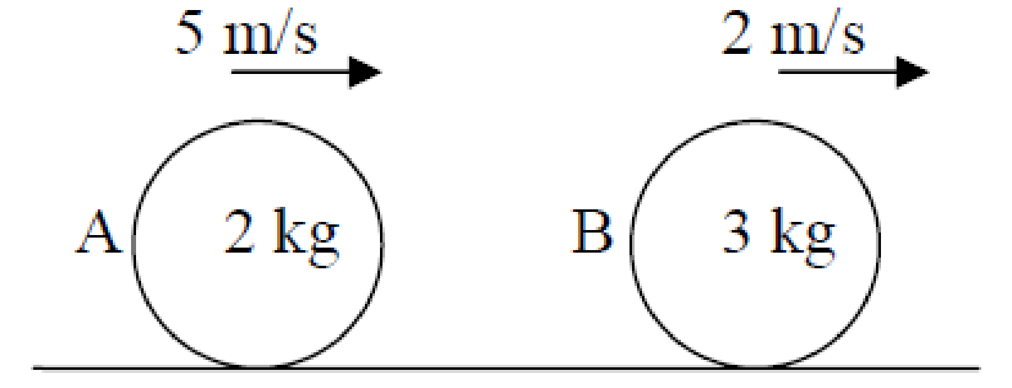
The coefficient of restitution for the collision is 2/3.
Find
- the speed of A and the speed of B after the collision
- the loss in kinetic energy due to the collision
- the magnitude of the impulse imparted to B due to the collision.

2006
A smooth sphere A, of mass 7 kg, 2 m/s 1 m/s collides directly with another smooth sphere B, of mass 3 kg, on a smooth horizontal table.
A and B are moving in opposite directions with speeds of 2 m/s and 1 m/s respectively.
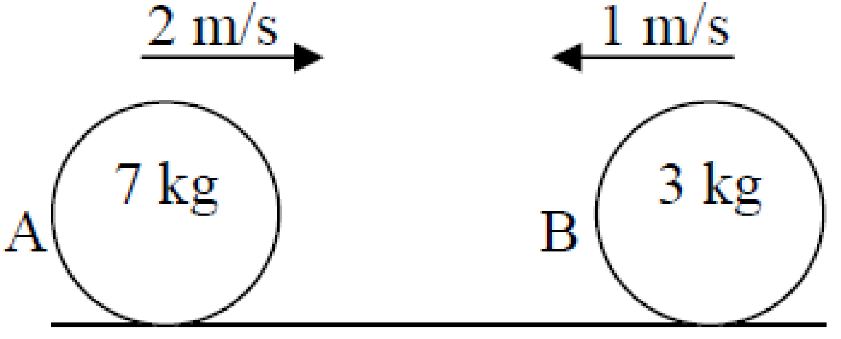
The coefficient of restitution for the collision is 1/3.
Find
- the speed of A and the speed of B after the collision
- the loss in kinetic energy due to the collision
- the magnitude of the impulse imparted to A due to the collision.

2016 (a)
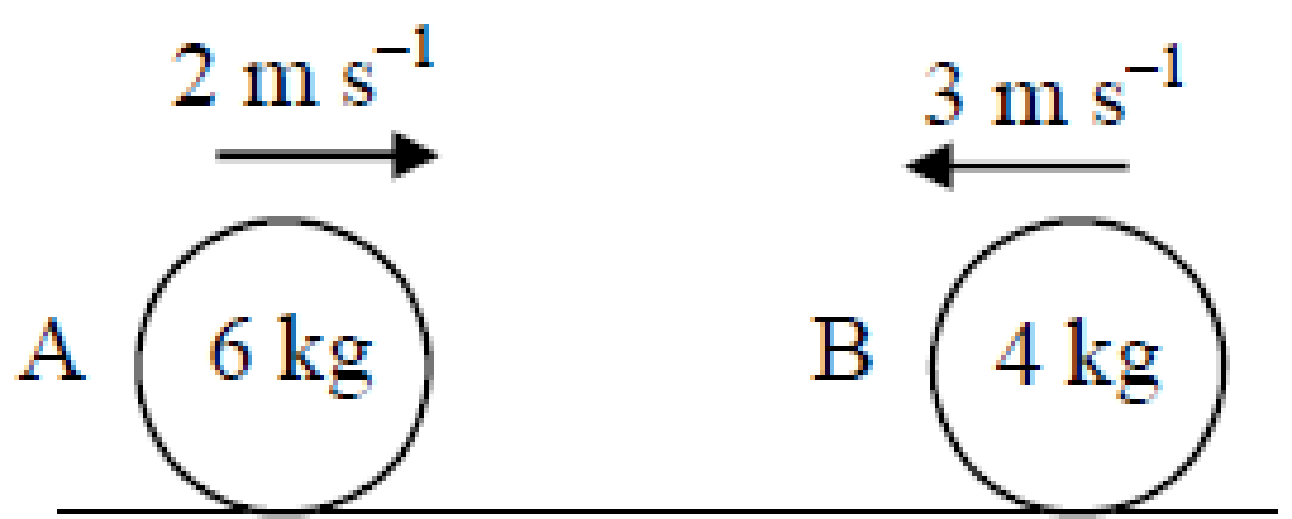
A smooth sphere A, of mass 6 kg, collides directly with another smooth sphere B, of mass 4 kg, on a smooth horizontal table.
Spheres A and B are moving in opposite directions with speeds of 2 m s^{–1} and 3 m s^{–1} respectively.
The coefficient of restitution for the collision is $\frac{2}{5}$ .
- Find the speed of A and the speed of B after the collision
- Find the loss in kinetic energy due to the collision
- Find the magnitude of the impulse imparted to A due to the collision.

2017 (a)
A smooth sphere A, of mass 1 kg, collides with another smooth sphere B, of mass 3 kg, on a smooth horizontal table.
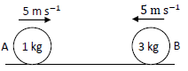
Spheres A and B are moving towards each other with a speed of 5 m s⁻¹.
The coefficient of restitution for the collision is $\frac{3}{5}$ .
Find
- the speeds of A and B immediately after the collision
- the loss of kinetic energy due to the collision
- the magnitude of the impulse imparted to B due to the collision.

2005
A smooth sphere P, of mass 2 kg, moving with a speed of 10 m/s collides directly with a smooth sphere Q, of mass 3 kg, moving in the same direction with a speed of 5 m/s on a smooth horizontal table.
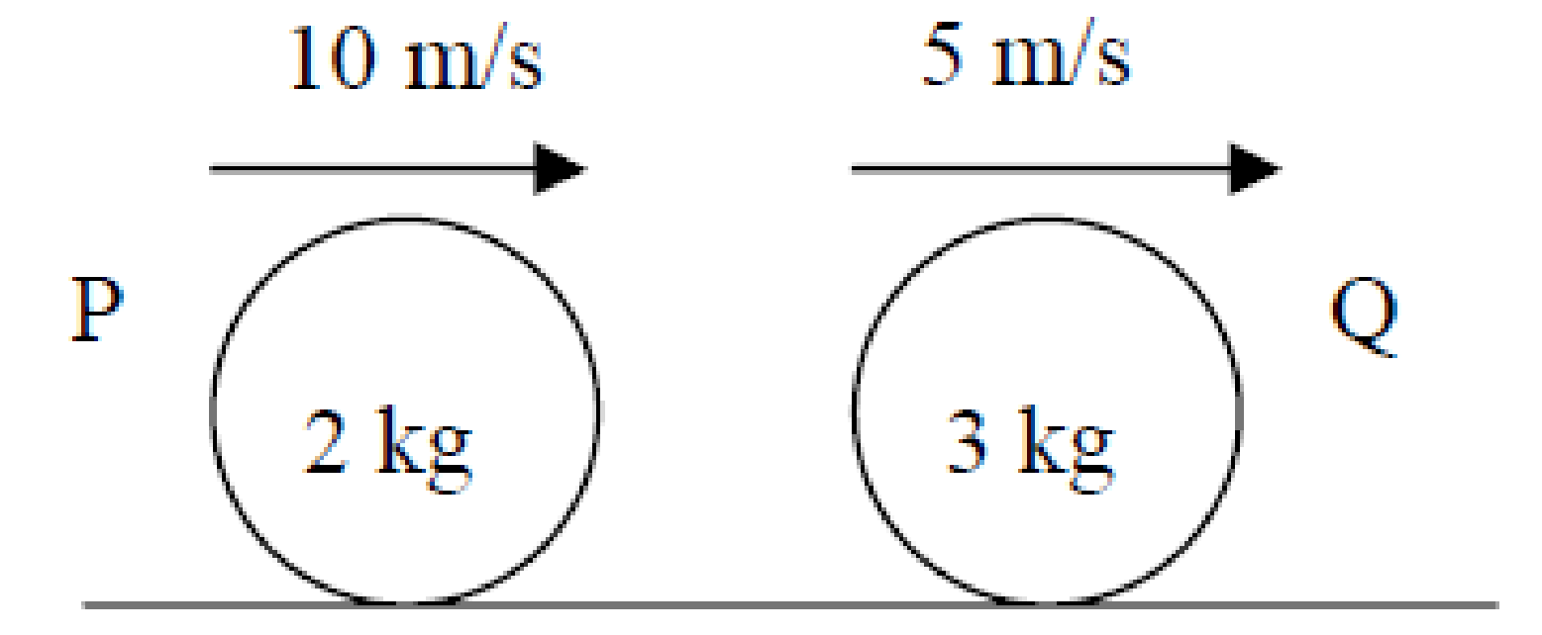
The coefficient of restitution for the collision is e.
After the collision, sphere Q continues to travel in the same direction but with a speed of 8 m/s.
- Find the speed of P after the collision.
- Find the value of e.
- Find the fraction of kinetic energy lost due to the collision.
- Find the magnitude of the impulse imparted to each sphere.
2004 (a)
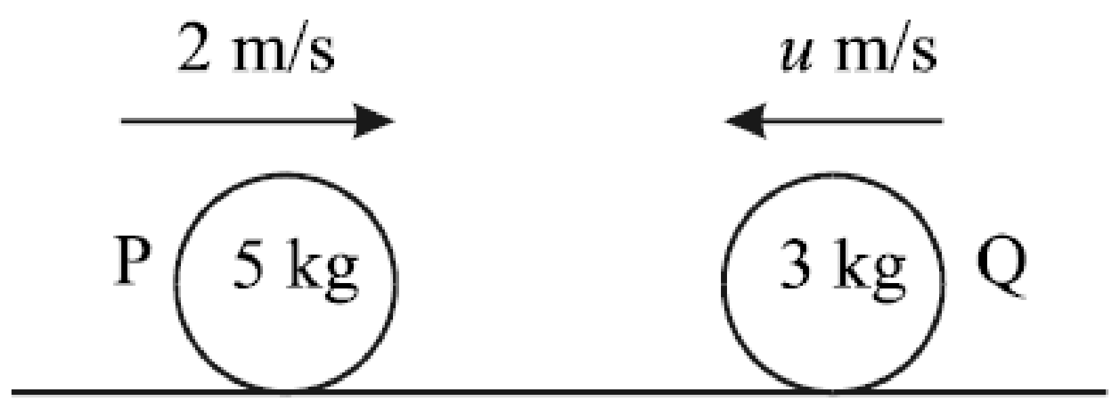
A smooth sphere P, of mass 5 kg, moving with a speed of 2 m/s collides directly with a smooth sphere Q, of mass 3 kg, moving in the opposite direction with a speed of u m/s on a smooth horizontal table.
The coefficient of restitution for the collision is ½.
As a result of the collision, sphere P is brought to rest.
- Find the value of u.
- Find the speed of Q after the collision.

2014
A smooth sphere A, of mass 2 kg, collides directly with another smooth sphere B, of mass 5 kg, on a smooth horizontal table.
A and B are moving in the same direction with speeds of 4 m s^{–1} and 2 m s^{–1} respectively.
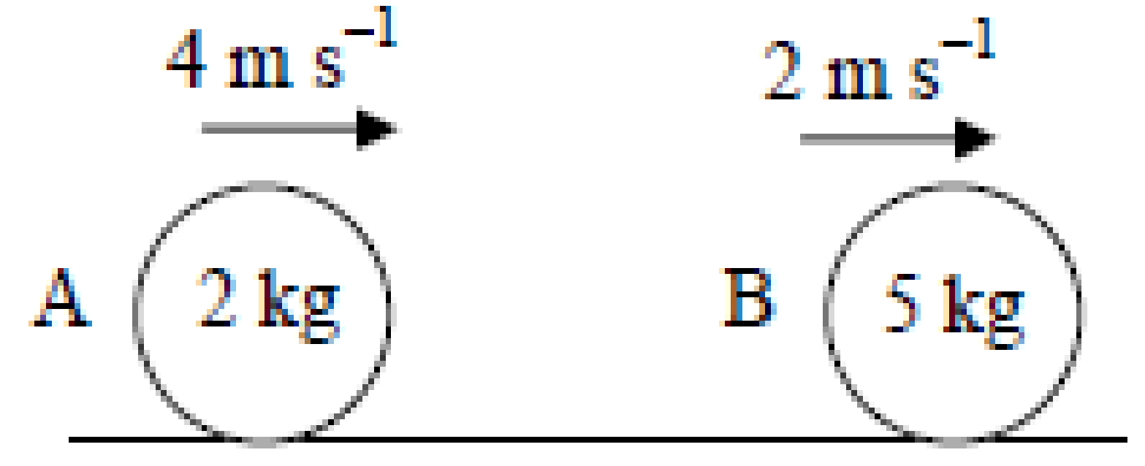
The impulse imparted to B due to the collision is 5 N s.
Find
- the speed of B after the collision
- the speed of A after the collision
- the coefficient of restitution for the collision
- the loss in kinetic energy due to the collision.

2003
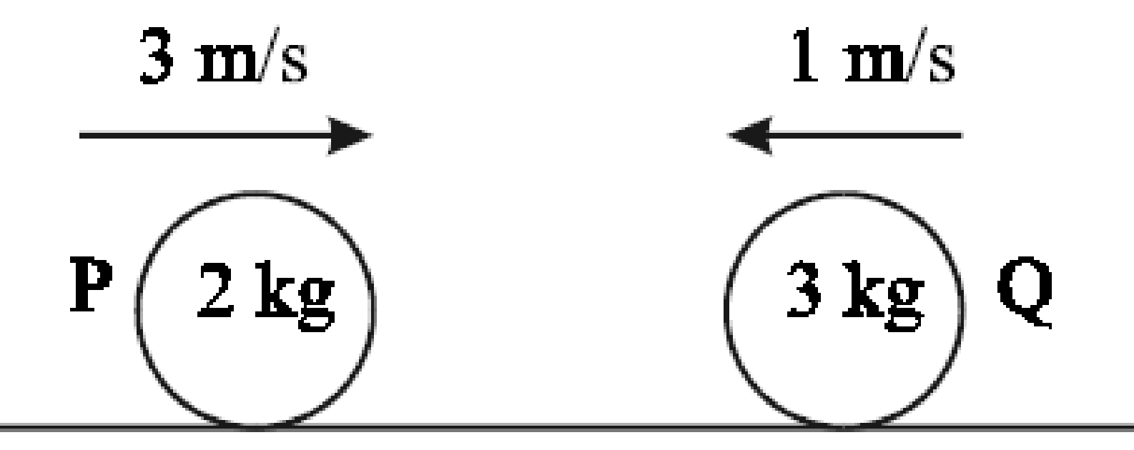
A smooth sphere P, of mass 2 kg, moving with a speed of 3 m/s collides directly with a smooth sphere Q, of mass 3 kg, moving in the opposite direction with a speed of 1 m/s on a smooth horizontal table.
The coefficient of restitution for the collision is e.
As a result of the collision, sphere P is brought to rest.
- Find the speed of Q after the collision.
- Find the value of e.
- Find the fraction of kinetic energy lost due to the collision.

2000
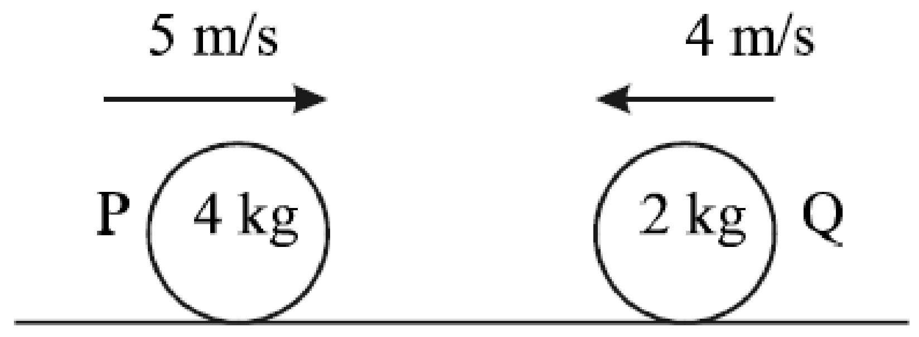
Two smooth spheres P and Q, of masses 4 kg and 2 kg respectively and travelling in opposite directions with speeds of 5 m/s and 4 m/s respectively, collide directly on a smooth horizontal table.
The coefficient of restitution between the spheres is e.
As a result of the collision P continues to move in the same direction with a speed of e m/s.
- Find the value of e.
- Find the loss in kinetic energy due to the collision.

Higher Level - Direct collisions
Remember that impulse = change in momentum = (mv – mu)

1982 (a)
A smooth Sphere of mass 10 kg moving at 10 m/s impinges directly on another smooth sphere of mass 50 kg moving in the opposite direction at 5 m/s.
If the coefficient of restitution is ½, calculate the speeds after impact and the magnitude of the impulse during impact.

2015 (a)
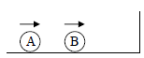
A small smooth sphere A, of mass 2m, moving with speed 9u m s^{–1}, collides directly with a small smooth sphere B, of mass 5m, which is moving in the same direction with speed 2u m s^{–1}.
Sphere B then collides with a vertical wall, rebounds and collides again with sphere A.
The wall is perpendicular to the direction of motion of the spheres.
The first collision takes place 35 cm from the wall.
The coefficient of restitution between the spheres is $\frac{4}{5}$ .
The coefficient of restitution between sphere B and the wall is $\frac{5}{14}$ .
- Show that, as a result of the first collision, A comes to rest.
- Find the time between the two collisions between A and B in terms of u.

Now it gets a bit trickier; the initial velocity is in terms of u rather than as a set number. This makes it look like it’s more difficult, but it’s not really.

The procedure here is the very same as for Ordinary Level, but the algebra is usually a little trickier and (usually) we end up calculating v in terms of u and e (instead of v turning out to be an exact number).
Simply set up the two equations as before and solve. Just remember that the terms u and ue are different and can only be expressed as u + ue rather than anything simpler.

The first few questions are more straightforward and just act as a gentle introduction.
Rather than starting and finishing the following questions, just find v₁ and v₂ in terms of u and e for a number of the questions and then, once that skill is mastered, go back and finish the questions}

1979 (a)
{Use principle of conservation of momentum to get an expression for v1 and then sub this into the second equation involving ‘e’}
Two smooth spheres of masses m and 2m collide directly when moving in opposite directions with speeds u and v, respectively.
The sphere of mass 2m is brought to rest by the impact.
Prove that 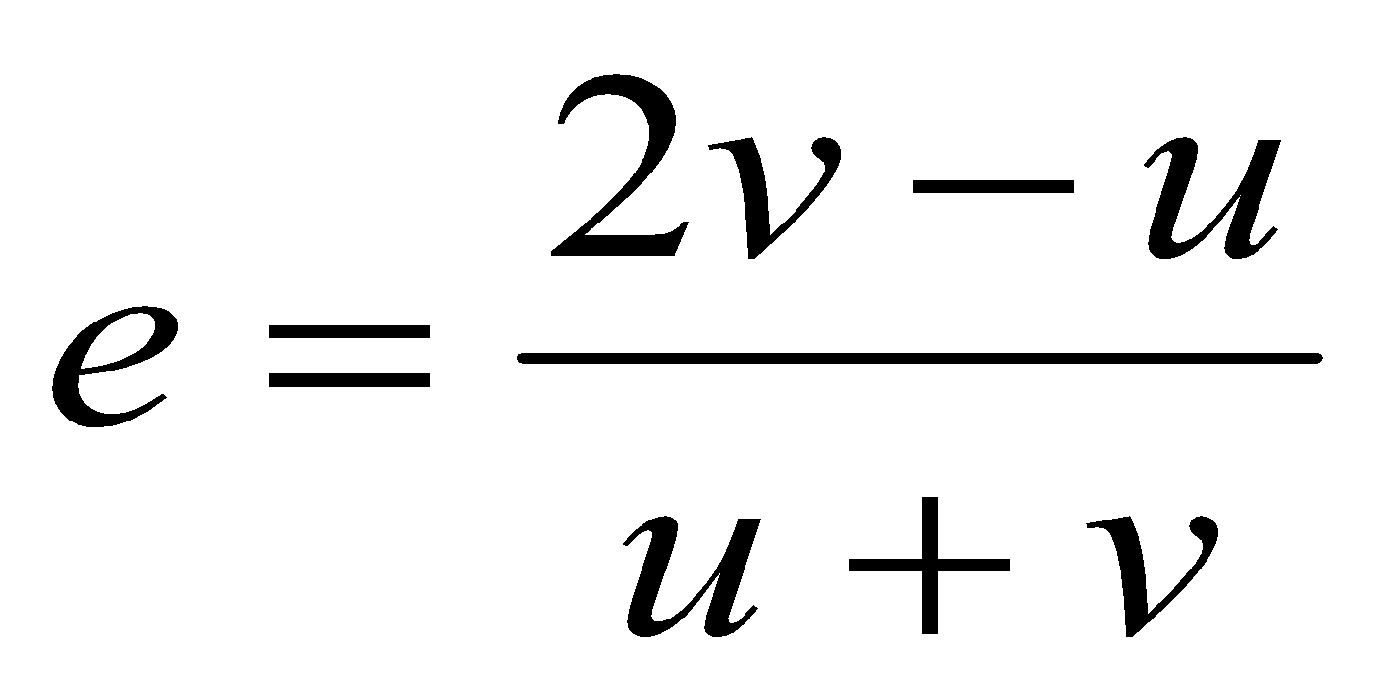

2007 (a)
A smooth sphere P, of mass 2 kg, moving with speed 9 m/s collides directly with a smooth sphere Q, of mass 3 kg, moving in the same direction with speed 4 m/s.
The coefficient of restitution between the spheres is e.
- Find, in terms of e, the speed of each sphere after the collision.
- Show that the magnitude of the momentum transferred from one sphere to the other is 6(1+ e).

2013 (a)
A smooth sphere A, of mass 3m, moving with speed u, collides directly with a smooth sphere B, of mass 5m, which is at rest.
The coefficient of restitution for the collision is e. Find
- the speed, in terms of u and e, of each sphere after the collision
- the value of e if the magnitude of the impulse imparted to each sphere as a result of the collision is 2mu.

1984 (a)
{algebra is just a little tricky}
A smooth sphere of mass 3 kg and velocity u₁ collides directly with another smooth sphere of mass 4 kg and velocity u₂ both moving in the same direction.
Show that 7v₁ = u₁(3 – 4e) + 4u₂(1 + e) where v₁ is the velocity of the 3 kg sphere after the collision.
Hence, show that the impulse which each sphere receives is 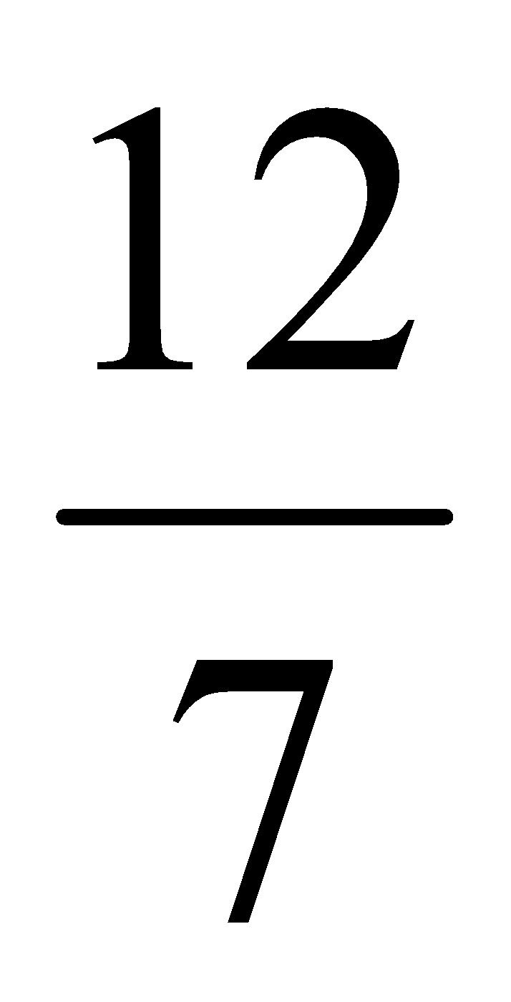(1 + e)(u₂ – u₁).

2002 (a) {Rule: draw a new table out for each separate collision}
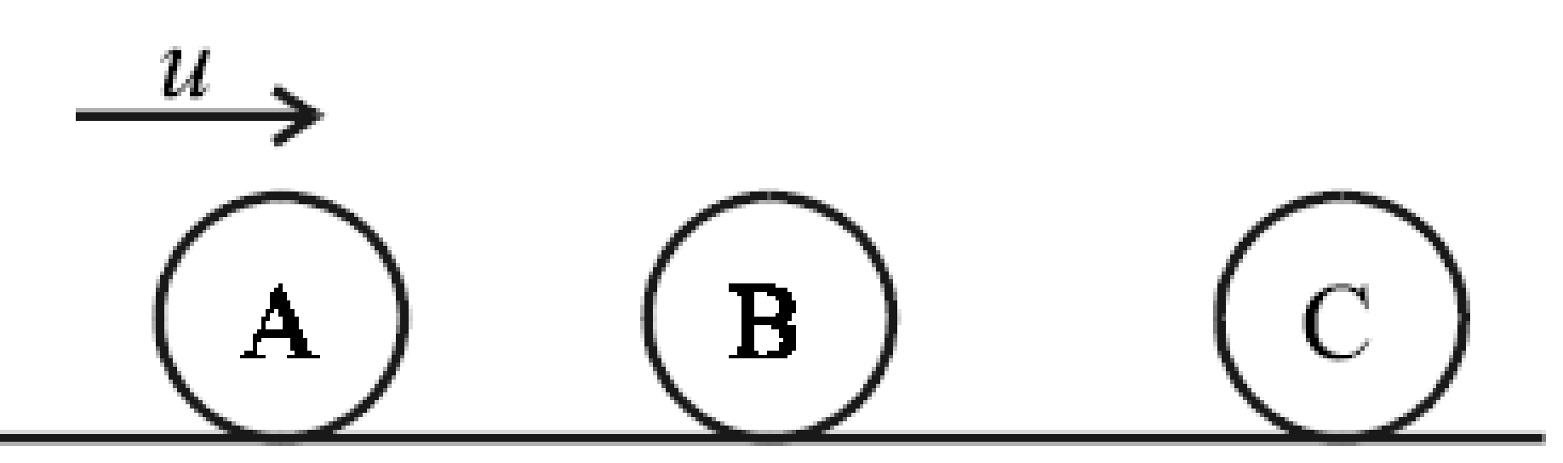
Three identical smooth spheres, A, B and C, lie at rest on a smooth horizontal table with their centers in a straight line. Sphere A is projected towards B with speed u.
Sphere A collides directly with B and then B collides directly with C.
Sphere C moves, after the collision, with a speed of 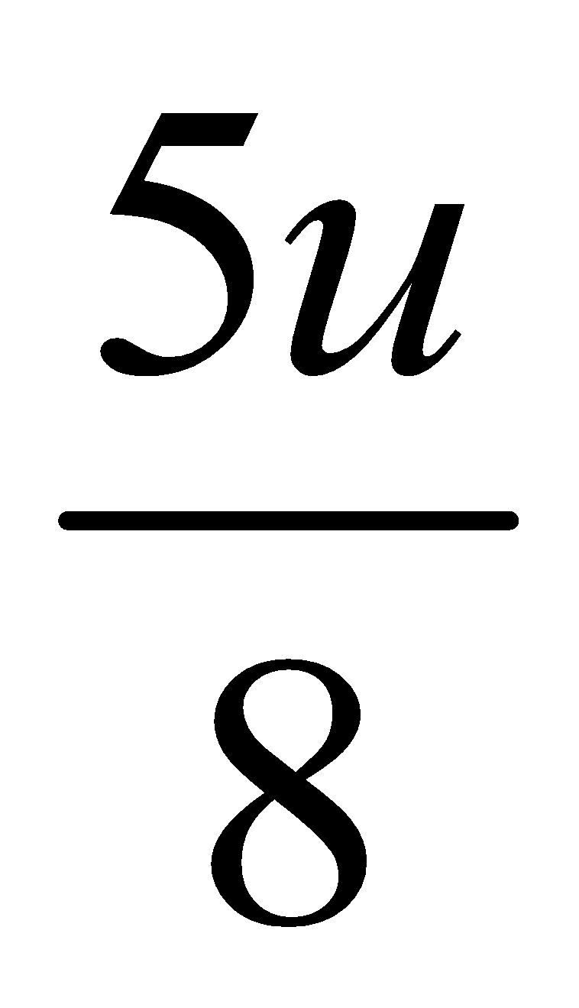.
The coefficient of restitution for each of the two collisions is e. Find e, correct to two places of decimals.
2018 (a)
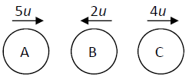
Three identical small smooth spheres A, B and C, each of mass m, lie in a straight line on a smooth horizontal surface with B between A and C.
Spheres A and B are projected towards each other with speeds 5u and 2u respectively, and at the same time C is projected along the line from B away from B with speed 4u.
The coefficient of restitution between each pair of spheres is e.
After the collision between A and B there is a collision between B and C.
- Find, in terms of e and u, the speed of each sphere after the first collision.
- Show e > $\frac{5}{7}$.
- If e = $\frac{6}{7}$ show that B will not collide with A again.

Direct Collisions involving inequalities

Inequalities (< or >) usually arise in one of the following two circumstances:
- The limits of e are 0 and 1 (perfectly inelastic and perfectly elastic respectively).
- The sign in front of the spheres’ velocities is determined by their directions.
This means that if you have to show that the two spheres move in opposite directions after the collision, one of the velocities must be > 0 and the other must be < 0.
- For three spheres I recommend that you make out a new table for each collision

Direct Collisions involving inequalities and three spheres
In general the questions involving three spheres can (strangely) be more straightforward in that most of the heavy lifting is associated with find an expression for the velocity of each sphere after all collisions.

2001
This question is Ordinary Level – it does not involve inequalities but does involve two collisions so acts as a gentle introduction
A smooth sphere P, of mass 4 kg, moving with a speed of 2 m/s collides directly with a smooth sphere Q, of mass 2 kg, travelling in the opposite direction with a speed of 2 m/s on a smooth horizontal table.
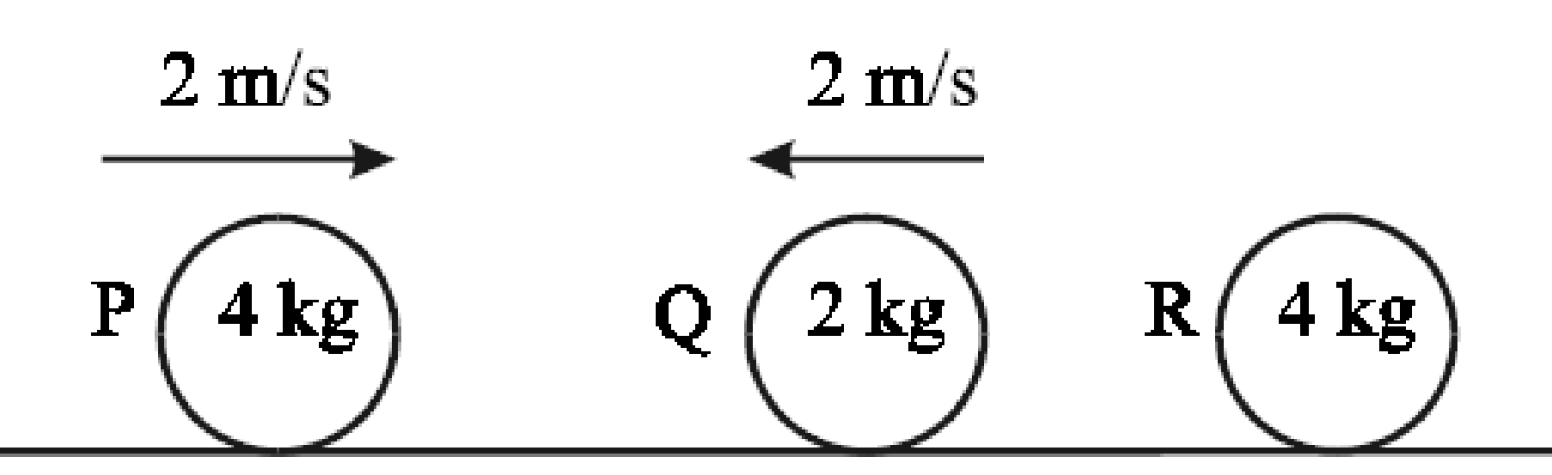
The coefficient of restitution for the collision is 1/3.
Find the speed of P and the speed of Q after the collision.
As a result of this collision Q goes on to collide directly with a stationary smooth sphere R, of mass 4 kg.
The collision between Q and R causes Q to come to rest.
Find the coefficient of restitution for the collision between Q and R.

2005 (a)
Three identical smooth spheres P, Q and R, lie at rest on a smooth horizontal table with their centers in a straight line. Q is between P and R. Sphere P is projected towards Q with speed 2 m/s.
Sphere P collides directly with Q and then Q collides directly with R.
The coefficient of restitution for all of the collisions is 3/4.
Show that P strikes Q a second time.

2008 (a)
Three identical smooth spheres lie at rest on a smooth horizontal table with their centres in a straight line. The first sphere is given a speed 2 m/s and it collides directly with the second sphere. The second sphere then collides directly with the third sphere.
The coefficient of restitution for each collision is e, where e < 1.
- Find, in terms of e, the speed of each sphere after two collisions have taken place.
- Show that there will be at least one more collision.

2012 (a)
Three smooth spheres, A, B and C, of mass 3m, 2m and m lie at rest on a smooth horizontal table with their centres in a straight line. Sphere A is projected towards B with speed 5 m s⁻¹. Sphere A collides directly with B and then B collides directly with C.
The coefficient of restitution between the spheres is e.
Show that if e > $\frac{3- √5}{2}$ there will be no further collisions.
2018 (a)
Three identical small smooth spheres A, B and C, each of mass m, lie in a straight line on a smooth horizontal surface with B between A and C.
Spheres A and B are projected towards each other with speeds 5u and 2u respectively, and at the same time C is projected along the line from B away from B with speed 4u.
The coefficient of restitution between each pair of spheres is e.
After the collision between A and B there is a collision between B and C.
- Find, in terms of e and u, the speed of each sphere after the first collision.
- Show e > $\frac{5}{7}$.
- If e = $\frac{6}{7}$ show that B will not collide with A again.

Direct Collisions involving inequalities and two spheres

2022 Deferred (a)
A smooth sphere, P, of mass 3m collides directly with another smooth sphere, Q, of mass 5m.
P and Q are moving in opposite directions before impact with speeds 4u and 2u respectively.
The coefficient of restitution for the collision is e.
(i) Find the speed of P and the speed of Q after impact in terms of u and e.
(ii) If P and Q are moving in the same direction after impact, show that 0 ≤ e ˂ $\frac{1}{15}$ .

2009 (a)
A smooth sphere P, of mass m kg, moving with speed 2u m/s collides directly with a smooth sphere Q, of mass 2m kg, moving in the same direction with speed u m/s.
The coefficient of restitution between the spheres is e.
- Find, in terms of e, the speed of each sphere after the collision.
- Prove that the speed of Q increases after the collision.
- Find the value of e if the speed of P after the collision is 10u/9 m/s.

2011 (a)
A smooth sphere P, of mass 2m kg, moving with speed u m s⁻¹ collides directly with a smooth sphere Q, of mass 3m kg, moving in the opposite direction with speed u m s⁻¹ .
The coefficient of restitution between the spheres is e and 0 < e <1.
- Show that P will rebound for all values of e.
- For what range of values of e will Q rebound?

1995 (a)
Two smooth spheres of masses 2m and 3m respectively lie on a smooth horizontal table.
The spheres are projected towards each other with speeds 4u and u respectively.
- Find the speed of each sphere after the collision in terms of e, the coefficient of restitution.
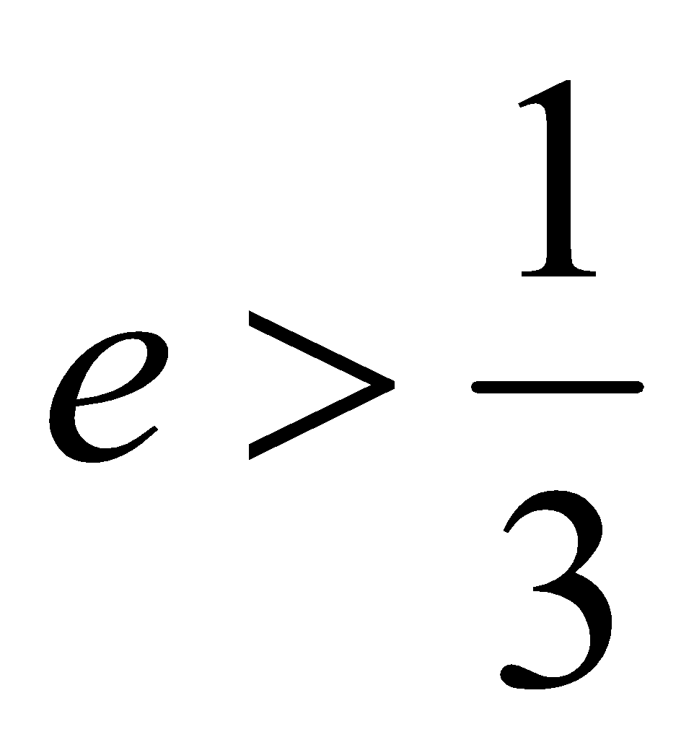
- Show that the spheres will move in opposite directions after the collision if

2004 (a)
A smooth sphere P, of mass 3m, moving with speed u, collides directly with a smooth sphere Q, of mass 5m, which is at rest. The coefficient of restitution for the collision is e.
(i) Find the speed, in terms of u and e, of each sphere after the collision
(ii) Find the condition to be satisfied by e in order that the spheres move in opposite directions after the collision.

2000 (a)
Two smooth spheres whose masses are m and 2m move towards each other in a straight line with speeds 4u and u, respectively. Show that the spheres will move in opposite directions after the collision if $e>\frac{1}{5}$, where e is the coefficient of restitution.

1997 (a)
A smooth sphere P, of mass m, moving with speed ku collides with a smooth sphere Q, of mass km, moving in the same direction with speed u. P is brought to rest by the impact.
(i) Find the velocity of Q after the collision in terms of u.
(ii) Prove that k 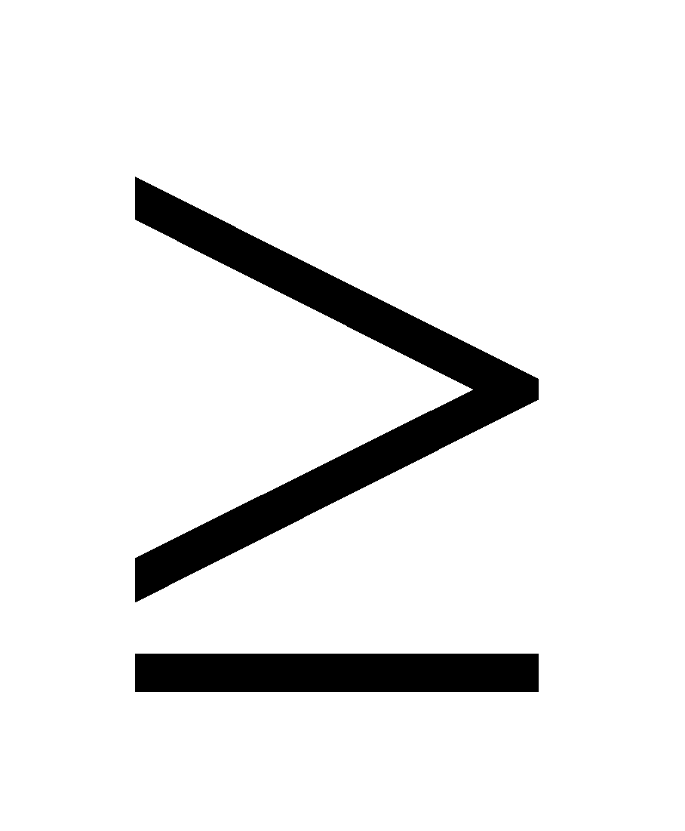3.
1986 (a)
A smooth sphere P of mass 3m and velocity 4u impinges directly on a smooth sphere Q of mass 5m and velocity 2u, moving in the same direction. The coefficient of restitution is e.
- For what value of e will the velocity of P be halved by the impact?
- Show that whatever the value of e in 0 < e < 1, the velocity of Q after impact exceeds 2u.

2021 (a)
A smooth sphere A of mass 4m, moving with speed u on a smooth horizontal table collides directly with a smooth sphere B of mass m, moving in the opposite direction with speed u.
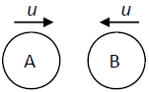
The coefficient of restitution between A and B is e.

- Find the speed, in terms of u and e, of each sphere after the collision.

- The magnitude of the impulse on B due to the collision is 𝑇.
Show that $\frac{8mu}{5}≤T≤\frac{16mu}{5}$

2003 (a) {the condition to be satisfied for part (ii) is a real head-melter}
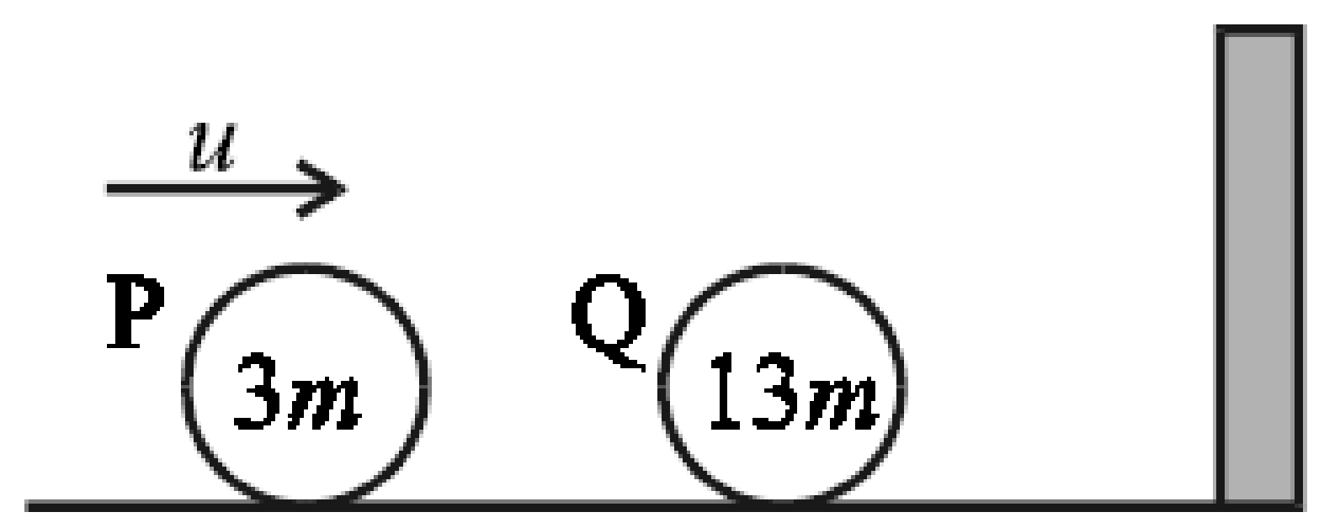
A smooth sphere P, of mass 3m, moving with speed u, collides directly with a smooth sphere Q, of mass 13m, which is at rest. Sphere Q then collides with a vertical wall which is perpendicular to the direction of motion of the spheres.
The coefficient of restitution for all of the collisions is e.
(i) Find the speed, in terms of u and e, of each sphere after the first collision.
(ii) Find the range of values of e for which there will be a second collision between the spheres.

2020 (a)
A smooth sphere A of mass m, moving with speed 3u on a smooth horizontal table collides directly with a smooth sphere B of mass 2m, moving in the opposite direction with speed u.
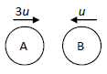
The directions of motion of A and B are reversed by the collision.
The coefficient of restitution between A and B is e.

- Find the speed, in terms of u and e, of each sphere after the collision.
Subsequently B hits a wall at right angles to the line of motion of A and B.
The coefficient of restitution between B and the wall is $\frac{1}{2}$.

- After B rebounds from the wall there is a further collision between A and B.
Show that $\frac{1}{8}<e<\frac{1}{4}$

1998 (a)
Two smooth spheres A and B have masses m₁ and m₂, respectively.
They are moving towards each other along the same horizontal line each with speed 2u.
After collision both spheres reverse their original directions of motion and A now travels with speed u.
Show that 3m₁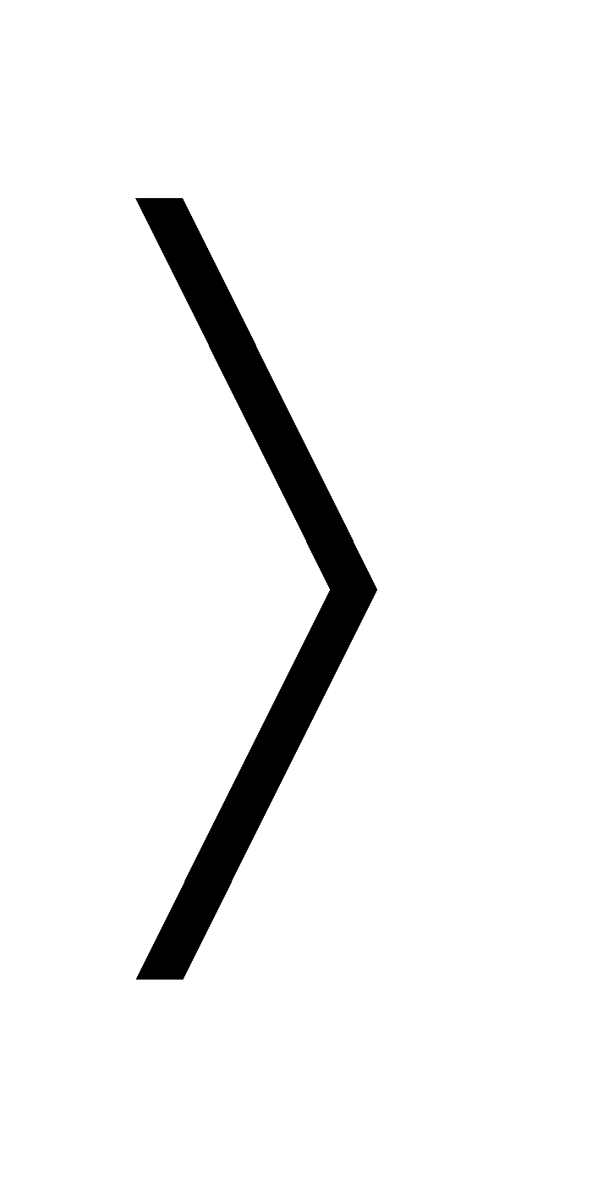2m₂.
Find an expression for e, the coefficient of restitution, and hence or otherwise show that 3m₁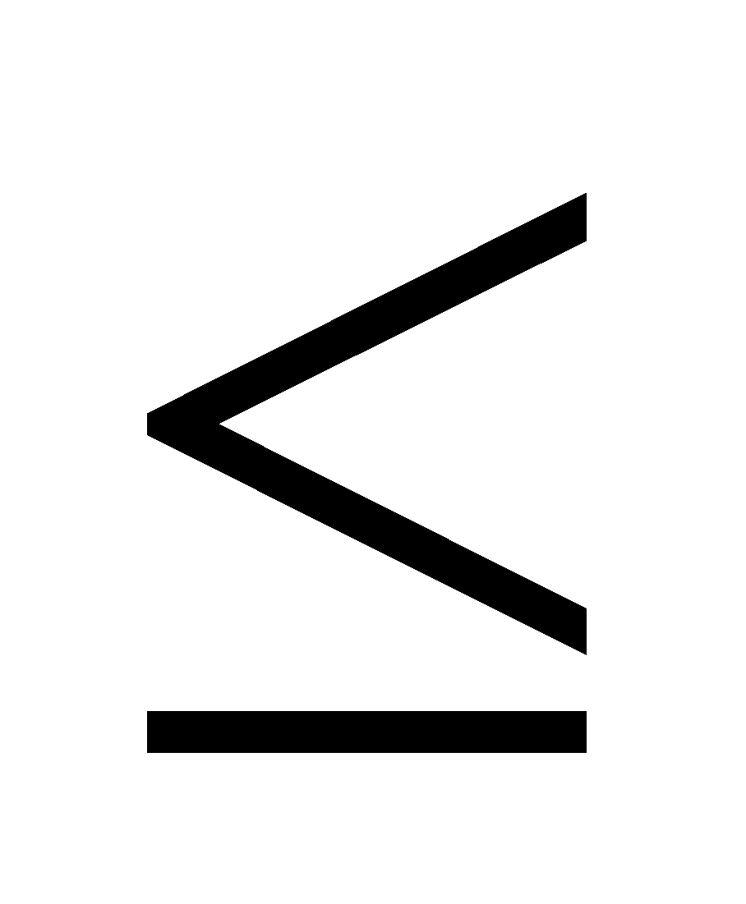 5m₂

1980 (a)
Two imperfectly elastic spheres of equal mass moving horizontally along the same straight line impinge and, as a result one of them is brought to rest.
Show that whatever be the value of the coefficient of restitution, e < 1, they must have been moving in opposite directions.

Kinetic energy
{The concept here is straightforward but the algebra can get quite tricky, so perhaps best left until revision in sixth year}
K.E. = ½ mv²

Change in Kinetic Energy = (Initial K.E. minus final K.E.)

Fractional change in Kinetic Energy = change in Kinetic Energy divided by the original (total) K.E.

Percentage change in K.E = Fractional change in Kinetic Energy multiplied by 100.

2022 (a)
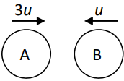
A smooth sphere A of mass 2m, moving with speed 3u on a smooth horizontal table collides directly with a smooth sphere B of mass m, moving in the opposite direction with speed u.
The coefficient of restitution between A and B is e.
Find, in terms of u and e,
- the speed of each sphere after the collision
- the magnitude of the impulse imparted to B due to the collision.
- The loss of the kinetic energy due to the collision is kmu²(1 – e²).
Find the value of k.

2017 (a)
A small smooth sphere A, of mass 1.5 kg, moving with speed 6 m s^{–1}, collides directly with a small smooth sphere B, of mass m kg, which is at rest.
After the collision the spheres move in opposite directions with speeds v and 2v, respectively.
80% of the kinetic energy lost by A as a result of the collision is transferred to B.
The coefficient of restitution between the spheres is e.
Find
- the value of v
- the value of e.

1996 (a)
Two smooth spheres of masses 2m and m moving in opposite directions with speeds u and 2u, respectively, collide directly. If E₁ and E₂ are the sums of the kinetic energies of the two spheres before and after impact respectively, prove that 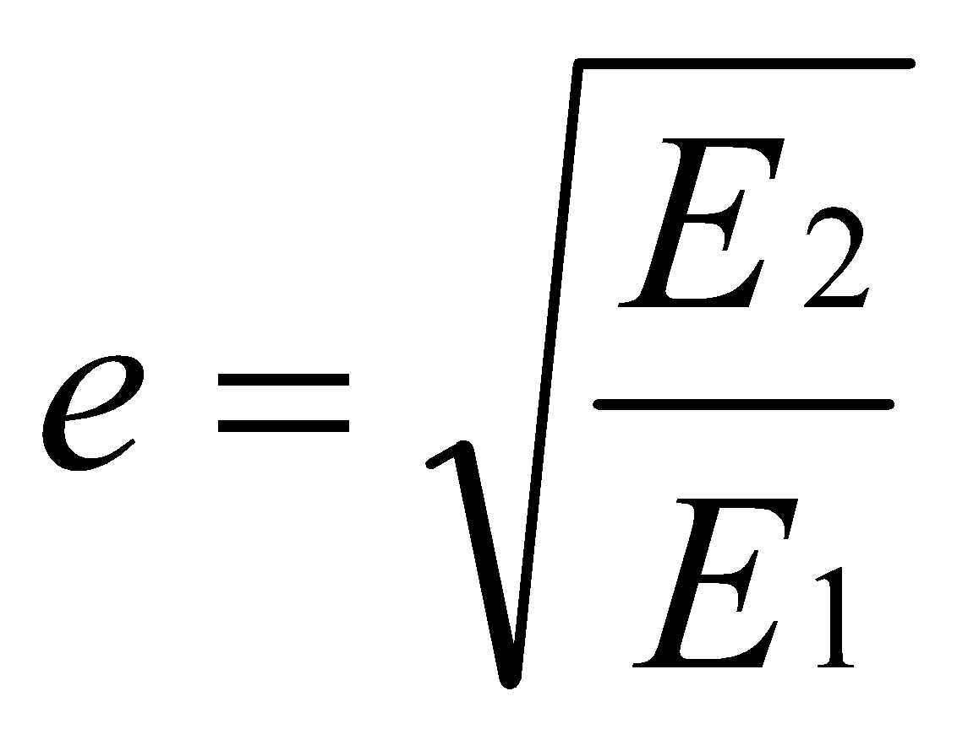 where e is the coefficient of restitution.

2010 (a) {ok – just}
A sphere, of mass m and speed u, impinges directly on a stationary sphere of mass 3m.
The coefficient of restitution between the spheres is e.
- Find, in terms of u and e, the speed of each sphere after the collision.
- If e = 1/4, find the percentage loss in kinetic energy due to the collision.

2001 (b)
In order to be able to do this question you need to understand the significance of the phrase ‘magnitude of the relative velocity between the spheres’- it means (V₂ – V₁) - and it’s okay to tell you because that concept is no longer on the course).
Part (ii) involves tricky algebra and is best left as a revision question in sixth year}
Two identical smooth spheres, each of mass m and moving in the same direction collide directly. The coefficient of restitution between the spheres is e. If u is the magnitude of the relative velocity between the spheres before impact, show that
(i) each sphere receives an impulse (change in momentum) of magnitude ½ mu (1 + e)
(ii) the loss in the total kinetic energy of the two spheres due to the impact is 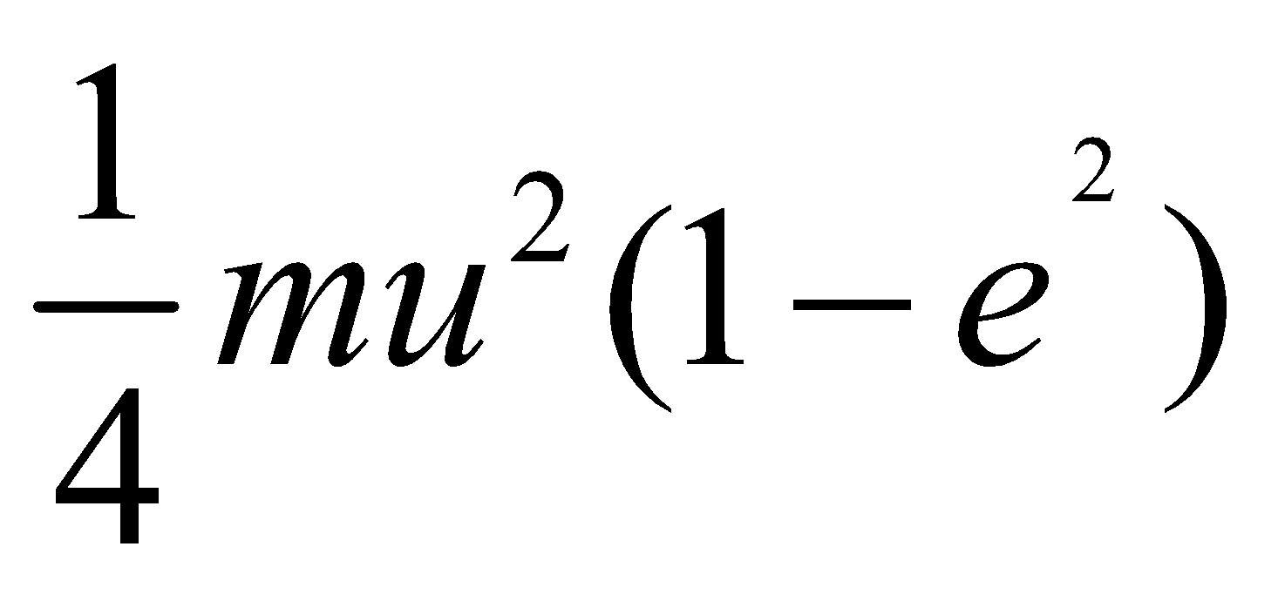.

2014 (a)
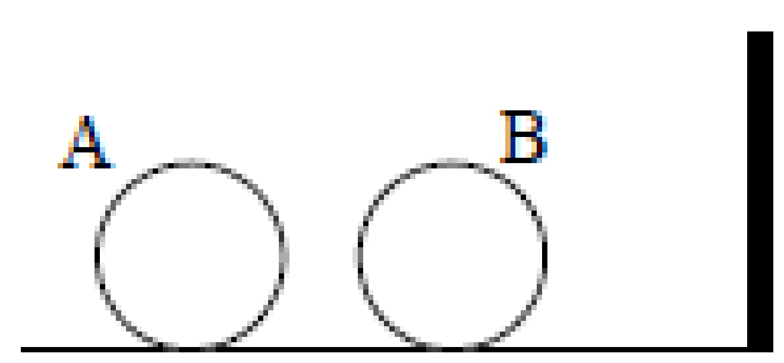
A smooth sphere A, of mass 2m, moving with speed u collides directly with a smooth sphere B, of mass 7m, which is at rest. B then collides with a vertical wall which is perpendicular to the direction of motion of the spheres.
The coefficient of restitution is ½ for all collisions.
- Show that the spheres will not collide for a second time.
- What is the total loss of kinetic energy due to the impacts?

1988 (full question)
Two smooth spheres A and B, of equal radii, have masses 4 kg and 8 kg respectively.
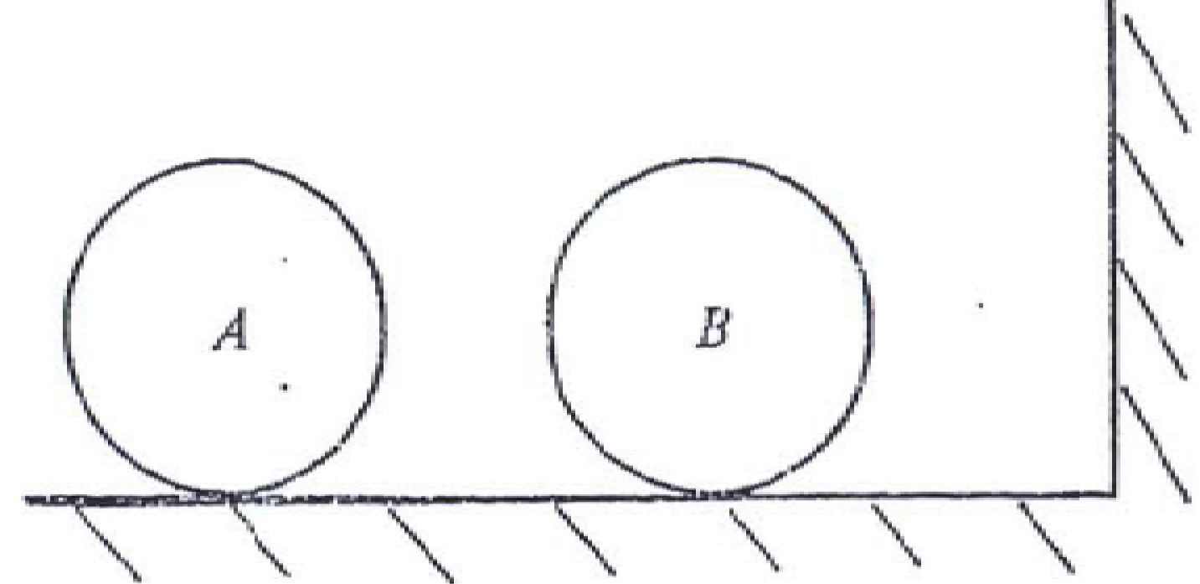
They lie at rest on a smooth horizontal floor so that the line joining their centres is perpendicular to the vertical wall. A is projected towards B with speed u and collides with B.
B then hits the wall, rebounds and collides with A again. `
This final collision reduces B to rest.
If the coefficient of restitution between A and B is ¼ , calculate
- the coefficient of restitution between B and the wall.
- the final velocity of A in terms of u.
- the total loss of energy due to the three collisions.

2006 (a) {Leave part (ii) for sixth year – tricky algebra}
A smooth sphere P, of mass 3 kg, moving with speed 6 m/s, collides directly with a smooth sphere Q, of mass 5 kg, which is moving in the same direction with speed 2 m/s. The coefficient of restitution for the collision is e.
- Find, in terms of e, the speed of each sphere after the collision.
- If the loss of kinetic energy due to the collision is k(1− e² ), find the value of k.

1991 (a) {Tricky algebra – leave for sixth year}
A sphere of mass 4m travelling with speed u, strikes directly a stationary sphere of mass 2m.
If the coefficient of restitution is e, prove that the energy lost in the collision is 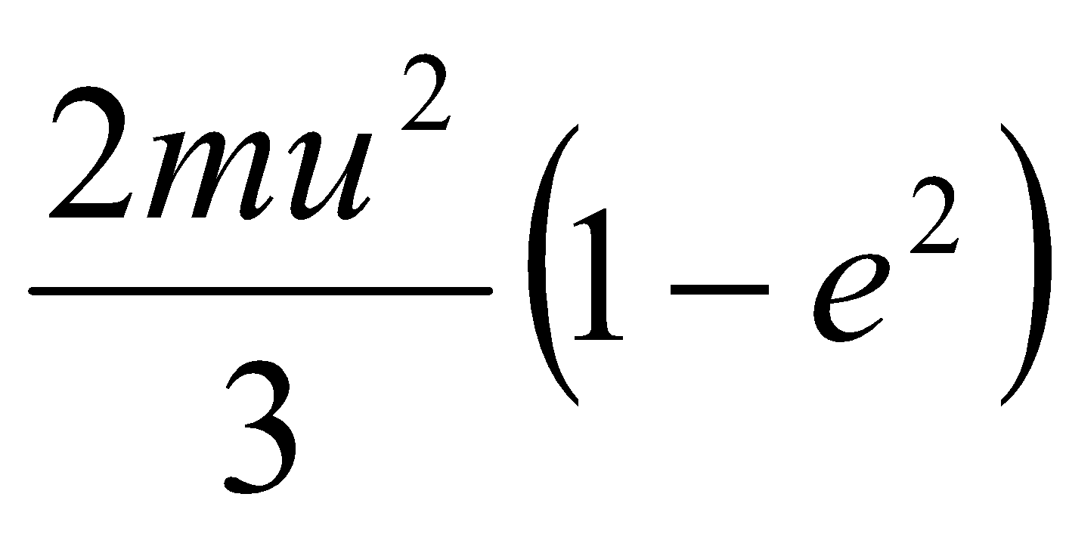.

Conservation of energy questions

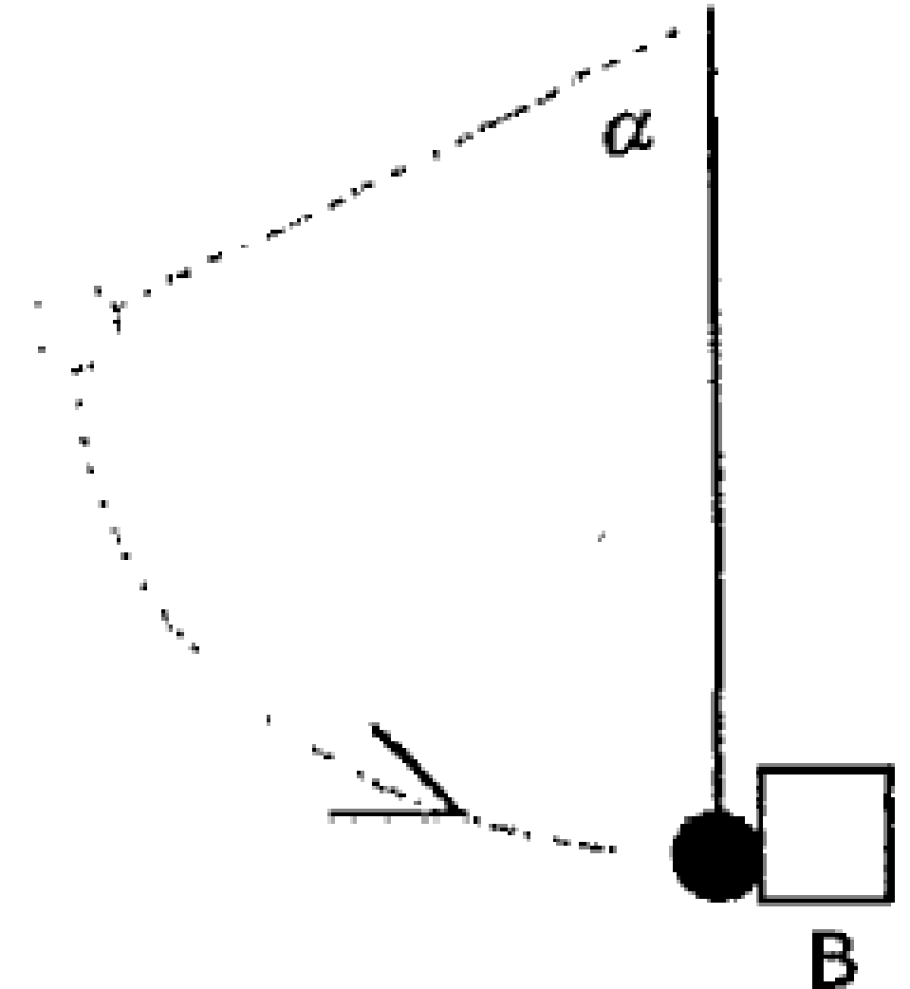
If an object’s height is given as part of the question you will need to invoke the conservation of energy {KE + PE before = KE + PE after}

1998 (b)
A sphere of mass 4kg is released from rest when α = 60⁰. It swings down and strikes a 7 kg box B when the string is vertical. The distance from the point of support to the centre of the sphere is one metre and the coefficient of restitution for the collision is ¾. Calculate the speed of the box immediately after the impact if the box is free to move.

2016 (a)
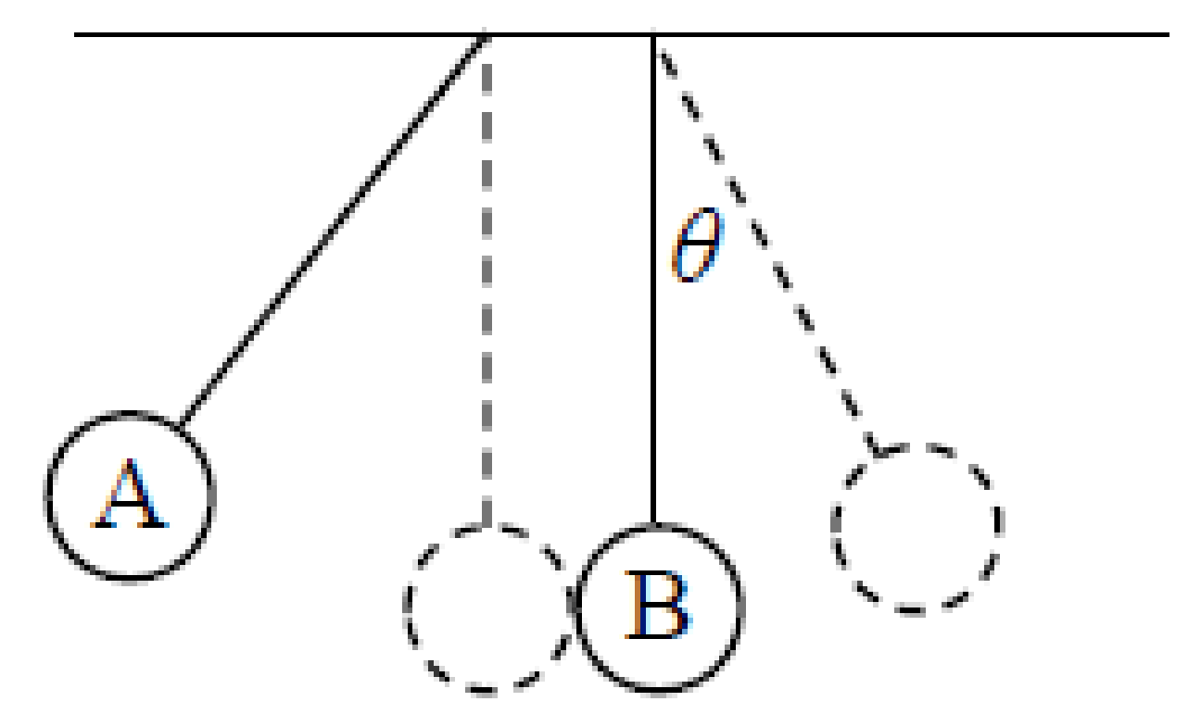
Two small smooth spheres A, of mass 2 kg, and B, of mass 3 kg, are suspended by light strings from a ceiling as show in the diagram. The distance from the ceiling to the centre of each sphere is 2 m.
Sphere A is drawn back 60° and released from rest.
A collides with B and rebounds. B swings through an angle θ.
The coefficient of restitution between the spheres is$\frac{3}{4}$.

- Show that A strikes B with a speed of $\sqrt{2g}$ m s^{–1}.
- Find the speed of each sphere after the collision.
- Find the value of θ.

“Sphere B collides with a wall and next collision takes place a distance ‘d’ from the wall.”

The key in this situation is to look at the different time intervals and describe each individual time in terms of distance divided by velocity.
A common error here is to assume that when a velocity is negative, the time will be also. But time is a scalar and therefore cannot be negative. Therefore if you get a negative time, simply ignore the minus sign.

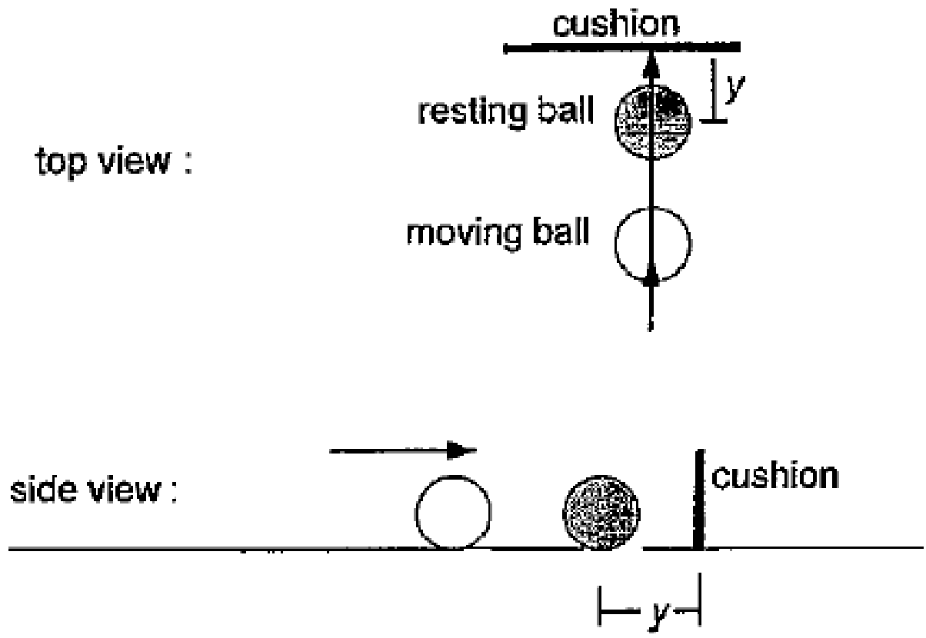
1999 (a)
A smooth sphere moves on a horizontal table. It strikes an identical sphere at rest on the table. The latter is at a distance y from a vertical cushion. The impact is along the line of centres and normal to the cushion. The next collision between the spheres takes place at a distance d from the cushion.

Prove that d = $\frac{2e^{2}y}{1+ e^{2}}$ , where e is the coefficient of restitution for impacts between spheres and between a sphere and cushion.
Interpret the result when e = 1.

1994 (full question)
A small smooth sphere moves on a smooth horizontal table and strikes an identical sphere lying at rest on the table at a distance of 1m from a vertical wall, the impact being along the line of centres and perpendicular to the wall.
Prove that the next impact between the two spheres will take place at a distance 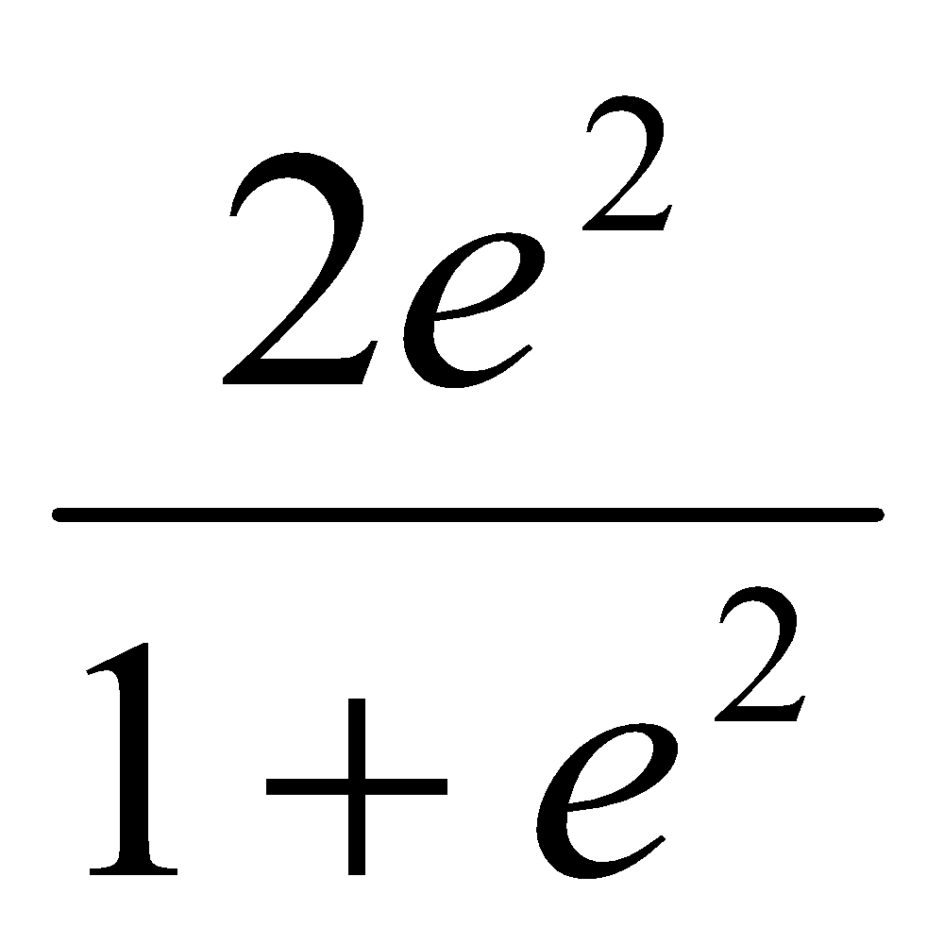 metres from the wall, where e is the coefficient of restitution for all impacts involved.

2019 (a)
A small smooth sphere A, of mass 3m moving with speed u, collides directly with a small smooth sphere B, of mass m moving with speed u in the opposite direction.
The coefficient of restitution between the spheres is $\frac{1}{2}$.
- Find, in terms of u, the speed of each sphere after the collision.

- After the collision B hits a smooth vertical wall which is perpendicular to the direction of motion of B. The coefficient of restitution between B and the wall is $\frac{2}{5}$.
The first collision between the spheres occurred at a distance 2 metres from the wall. The spheres collide again 4 seconds after the first collision between them.
Find the value of u.

And this one is just a complete oddball

2013 (b)
A ball is dropped on to a table and it rises after impact to one-quarter of the height of the fall.
- Find the value of the coefficient of restitution between the ball and the table.
- If sheets of paper are placed on the table the coefficient of restitution decreases by a factor proportional to the thickness of the paper.
When the thickness of the paper is 2·5 cm it rises to only one-ninth of the height of the fall.
Find the value of the coefficient of restitution between the ball and this thickness of paper.
- What thickness of paper is required in order that the rebound will be one-sixteenth of the height of the fall?

Feedback on 2013 (b)
Only a handful of students nationwide got full marks for this question.
I think it was made unnecessarily extra difficult by bringing in the following phrase too early.
"When the thickness of the paper is 2·5 cm it rises to only one-ninth of the height of the fall."

Approach to solving the last part:
"the coefficient of restitution decreases by a factor proportional to the thickness of the paper. "
This means (obviously in hindsight) that e_{orig}/e_{new} = k (x_{new}), where x is the thickness of the paper.
We have information for an earlier situation where we know e_{old}, e_{new} and the thickness (2.5)
So this allows us to find k.
We then apply the same approach to the new situation where this time we now know everything except x (the new thickness).

As I say - in hindsight.

Never let a physics teacher be in charge in a playground!

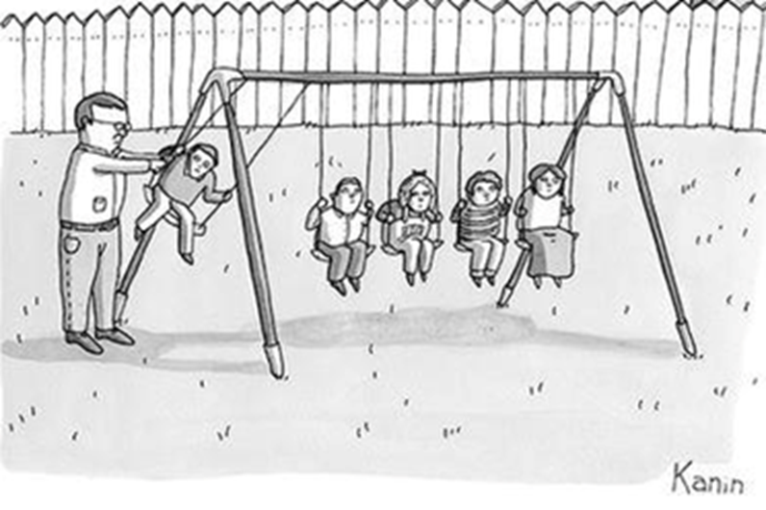

Oblique Collisions

Introduction

To answer these questions we assume that as a result of the collision the i-component of the velocities will change (if the i-axis is along the line of centres at impact).
We will look at exceptions later.

If a value for e is not given then both velocities afterwards will be in terms of e.

Diagram

Begin by setting up the table as follows:

A | U Cos ⎝ i | U Sin ⎝ j | m₁ | V₁ i | U Sin ⎝ j
B | 0 i | 0 j | m₂ | V₂ i | 0 j

(this assumes sphere B was initially at rest – this won’t always be the case)

The first part of these questions is always the same; find the final velocities of the two spheres immediately after impact

Two laws as before, but this time we just look at the i-direction only

The Principle of Conservation of Momentum (P.C.M.)
P.C.M.: M₁ U₁ + M₂ U₂ = M₁ V₁ + M ₂V₂

Newton’s Law of Restitution (N.L.R.)
N.L.R.: V₂ – V₁ = -e (U ₂– U₁) {along line joining the centres}

_ _ _ _ _ _ _ _ _ _ _ _ _ _ _ _ _ _ _ _ _ _ _ _ _ _ _ _ _ _ _ _ _ _ _ _ _ _ _ _ _ _ _ _ _ _ _
_ _ _ _ _ _ _ _ _ _ _ _ _ _ _ _ _ _ _ _ _ _ _ _ _ _ _ _ _ _ _ _ _ _ _ _ _ _ _ _ _ _ _ _ _ _ _

You need to be comfortable playing with trigonometric expressions for all topics in Applied Maths, but particularly for this chapter.

Use a 3-4-5 right-angled triangle to verify the first three points in the following list.

- $tantan θ= \frac{1}{tantan (90- θ) }$

- Cos ⎝ = Sin (90–⎝) Sin ⎝ = Cos (90 –⎝)

- This also means if ⟨+® = 90⁰, then Cos ⟨ = Sin ® and vice versa.

- Sin ⎝ is symmetrical about 90 ⁰, e.g. Sin 75 ⁰ = Sin 105⁰.

- Cos² ® = 1/ Sin²® = 1/1+ Tan²®

- $tantan \left(α+θ\right)= \frac{tantan α+tantan θ }{1-tantan αtantan θ }$ NB: $tantan \left(α+θ\right) ≠tantan α+tantan θ$

Take note of others as you come across them in all topics and gradually build up a bank for future use.

Direction of spheres after collision

We can see from the diagram that the direction of the first sphere after the collision is
given by:

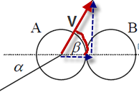

$$tantan (β)= \frac{v_{j}}{v_{i}}$$

2015 (b)
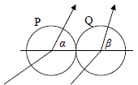
{This question acts as a nice gentle introduction to the concept of oblique collisions, along with the significance of the tan of the angles}
Two identical smooth spheres, P and Q, collide.
The coefficient of restitution is 1.
The velocity of P before impact is a i + b j and the velocity of Q before impact is c i + d j, where i is along the line of the centres of the spheres at impact.
After impact the direction of motion of P makes an angle α with their line of centres and the direction of motion of Q makes an angle β with their line of centres.
Show that tanα tanβ = $\frac{bd}{ac}$.

1977 (full question) {nice question}
A smooth sphere of mass 3 kg moving at 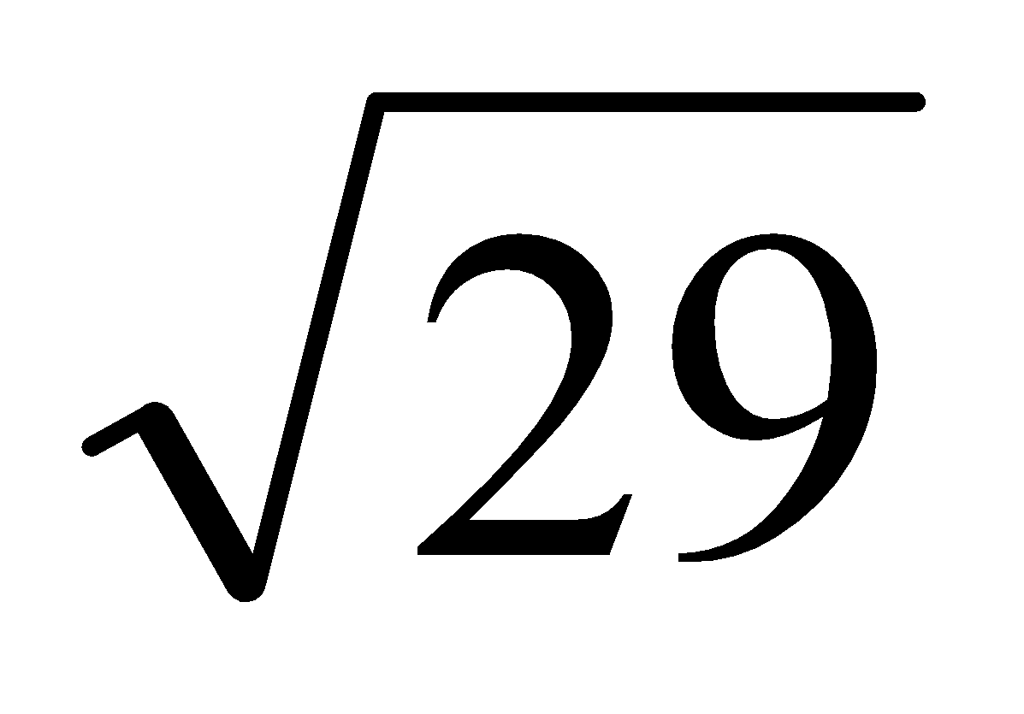m/s collides with a second sphere of mass 6 kg moving at 5 m/s.
The directions of motion of the spheres make angles of tan⁻¹ (²/₅) and tan⁻¹ (⁴/₃) respectively with the line of centres, both angles being measured in the same sense.
The coefficient of restitution is ¾.
- Find the speeds and directions of motion of the spheres after impact
- Calculate the kinetic energy lost in the collision {leave this part out for now}.

2011 (b)
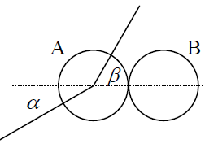
A smooth sphere A, of mass m, moving with speed u, collides with an identical smooth sphere B which is at rest.
The direction of motion of A before and after impact makes angles α and β respectively with the line of centres at the instant of impact.
The coefficient of restitution between the spheres is e.
(i) If tan α = k tan β, find k, in terms of e.
(ii) If the magnitude of the impulse imparted to each sphere due to the collision is $\frac{7}{8}$ mu cosα, find the value of e.

2001 (a)
A uniform smooth sphere of mass 2 kg and moving with speed u m/s collides with another uniform smooth sphere of mass 3 kg which is at rest.
The velocity of the sphere of mass 2 kg before impact makes an angle of 45° with the line of centers at impact.
The coefficient of restitution between the spheres is e.
(i) Find, in terms of e and u, the speed of each sphere after the collision.
(ii) If the sphere of mass 2 kg makes an angle 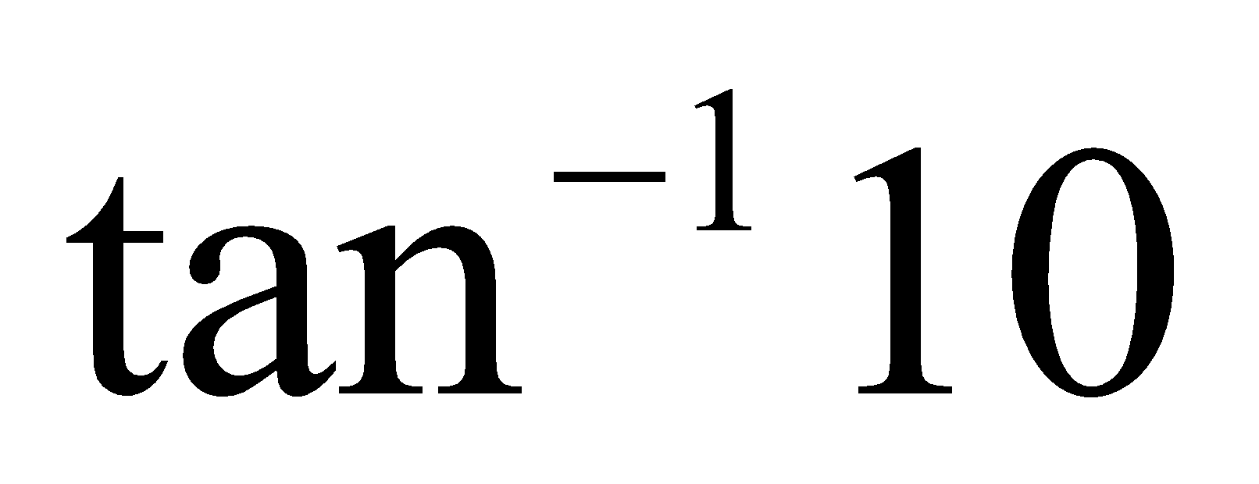 with the line of centers after impact, find e.
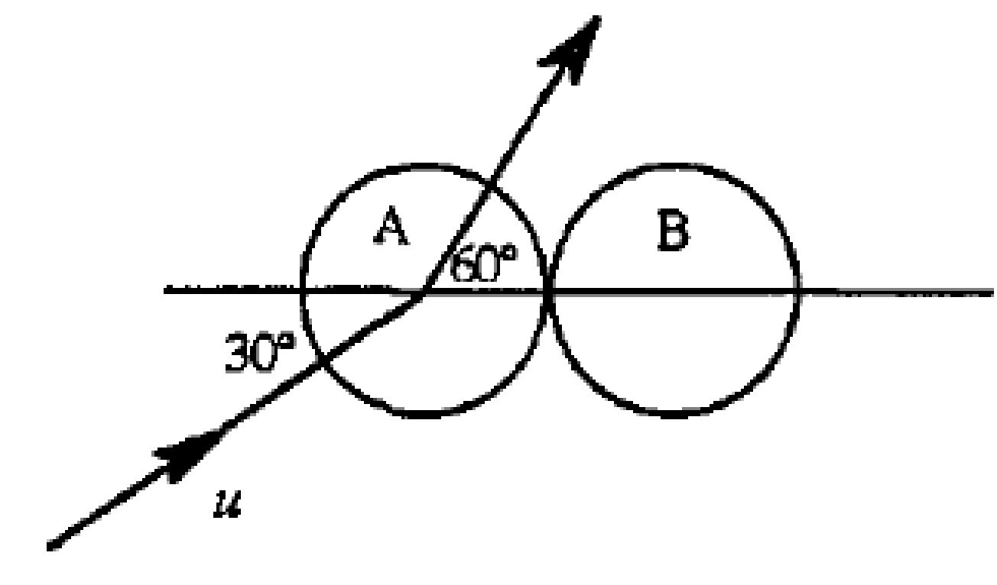
1997 (b)
A smooth sphere A, of mass m, moving with speed u collides with a smooth sphere B, of mass m, which is at rest.
The direction of motion of A before impact makes an angle of 30⁰ with the line of centres. If the coefficient of restitution between the spheres is e, find
(i) the velocity of each sphere after impact
(ii) the value of e if after impact the direction of A makes an angle 60⁰ with the line of centres.

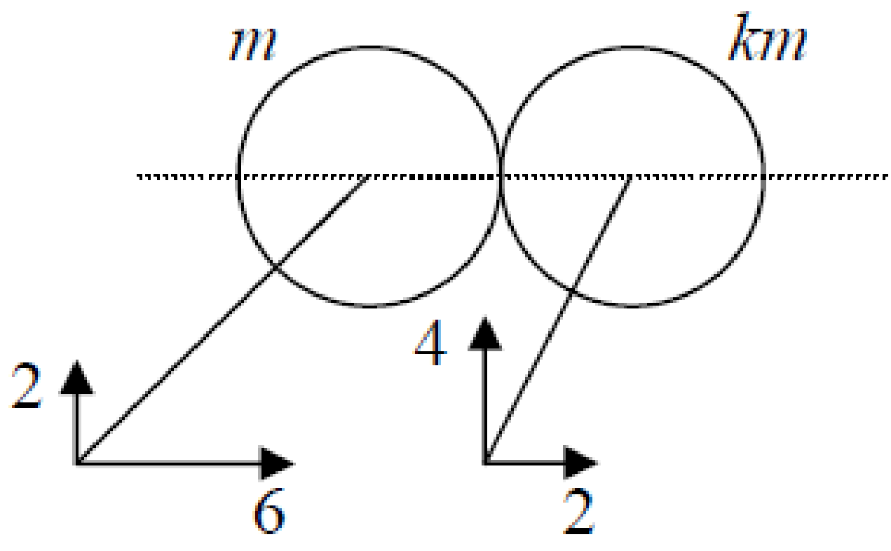
2010 (b)
A smooth sphere, of mass m, moving with velocity 6i + 2j collides with a smooth sphere, of mass km, moving with velocity 2i + 4j on a smooth horizontal table.
After the collision the spheres move in parallel directions.
The coefficient of restitution between the spheres is e.

Find e in terms of k.
Prove that k $≥$ $\frac{1}{3}$.

2004 (b)
A smooth sphere A, of mass m, moving with speed u, collides with an identical smooth sphere B which is at rest.
The direction of motion of A, before impact, makes an angle 30º with the line of centres at impact.
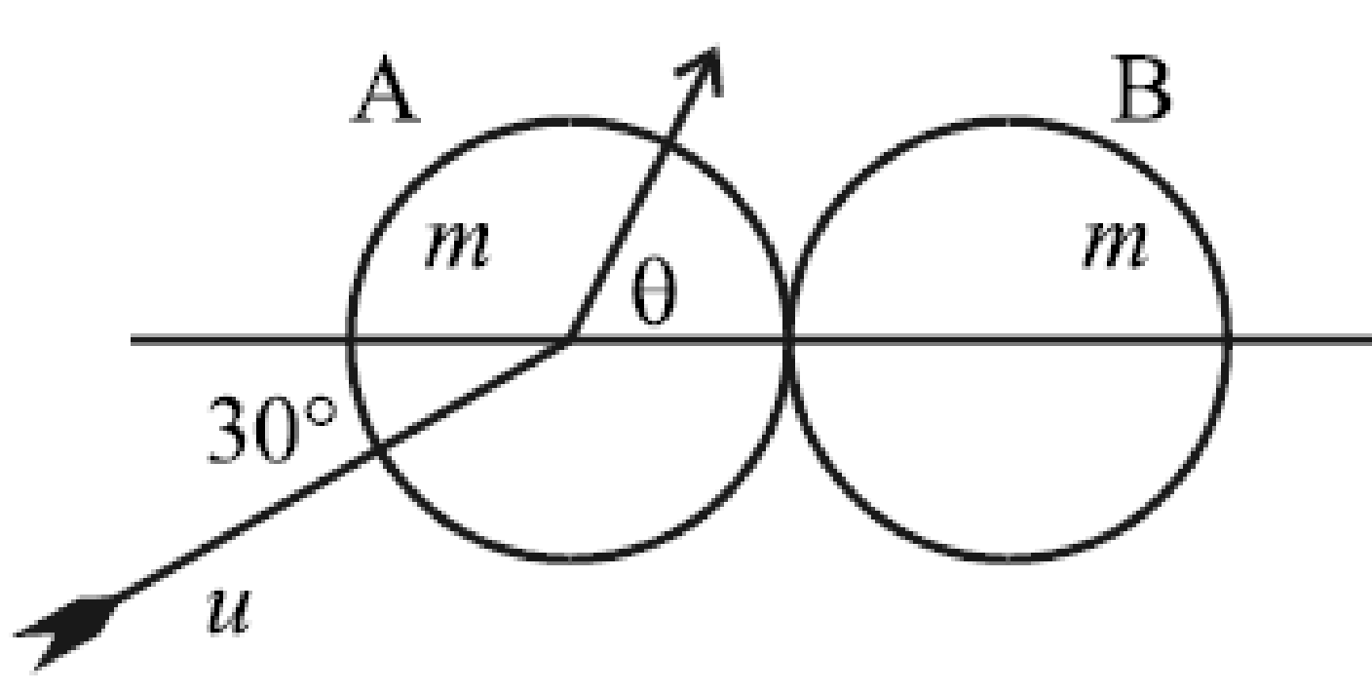
After impact the direction of A makes an angle θ with the line of centres, where 0º ≤ θ < 90º.
The coefficient of restitution between the spheres is e.
The speeds of A and B immediately after impact are equal.
(i) Calculate the value of θ.
(ii) Find e.

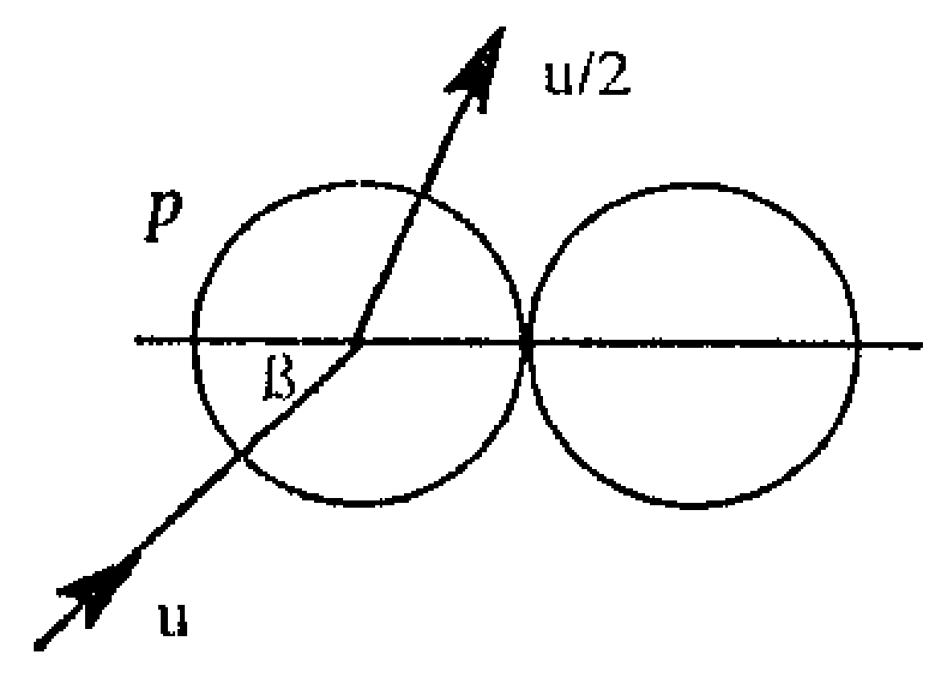
1996 (b)
A smooth sphere P, moving with velocity u, impinges on an equal smooth sphere at rest, the direction of u just before impact being inclined at an angle β to the line of centres.
If the speed of P after impact is $\frac{u}{2}$ and tan β = ½, show that the coefficient of restitution is also ½.

2005 (b)
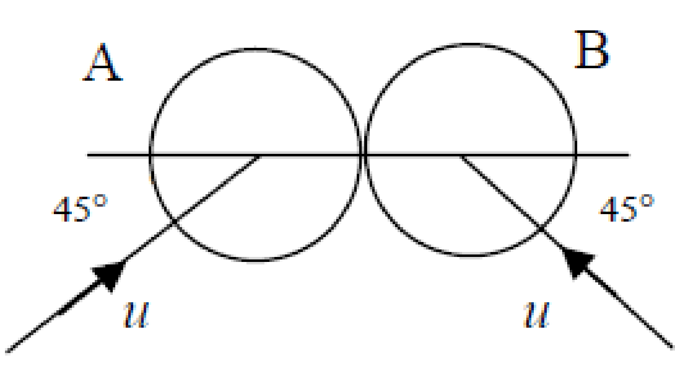
A smooth sphere A, of mass m, moving with speed u, collides with an identical smooth sphere B moving with speed u.
The direction of motion of A, before impact, makes an angle 45° with the line of centers at impact.
The direction of motion of B, before impact, makes an angle 45° with the line of centers at impact.
The coefficient of restitution between the spheres is e.
(i) Find, in terms of e and u, the speed of each sphere after the collision.
(ii) If e = ½, show that after collision the angle between the direction of motion of the two spheres is $\frac{4}{3}$

2019 (b)
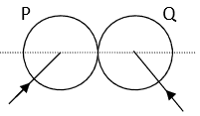
A smooth sphere P, of mass 2m, collides with a smooth sphere Q, of mass m.
The velocity of P is 3𝑢 𝚤⃗+4𝑢 𝚥 ⃗ and the velocity of Q is −4𝑢 𝚤⃗+3𝑢 𝚥 ⃗, where 𝚤 ⃗ is along the line of centres at impact.
The coefficient of restitution between the spheres is $\frac{5}{7}$.
Find
- in terms of 𝑢, the speed of each sphere after the collision
- the angle between the directions of P and Q after the collision.

2018 (b)
A small smooth sphere P, of mass 2m, moving with speed 4u, collides obliquely with an equal smooth sphere Q, of mass 3m, moving with speed u.
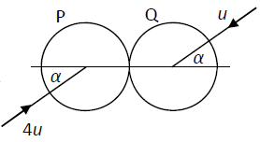
Before the collision the spheres are moving in opposite directions, each making an angle α to the line of centres, as shown in the diagram.
The coefficient of restitution between the spheres is $\frac{1}{5}$.
- Find, in terms of u and α, the speed of each sphere after the collision.
- After the collision the speed of P is twice the speed of Q.
Find the value of α.

2021 (b)
A smooth sphere P has mass 2m and speed u. It collides obliquely with a smooth sphere Q of mass m which is moving with speed ku, as shown in the diagram.

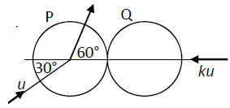
Before the collision, the direction of P makes an angle of 30° to the line of centres. After the collision, the direction of P makes an angle of 60° to the line of centres.
The coefficient of restitution between the spheres is 𝑒.
- Show that $k= \frac{\sqrt{3}(1-e)}{2(1+e)}$
- Find the speed of Q immediately after the collision.

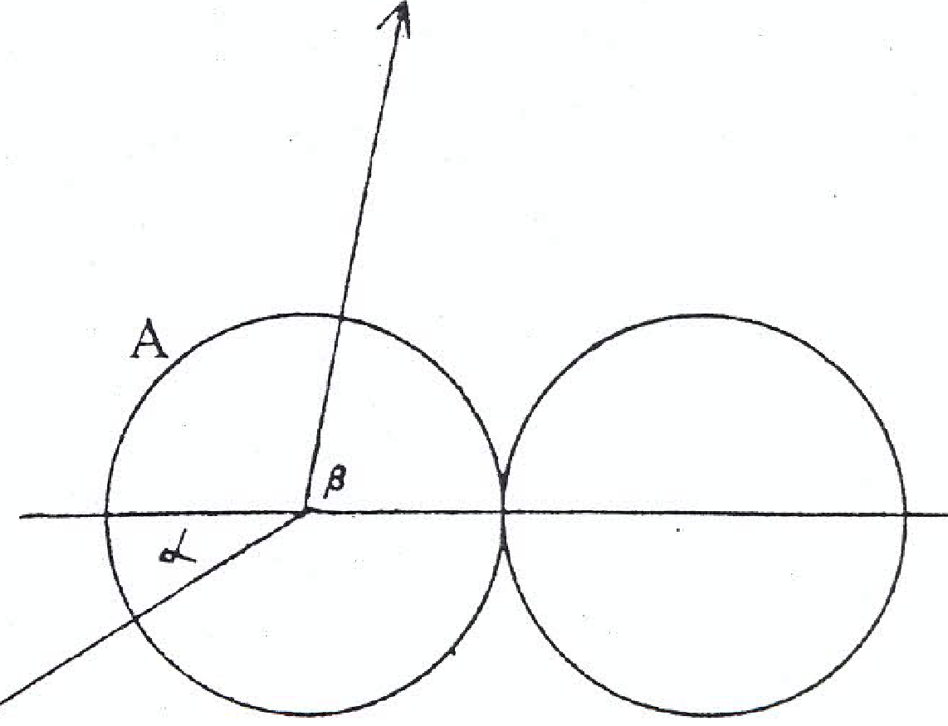
1979 (b)
A smooth sphere A collides obliquely with another smooth sphere of equal mass which is at rest.
Before impact the direction of motion if A makes an angle α with the line of centres at impact (see diagram).
After impact it makes and angle β with that line.
If the coefficient of restitution is ½, prove that tan β = 4 tan α

1978 (full question)
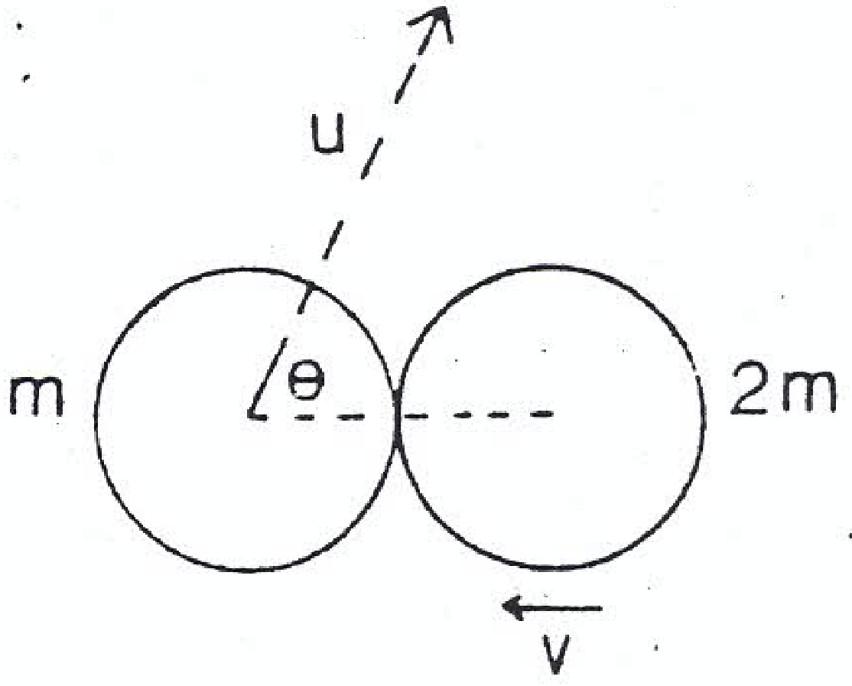
Two vectors a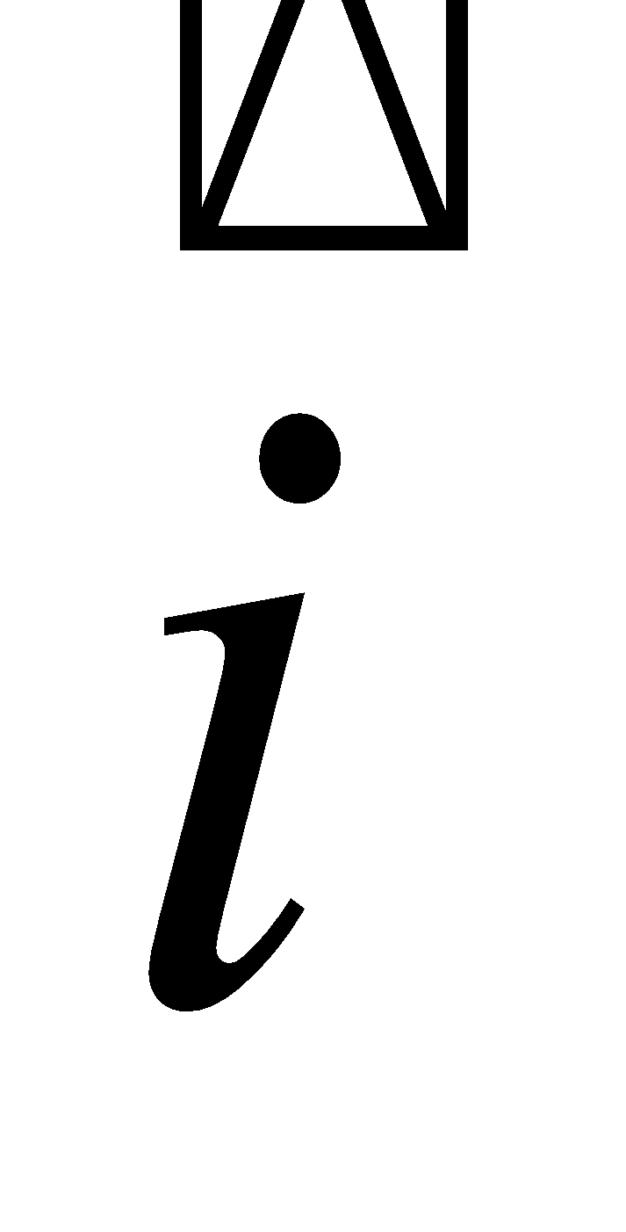 + b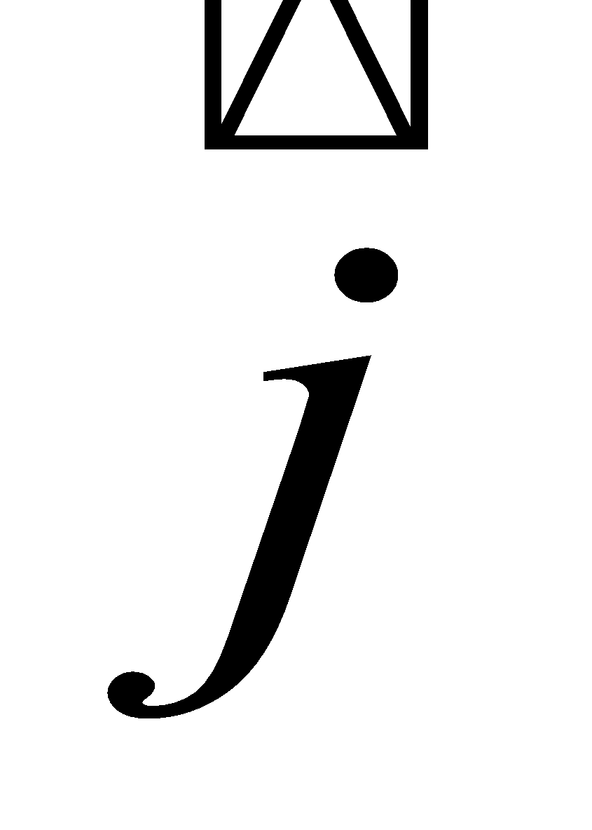 and c + d are at right angles.
Write down the condition satisfied by the scalars a, b, c, d.
Two smooth spheres of masses m and 2m and velocities u and v respectively, collide as shown in the diagram, where cos θ = ³/₇.
The sphere of mass m is deflected through an angle of 90⁰ by the collision.
If the coefficient of restitution is ¾, show that 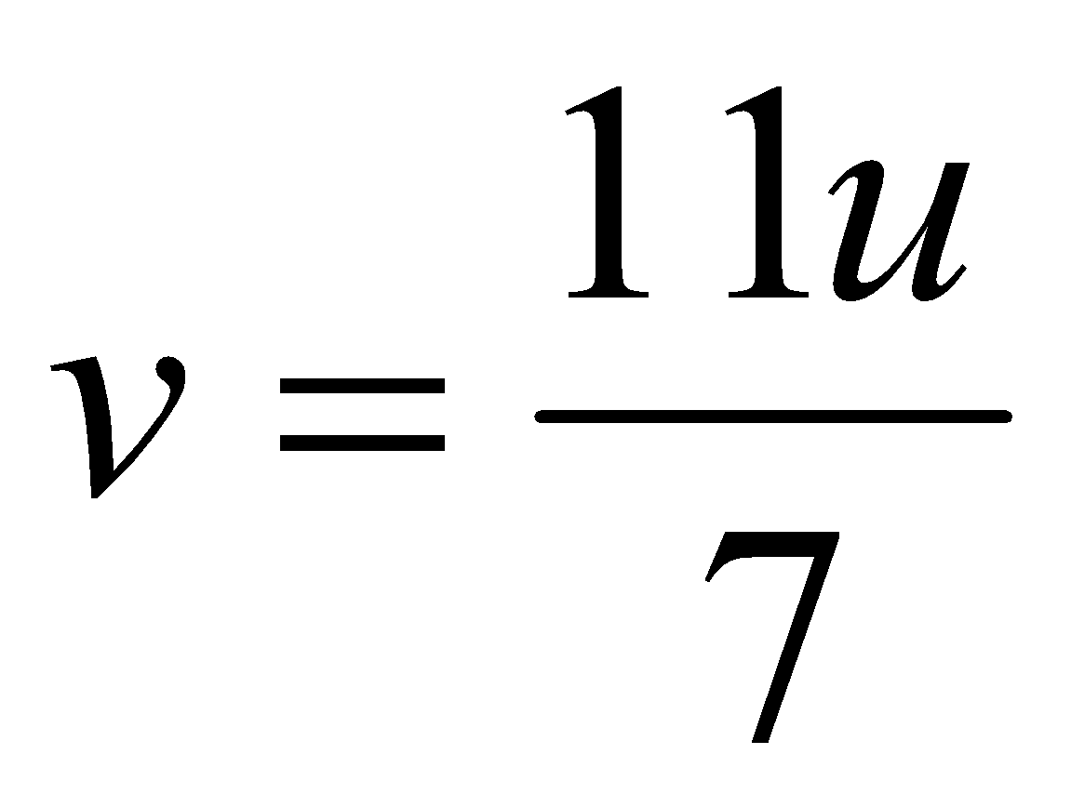.
Find the direction of motion of the other sphere after the collision.

1999 (b)
Two equal smooth spheres A and B collide. The velocity of A before the collsion is 3√3 $\vec{i}$ + 3 $\vec{j}$ and the velocity of B before the collision is ½ (-u√3 $\vec{i}$ + u $\vec{j}$) where $\vec{i}$ and $\vec{j}$ are unit perpindicular vectors along and perpindicular to the line of centres, respectively.
The velocity of A after the collision is ½ (-v$\vec{ i}$+ v√3 $\vec{j}$).
If the coefficient of restitution is 0.7, find the magnitude and direction of the velocity of sphere B after the collision.

“The spheres move at right angles after the collision”

If the second sphere was at rest initially then its velocity is represented by 0i +0j.
Therefore its velocity after must be V₁i + 0j (as normal).
Therefore it only moves in the i direction (as normal).
If after impact both move at right angles to one another, then the second sphere must now move only in the j direction.
Therefore the velocity of B is represented by 0 i + U Sin⎝ j.

1987 (full question)
Two smooth elastic spheres A and B of mass 4 kg and 8 kg respectively, collide obliquely.
The coefficient of restitution is 0.4.
Before collision the velocity of A is (3 + 4) m/s and that of B is (– 4½ – p) m/s where and are unit vectors along and perpendicular to the lines of centres at the moment of impact
- Find the velocity of each sphere after impact
- Show that the loss of kinetic energy, as a result of the impact is 63 J
- If after impact the spheres are moving at right angles to each other calculate the value of p.

1976 (full question)
State the laws governing the oblique collision of elastic spheres.
A sphere of mass M moving with speed u collides with a second sphere at rest.
The direction of motion of the moving sphere is inclined at 45⁰ to the line of centres at impact, and the coefficient of restitution is ½.
After impact the directions of motion of the spheres are at right angles.
Find the mass of the second sphere in terms of M, and the velocities of the two spheres after impact in terms of u.
Hence show that one quarter of the kinetic energy is lost.

1984 (b)
A smooth sphere of mass 4 kg collides with another smooth sphere of mass m which is at rest.
After impact the two spheres move at right angles to each other.
If the coefficient of restitution was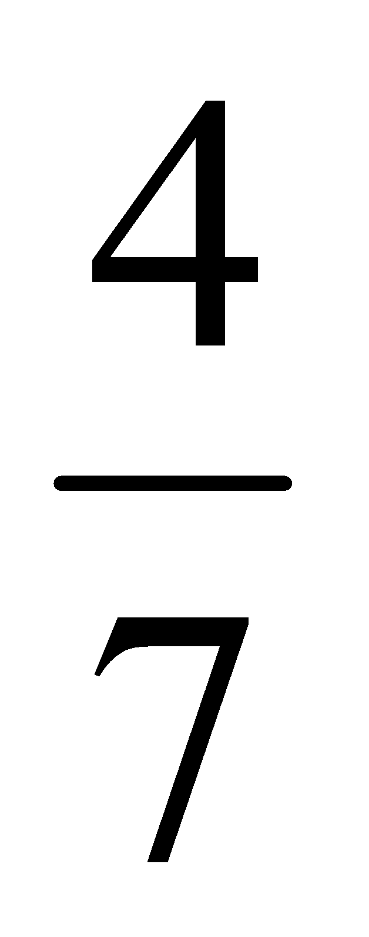, calculate the value of m.

1972 (full question)
State the laws governing oblique, perfectly elastic collision between two spheres.
A small sphere collides obliquely with a similar sphere of equal mass at rest – both spheres being smooth and perfectly elastic.
Show that the paths of the two spheres after collision are at right angles.
Prove that there is no loss in kinetic energy.
{Note: ‘perfectly elastic’ means e = 1}

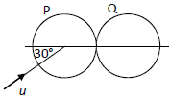
2020 (b)
A smooth sphere P has mass m₁ and speed u.
It collides obliquely with a smooth sphere Q, of mass m₂, which is at rest.
Before the collision the direction of P makes an angle of 30° to the line of centres, as shown in the diagram.
The coefficient of restitution between the spheres is 𝑒.
Prove that P will turn through a right‐angle if 4𝑚₁ = (3e - 1)m₂.

Angle of deflection
This is a very popular type of question.
The angle of deflection is equivalent to the difference between the tan of the angle before collision and the tan of the angle after collision (with respect to the i-axis).
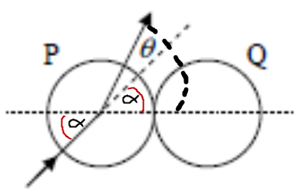

Method One

We can see from the diagram that the direction of P after the collision is given by:
$$tantan (α+θ)= \frac{v_{j}}{v_{i}}$$

We also know (from log tables) that
$tantan \left(α+θ\right)= \frac{tantan α+tantan θ }{1-tantan αtantan θ }$

Equate these to get $\frac{tantan α+tantan θ }{1-tantan αtantan θ }=\frac{v_{j}}{v_{i}}$

Now sub in the relevant values and rearrange to get the desired expression

Exam questions involving angle of deflection
2007 (b)
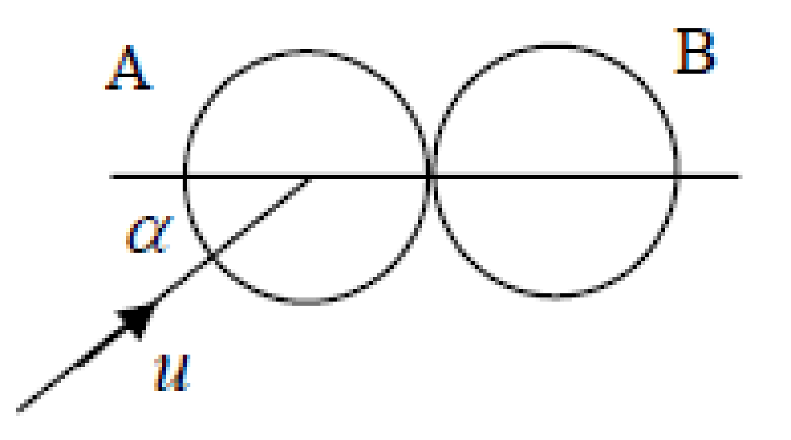
A smooth sphere A, of mass 4 kg, moving with speed u, collides with a stationary smooth sphere B of mass 8 kg.
The direction of motion of A, before impact, makes an angle α with the line of centres at impact.
The coefficient of restitution between the spheres is ½.
Find in terms of u and α
(i) the speed of each sphere after the collision
(ii) the angle through which the 4 kg sphere is deflected as a result of the collision
(iii) the loss in kinetic energy due to the collision {leave part (iii) for a later time}

2022 Deferred (b)
A smooth sphere, A, of mass m collides obliquely with
another smooth sphere, B, of mass m.
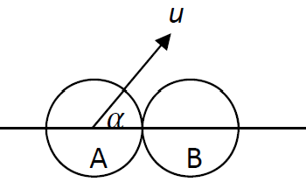
Before impact, A is moving with speed u at an angle 𝛼 to the
line of centres of the spheres, where 0° ≤ 𝛼 ˂ 45°.
B is at rest before the impact.
The coefficient of restitution for the collision is e.
(i) Find the speed of A and the speed of B after impact in terms of u, e and 𝛼.
(ii) Given that A is deflected through angle 𝛼 because of the collision, show that tan² 𝛼 = e.

2012 (b)
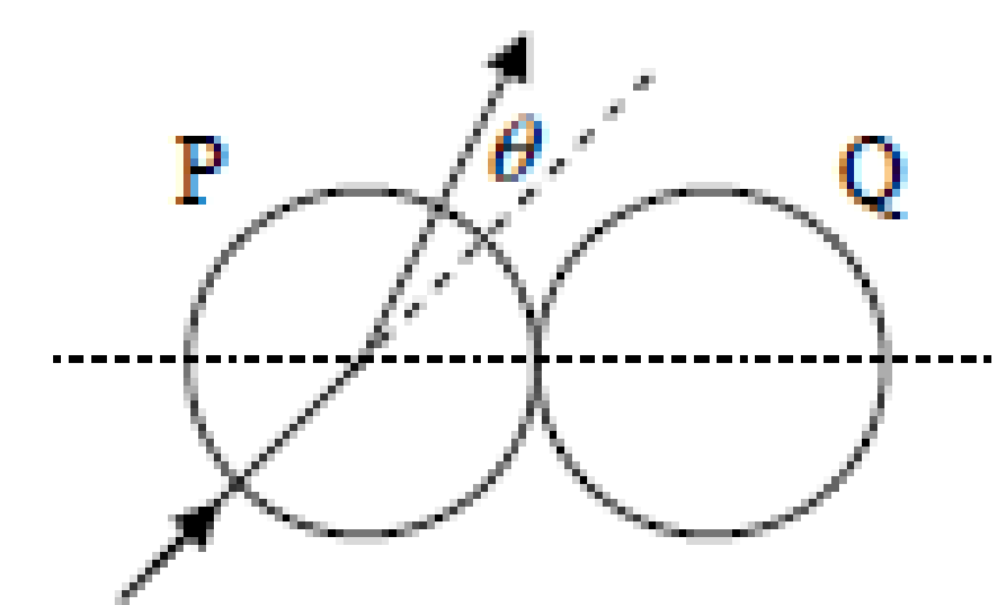
A smooth sphere P collides with an identical smooth sphere Q which is at rest.
The velocity of P before impact makes an angle α with the line of centres at impact, where 0° ≤α < 90°.
The velocity of P is deflected through an angle θ by the collision.
The coefficient of restitution between the spheres is 1/3.
Show that tan ϑ = $\frac{2tantan α }{1+3 \tan^{2}α}$

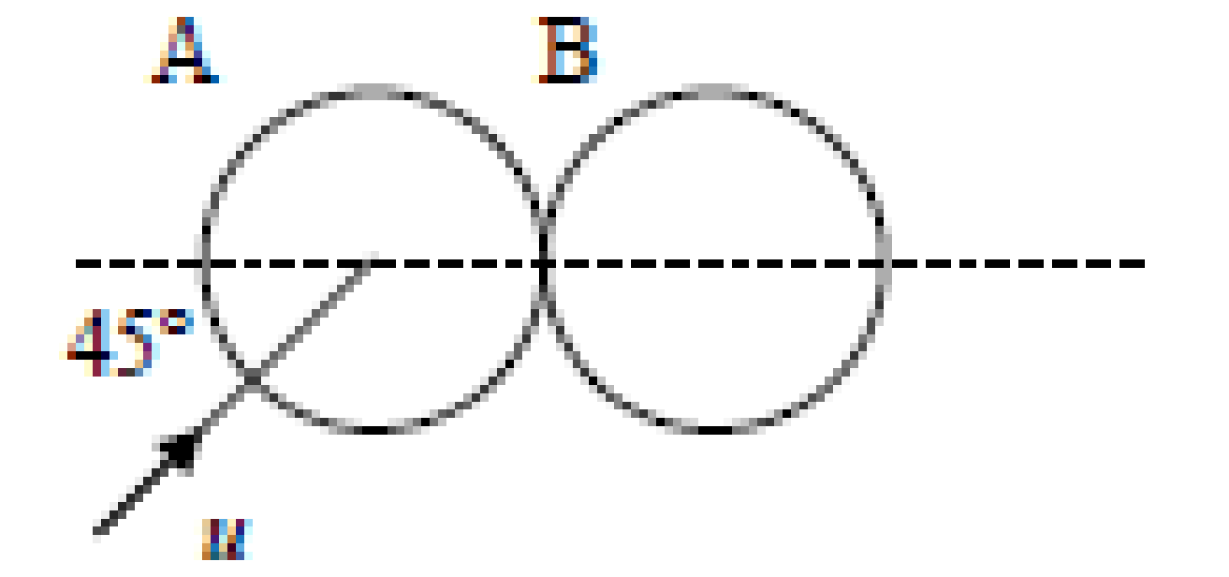
2008 (b)
A smooth sphere A moving with speed u, collides with an identical smooth sphere B which is at rest.
The direction of motion of A, before impact, makes an angle of 45° with the line of centres at the instant of impact.
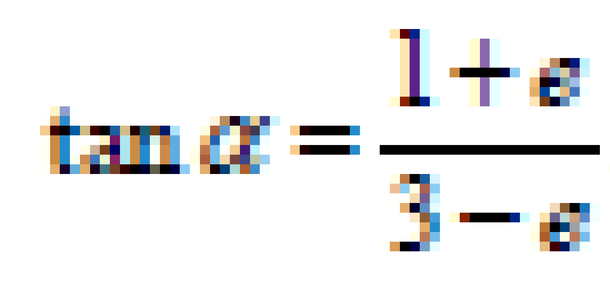
The coefficient of restitution between the spheres is e.
Show that the direction of motion of A is deflected through an angle α where

2002 (b)
A smooth sphere P collides with an identical smooth sphere Q which is at rest.
The velocity of P before impact makes an angle α with the line of centres at impact, where 0° ≤ α < 90°.
The velocity of P is deflected through an angle θ by the collision, so that its velocity after impact makes an angle 𝜃 +α with the line of centres at impact.
The coefficient of restitution between the spheres is 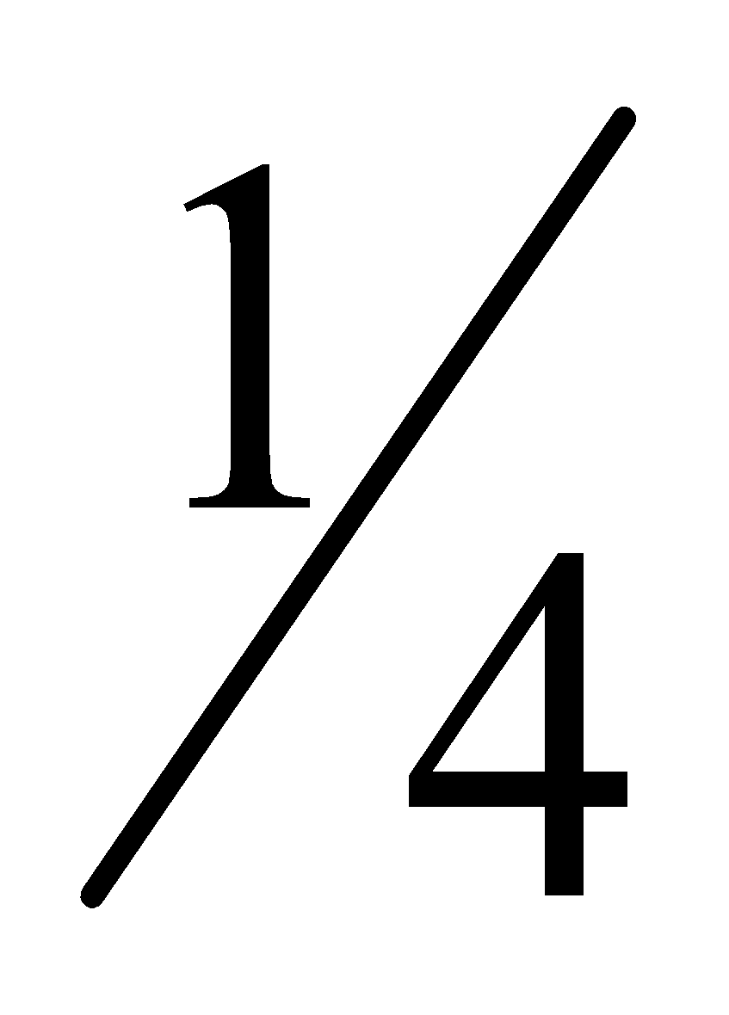.
Show that 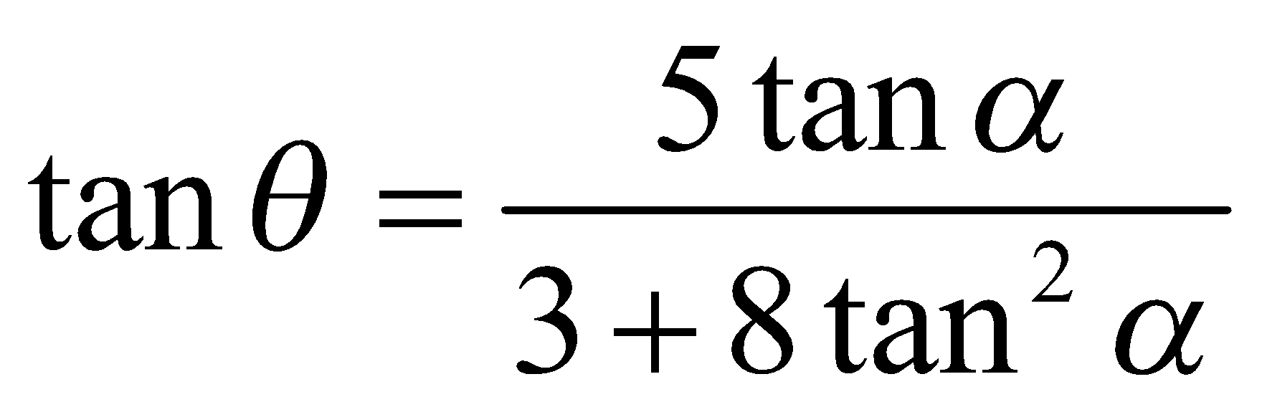

2000 (b)
A smooth sphere A collides with an identical smooth sphere B which is at rest. The velocity of A before impact makes an angle 𝛼 with the line of centres at impact, where 0° ≤ 𝛼 < 90° .
The coefficient of restitution between the spheres is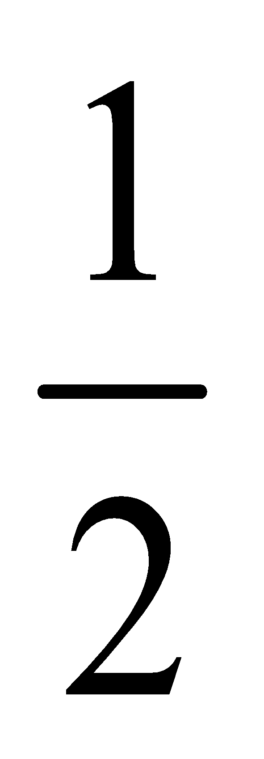.
Show that the angle θ through which the path of A is deflected is given by 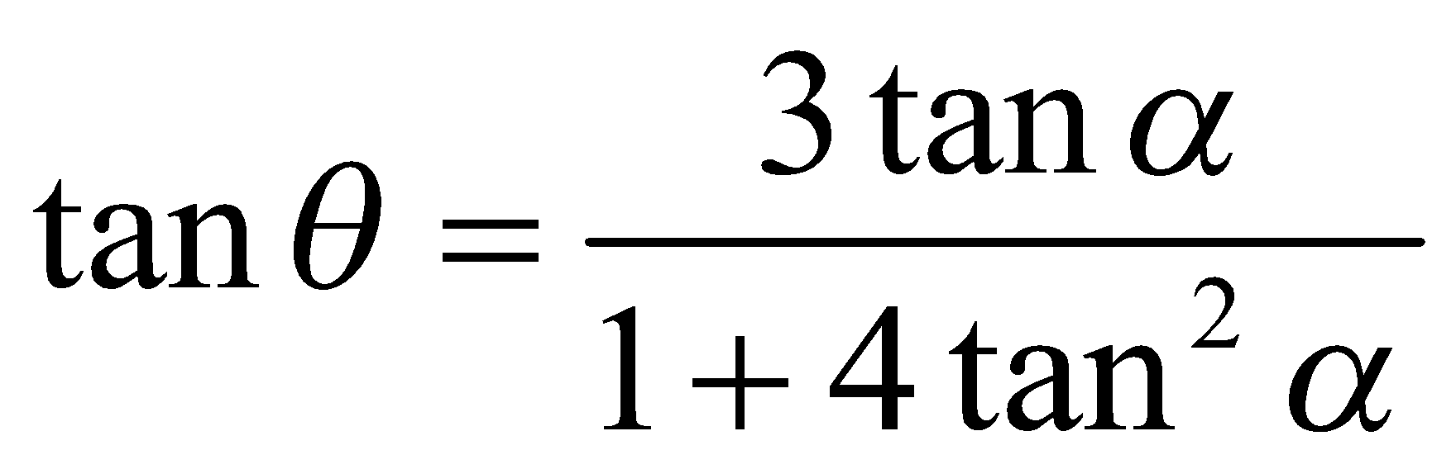

2022 (b)
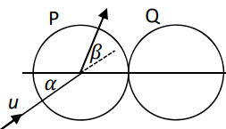
A smooth sphere P has mass m and speed u. It collides obliquely with a smooth sphere Q, of mass m, which is at rest. Before the collision, the direction of P makes an angle 𝛼 with the line of centres, as shown in the diagram.
The coefficient of restitution between the spheres is $\frac{1}{3}$.

During the impact the direction of motion of P is turned through an angle 𝛽.
Show that tan β = $\frac{5tantan α }{3+8 \tan^{2}α}$

1991 (b)
A smooth sphere P, moving with velocity 4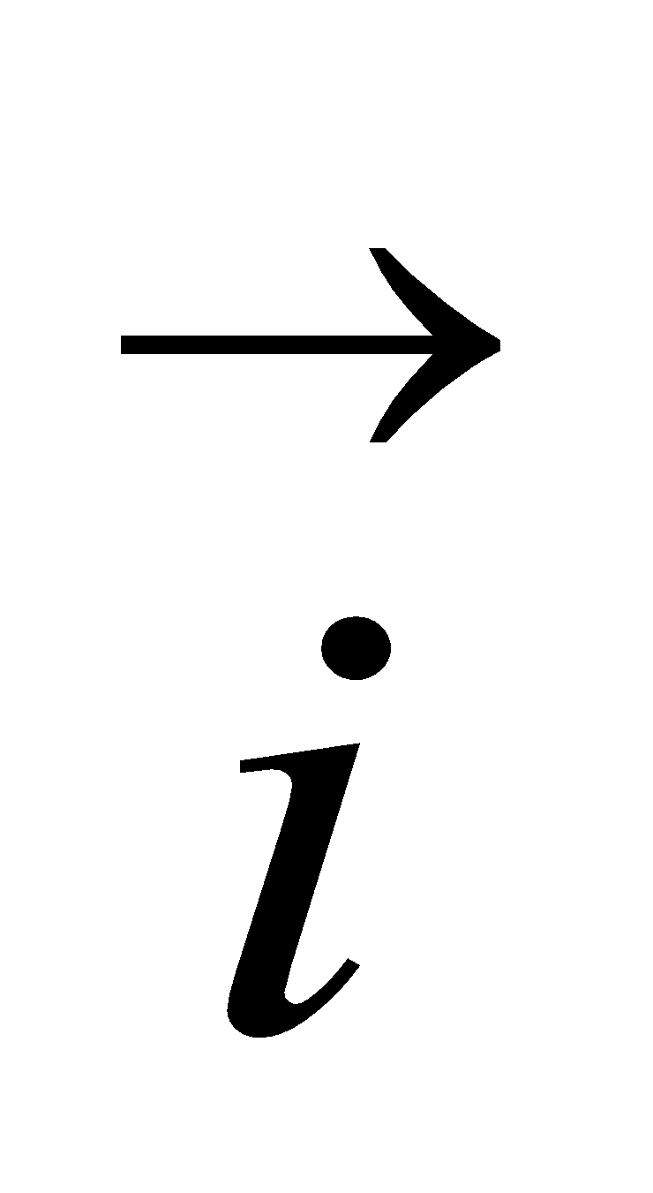 + 5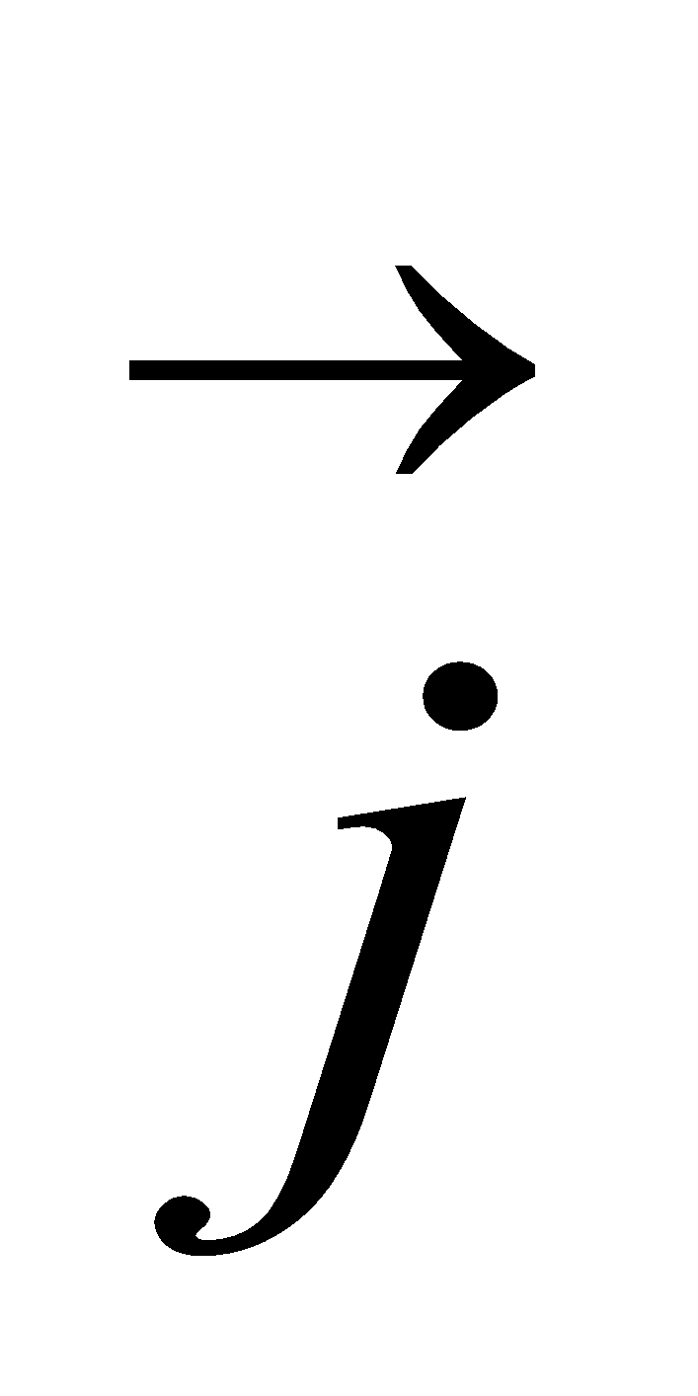 m/s collides with an identical sphere Q moving with velocity 2 + 3 m/s where is a unit vector along the line of centres at the moment of impact.
If e is the coefficient of restitution
- find the velocity of each sphere after impact.
- Calculate the value of e if P is deflected through an angle tan⁻¹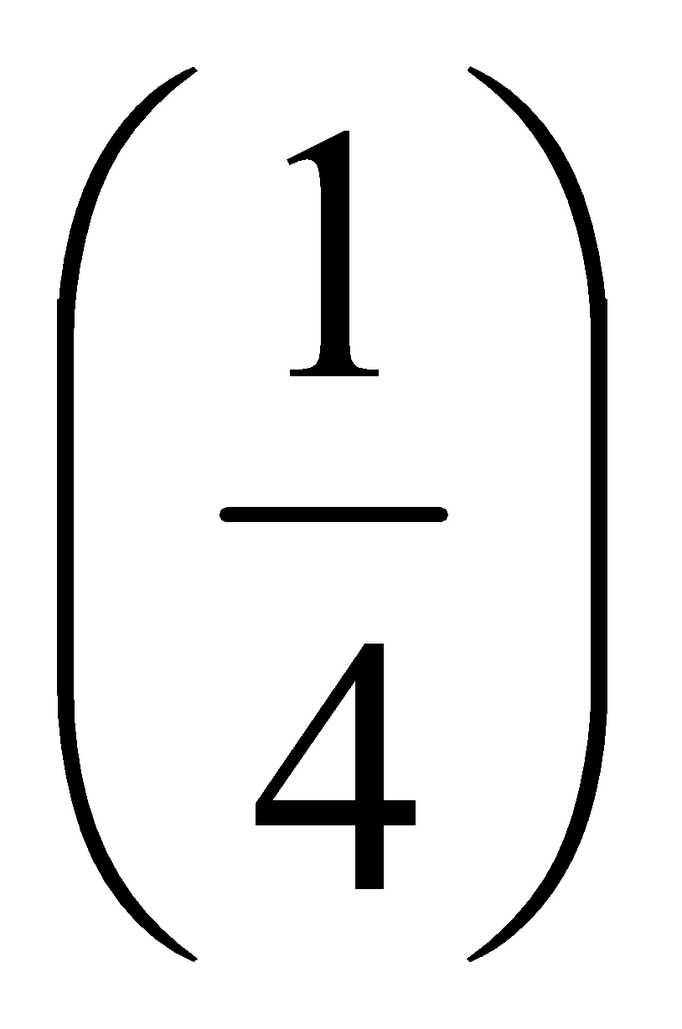as a result of the collision.

1983 (full question)
State the laws governing oblique collisions between two smooth elastic spheres.
Two such spheres A and B of mass 5 kg and 10 kg respectively, collide obliquely.
The coefficient of restitution is ¹/₇. Immediately before collision the velocity of A is 5 + 4 and that of B is –2–2, where speeds are in m/s and and are unit vectors along and perpendicular to the line of centres.
- Find the velocity of (i) A and (ii) B after impact.
- Show that the loss of kinetic energy is 80 J.
- Calculate the tan of the angle through which B is deflected after the collision.

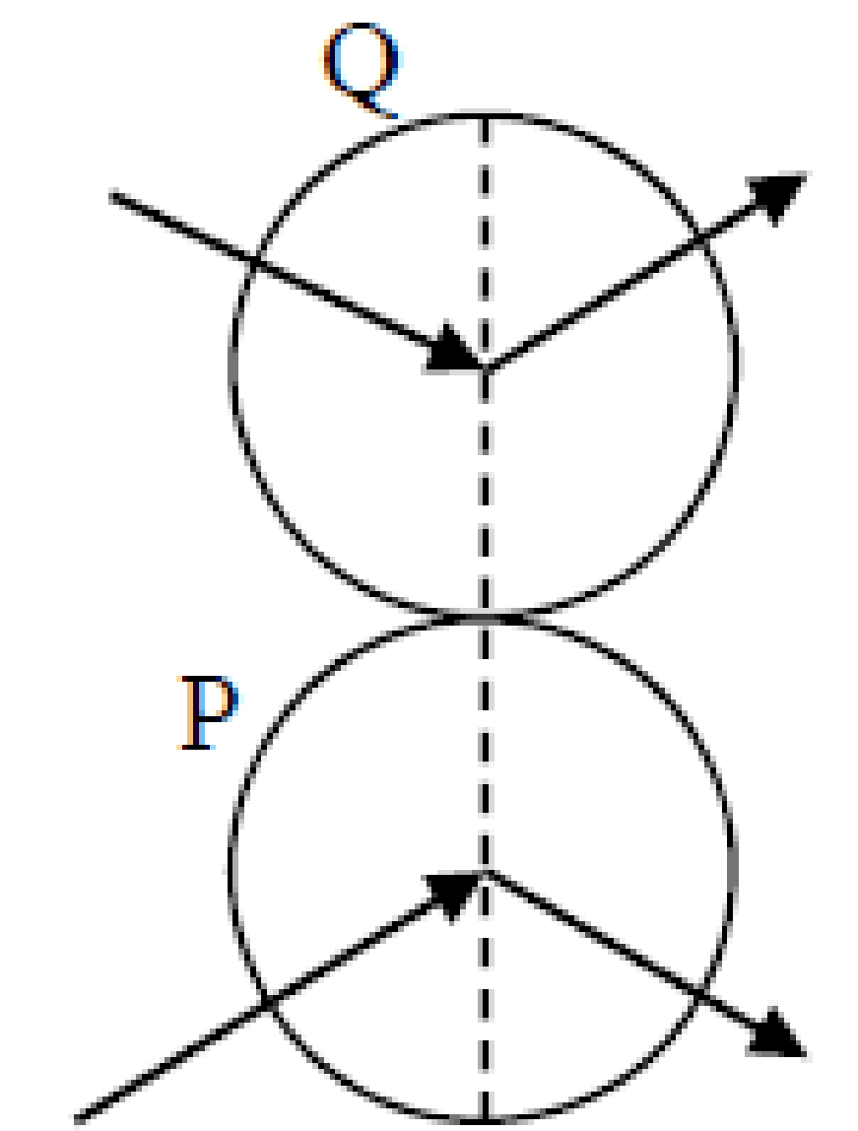
2016 (b)
Two identical smooth spheres P and Q collide.
The velocity of P after impact is 3i – j and the velocity of Q after impact is 2i +j, where j is along the line of the centres of the spheres at impact.
The coefficient of restitution between the spheres is ½.
Find
- the velocities, in terms of and j, of the two spheres before impact
- to the nearest degree, the angle through which the direction of motion of P is deflected by the collision.

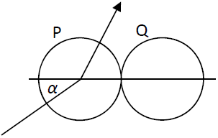
2017 (b)
A small smooth sphere P, of mass 3m, collides obliquely with a small smooth sphere Q, of mass 7m, which is at rest.
Before the collision the velocity of P makes an angle α with the line joining the centres of the spheres.
After the collision the speed of Q is v.
The coefficient of restitution between the spheres is $\frac{2}{7}$.
- Find, in terms of v and α, the speed of P before the collision.
- If α = 30° find the angle through which the direction of motion of P is deflected as a result of the collision.

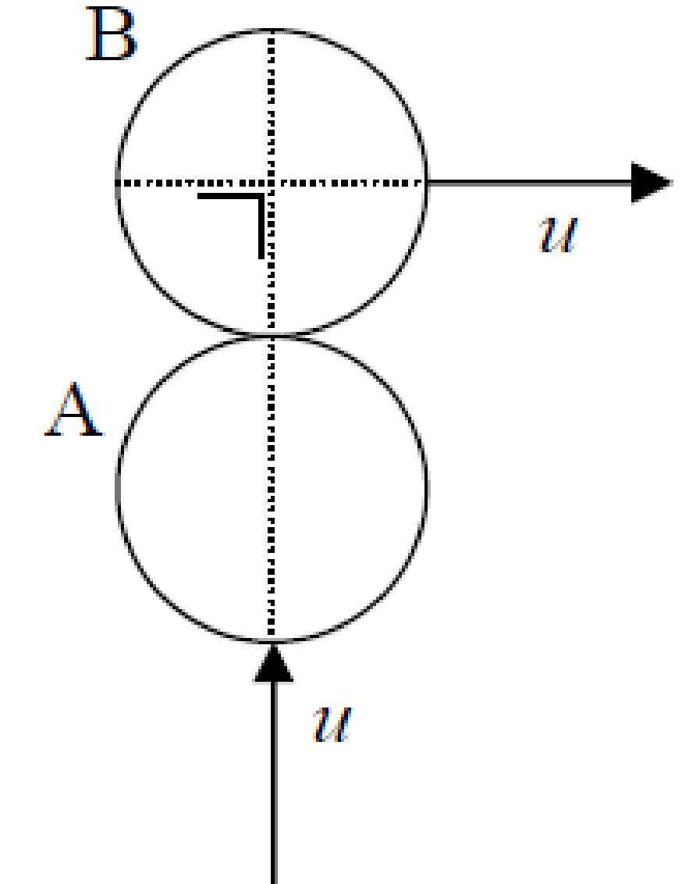
2006 (b)
A smooth sphere A moving with speed u, collides with an identical smooth sphere B which is moving in a perpendicular direction with the same speed u
The line of centers at the instant of impact is perpendicular to the direction of motion of sphere B.
The coefficient of restitution between the spheres is e
- Find, in terms of e, the speed of each sphere after impact and hence, or otherwise, show that it is not possible for the two spheres to have the same speed after impact.
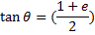
- Prove that where θ is the angle through which sphere B is turned as a result of the impact.

Deflected through an angle of 90°
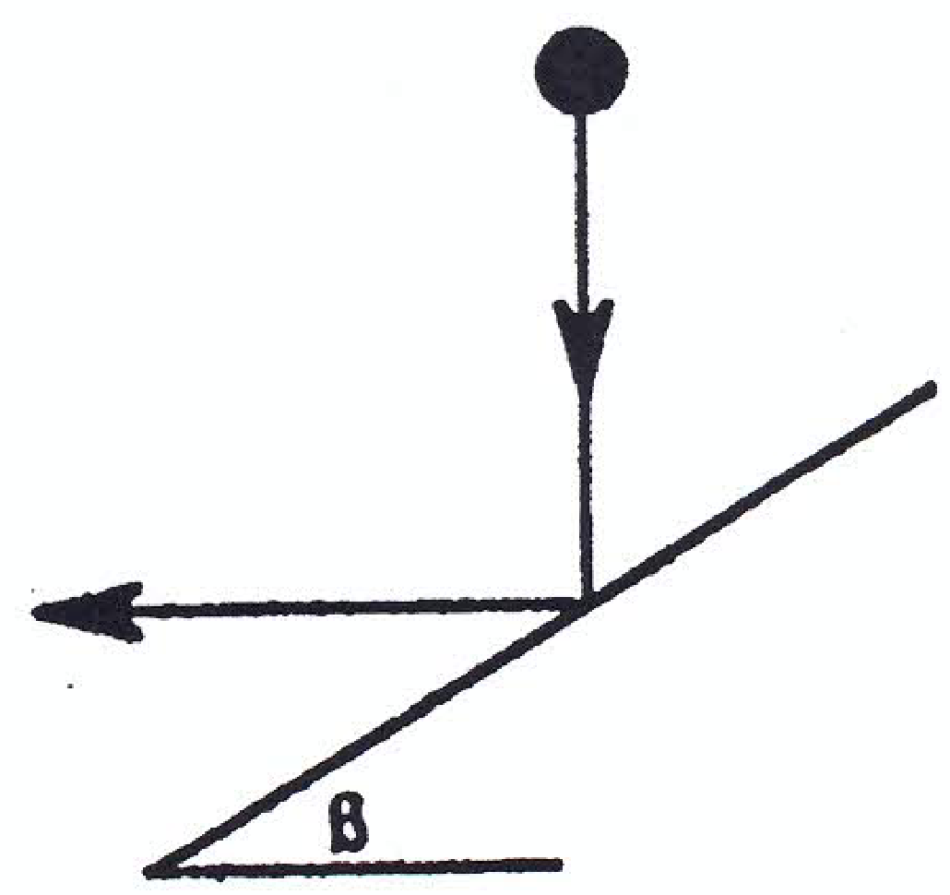
1995 (b)
A ball falls vertically and strikes a smooth fixed plane.
The plane is inclined at an angle β to the horizontal (β < 45⁰).
The ball rebounds horizontally.
- Prove that tanβ = 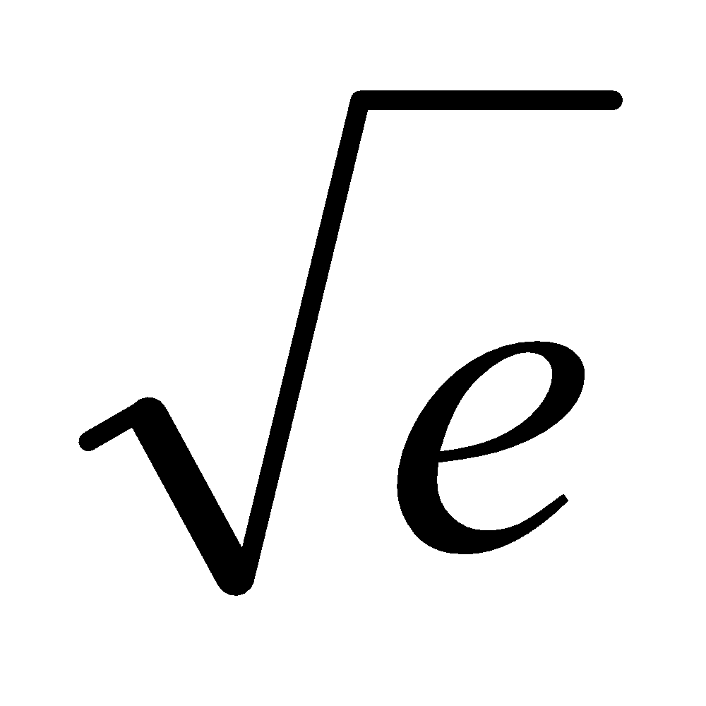, where e is the coefficient of restitution.
- Show that the fraction of kinetic energy lost during impact is (1 – e).

2003 (b)
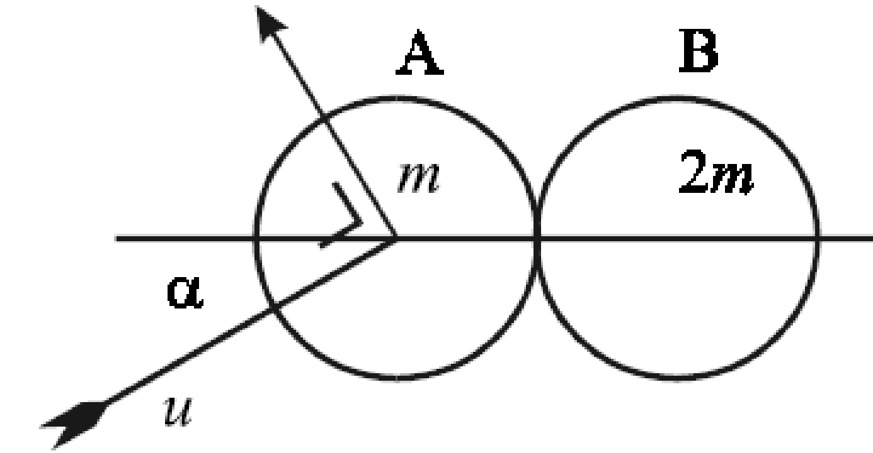
A smooth sphere A, of mass m, moving with speed u, collides with a smooth sphere B, of mass 2m, which is at rest.
The direction of motion of A, before impact, makes an angle α with the line of centers at impact, where 0° ≤ α < 90°.
As a result of the collision, the direction of A is deflected through an angle of 90°.
The coefficient of restitution between the spheres is e.
(i) Show that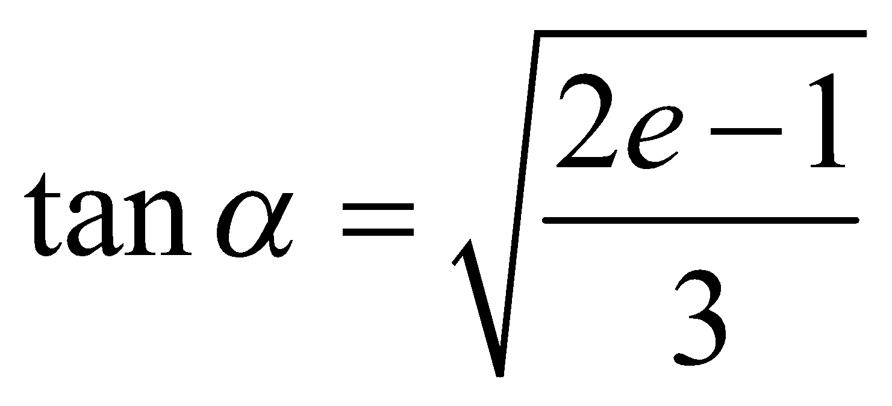
(ii) Find e, if the magnitude of the impulse exerted by A on B is mu cos α.

1989 (full question)
State the laws governing the oblique collision of elastic spheres.
A smooth sphere A, of mass m, moving with speed 0.6 m/s, impinges obliquely on a smooth sphere B, of mass 2m, which is at rest.
After the collision A is found to move with speed 0.2 m/s in a direction at right angles to its original direction.
- Find the direction of A before impact.
- Find the coefficient of restitution.
- Show that the loss of kinetic energy, as a result of the impact, is 0.06m.

Kinetic energy
1992 (full question)
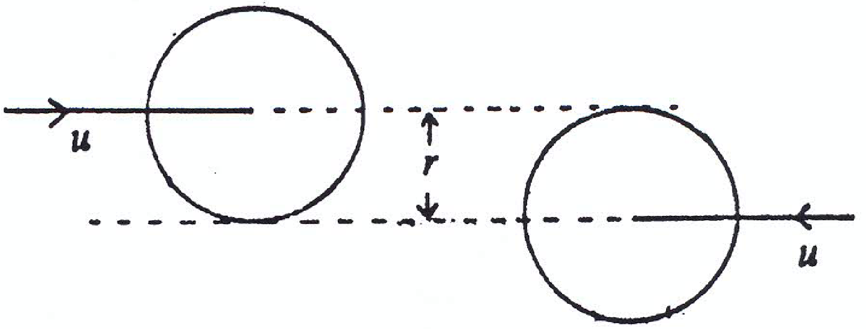
Two equal smooth spheres, of radius r, move horizontally in opposite directions with speed u.
Their centres lie on two parallel lines a distance r apart.
The coefficient of restitution is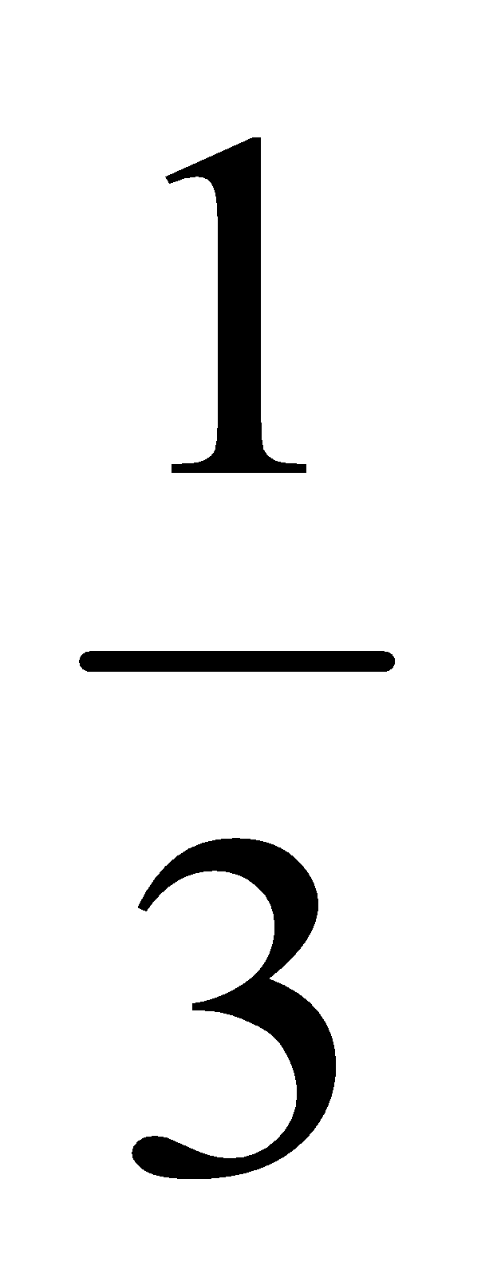.
- Prove that at the moment of impact the line of centres makes an angle of 30⁰ with the previous direction of motion.
- Find the velocity of each sphere after impact.
- What fraction of the kinetic energy is lost as a result of the collision?

2009 (b)
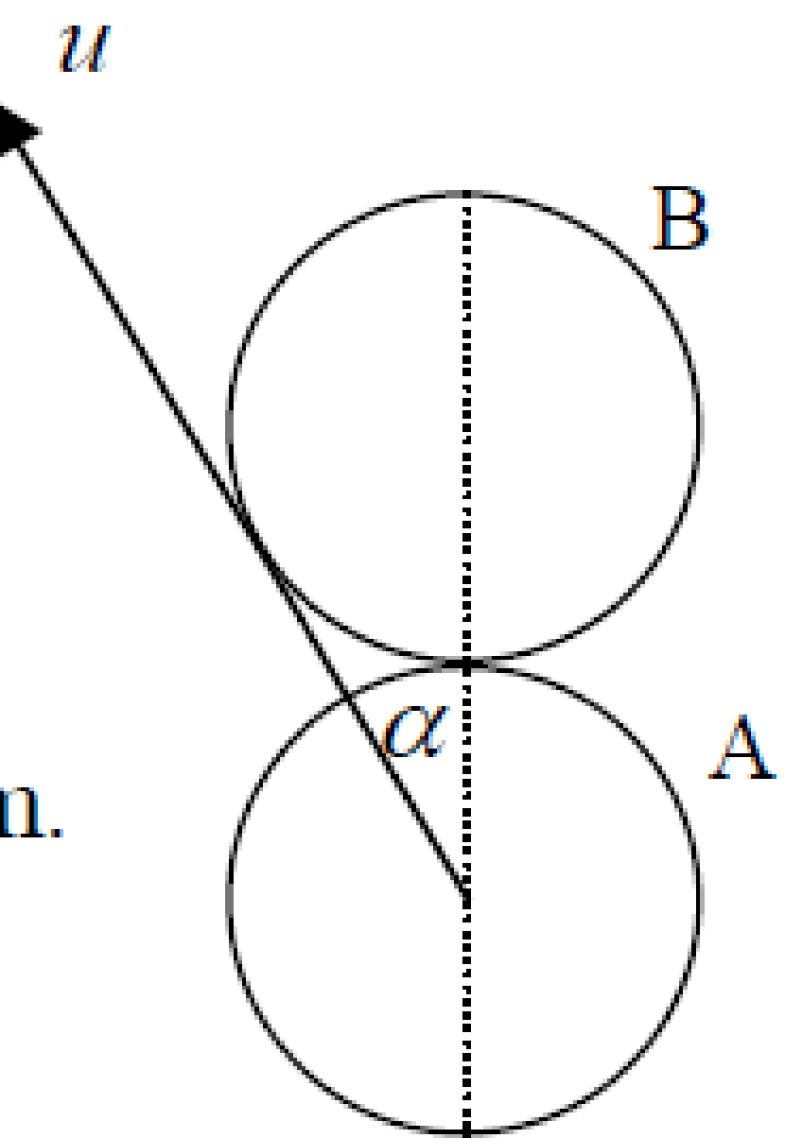
A smooth sphere A, of mass m kg, moving with speed u, collides with a stationary identical smooth sphere B.
The direction of motion of A, before impact, makes an angle α with the line of centres at impact and just touches sphere B, as shown in the diagram.
The coefficient of restitution between the spheres is 4/5.
(i) Show that α = 30°.
(ii) Find the direction in which each sphere travels after the collision.
(iii) Find the percentage loss in kinetic energy due to the collision.

2014 (b)
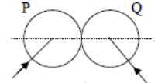
A smooth sphere P, of mass 2m, collides with a smooth sphere Q, of mass m.
The velocity of P is 3u i + 4u j and the velocity of Q is - 4u i + 3u j
When they collide their line of centres is parallel to the unit vector i.
The impact causes a loss of kinetic energy equal to $\frac{{25mu}^{2}}{2}$.
- Find the coefficient of restitution between the spheres.
- If the magnitude of the impulse imparted to each sphere due to the collision is kmu, find the value of k.

1993 (full question)
A smooth sphere A, of mass m, moving with speed u, collides with a smooth sphere B, of mass m, which is at rest. The direction of motion of A before and after impact makes angles 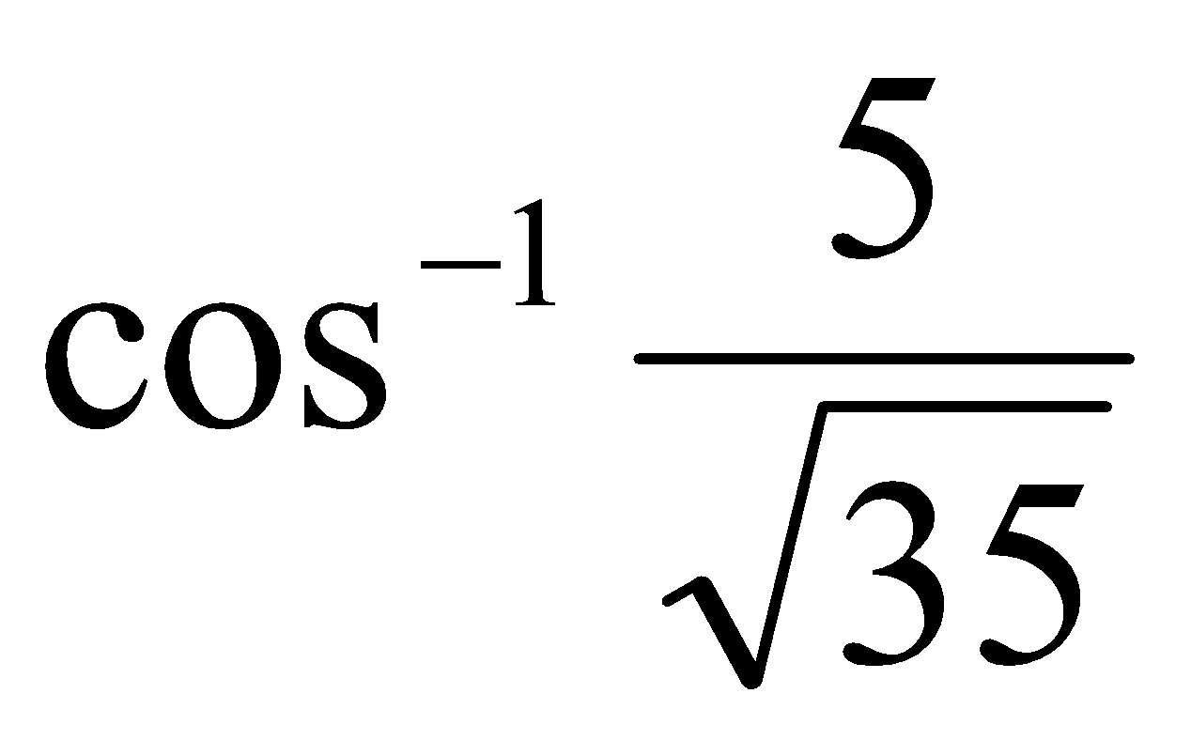 and 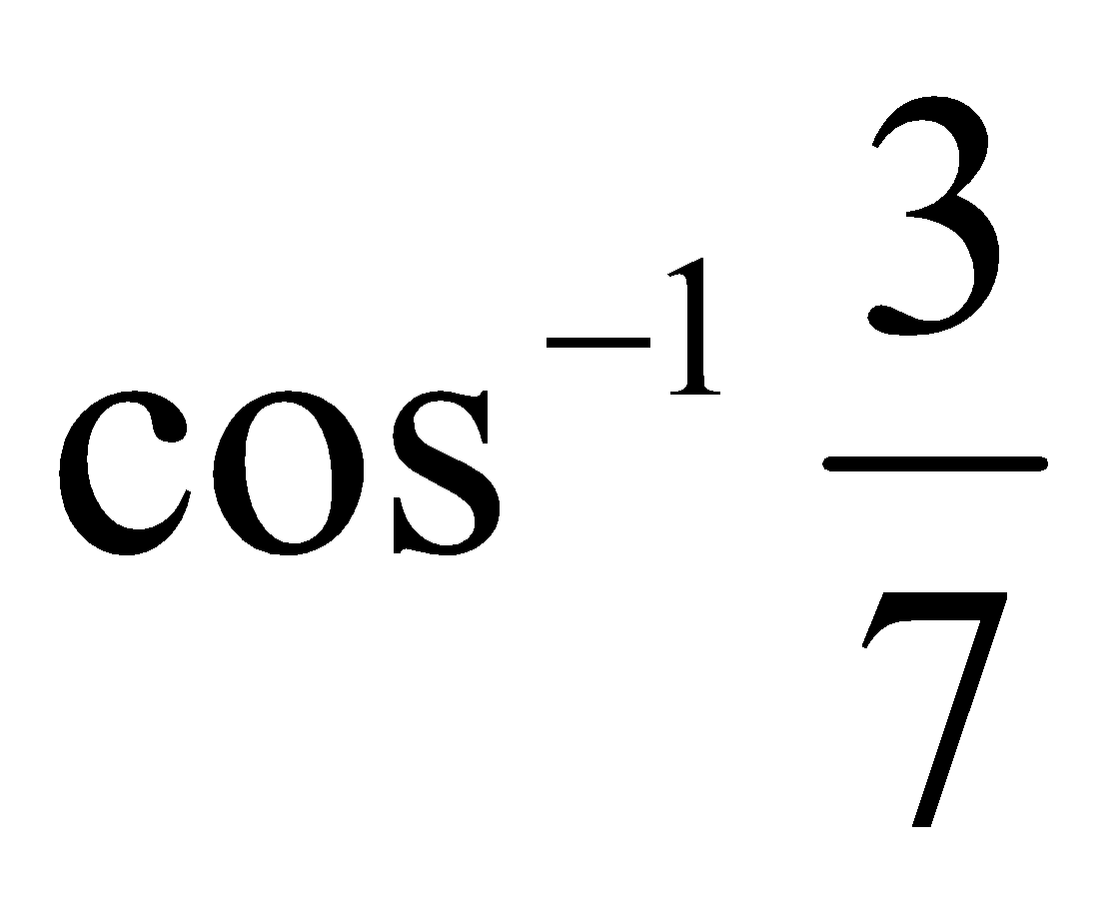 respectively with the line of centres. The coefficient of restitution between A and B is 2/5.
- Show that after impact, A and B have the same speed.
- Calculate the loss of kinetic energy due to the impact.

1986 (b)
Two smooth spheres of masses 4 kg and 2 kg impinge obliquely.
The 2 kg mass is brought to rest by the impact.
- Prove that, before impact, they were moving in directions perpendicular to each other.
- Show that, as a result of impact, the kinetic energy gained by the 4 kg mass is equal to half that lost by the 2 kg mass.

1974 (full question)
Two smooth spheres p and q of masses 2k and k, respectively, collide obliquely and the coefficient of restitution for the collision is ½.
The velocity of p before impact is 2v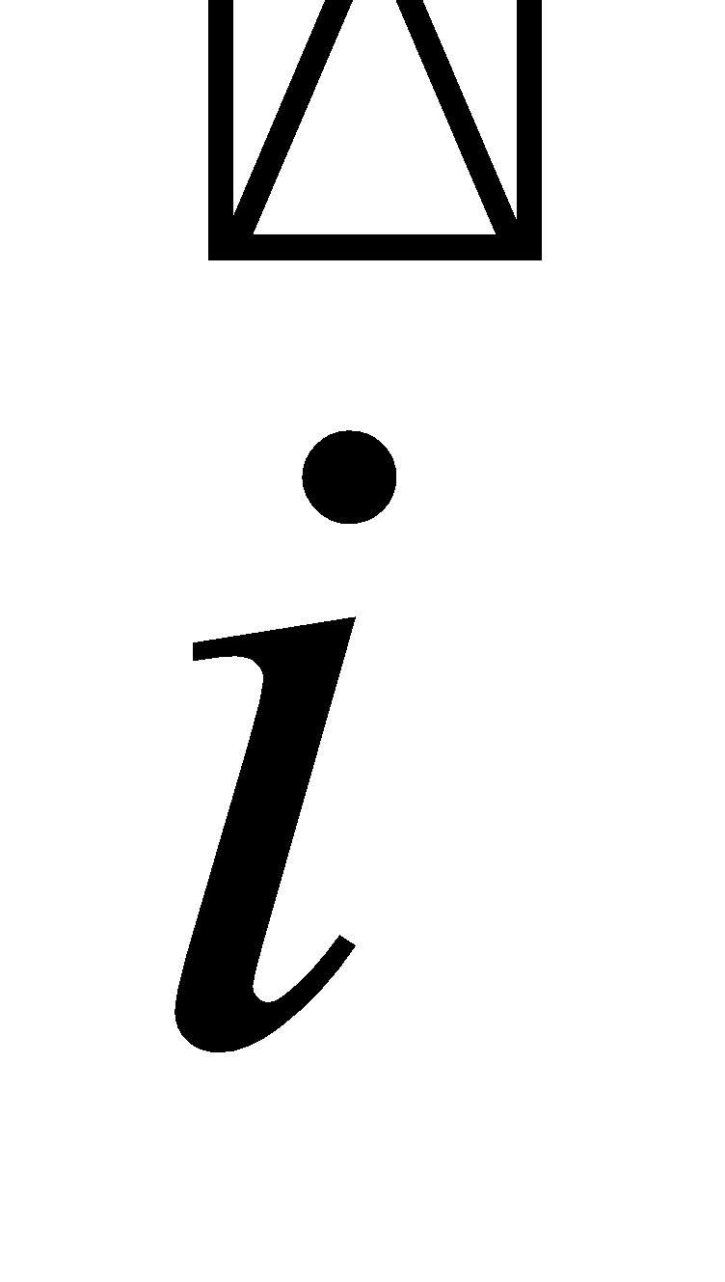 + 5vand the velocity of q before impact is – 4v + 3v, where points along the line of centres at impact.
Find the velocities of the spheres after the impact and show that the loss in kinetic energy is 9kv².

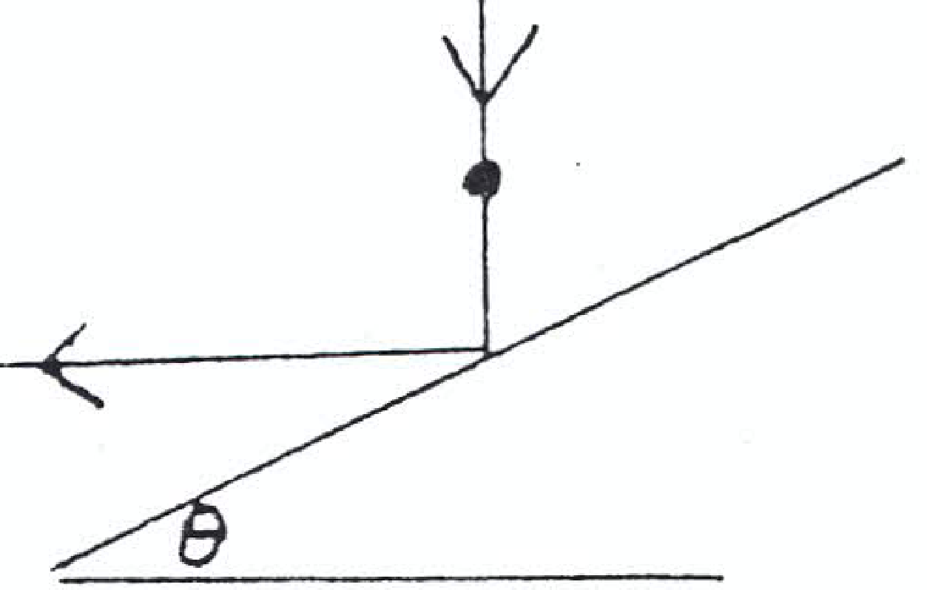
1982 (b)
A smooth metal sphere falls vertically and strikes a fixed smooth plane inclined at an angle θ to the horizontal.
If the coefficient of restitution is ²/₃ and the sphere rebounds horizontally, calculate the fraction of kinetic energy lost during impact.

1985 (full question)
State the laws governing the oblique collision of elastic spheres.
A smooth sphere A impinges obliquely on an identical smooth sphere B which is at rest.
The direction of A before and after impact makes an angle 60⁰ and θ, respectively, with the line of centres.
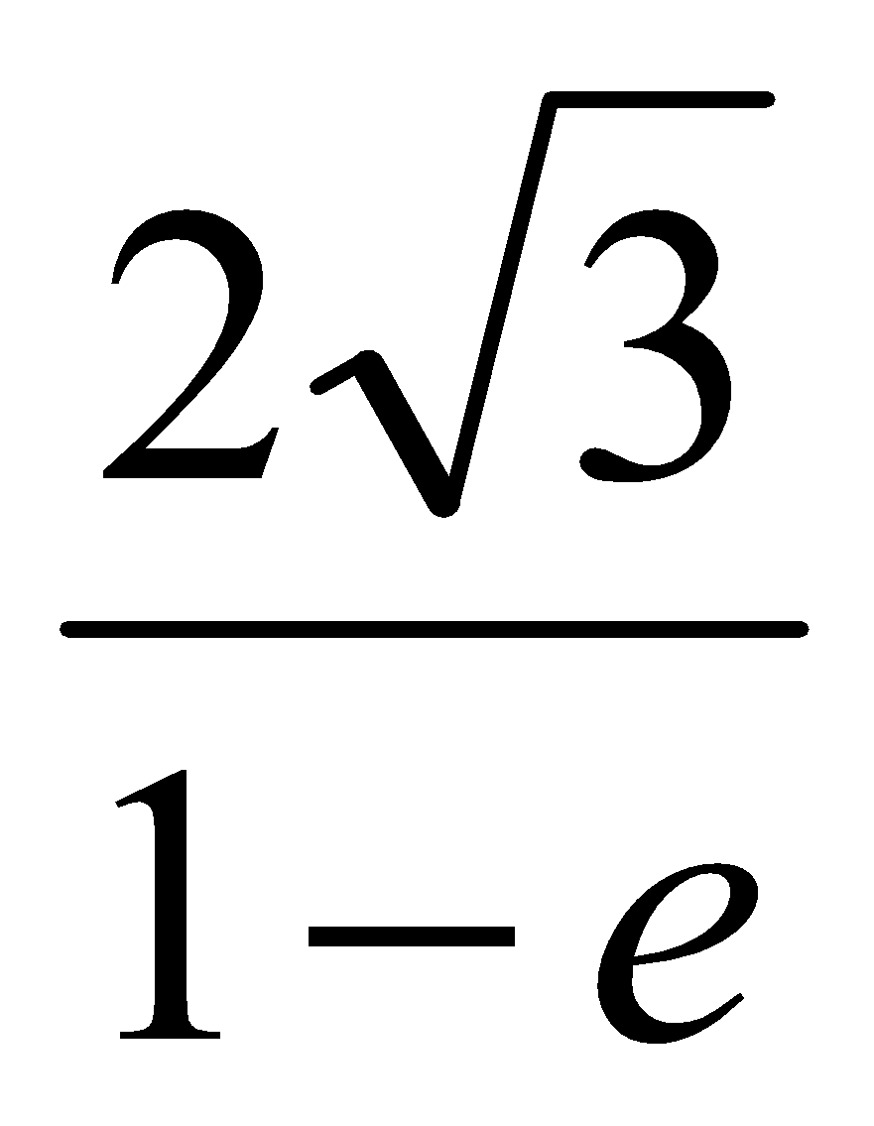
- Prove that tan θ = where e is the coefficient of restitution between the spheres.

- Show that the maximum percentage loss in kinetic energy due to the impact is 12½ %
- For what value of e will the kinetic energies of A and B after impact be in the ratio 7:1 ?

1981 (full question)
A sphere A, mass m, moving with velocity 2u impinges directly on an equal sphere B, moving in the same direction with velocity u.
- Show that the loss in kinetic energy due to the impact is 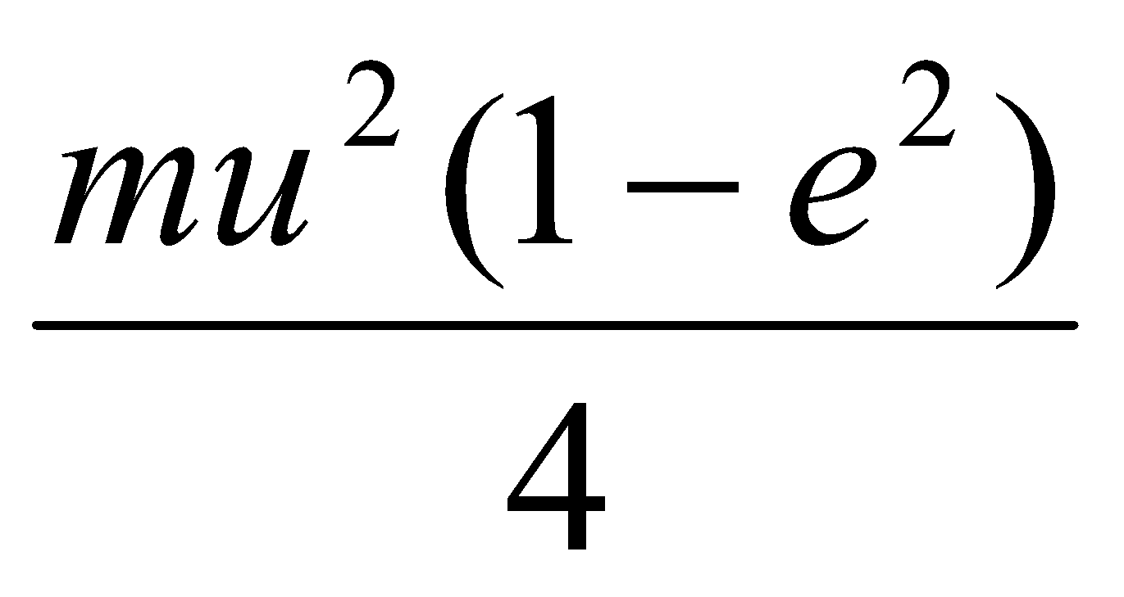 where e is the coefficient of restitution between the spheres.
- If B had been at rest and A impinged obliquely, so that after impact, A moved with velocity 2u in a direction making an angle of 30⁰ with the line of centres of the spheres, show that the loss in kinetic energy is three times greater that in (i).

General questions
1971 (full question)
Two smooth spheres A and B of equal radii but of masses 20 kg and 10 kg respectively collide on a smooth horizontal table.
Before collision the velocity of A is (5 + 3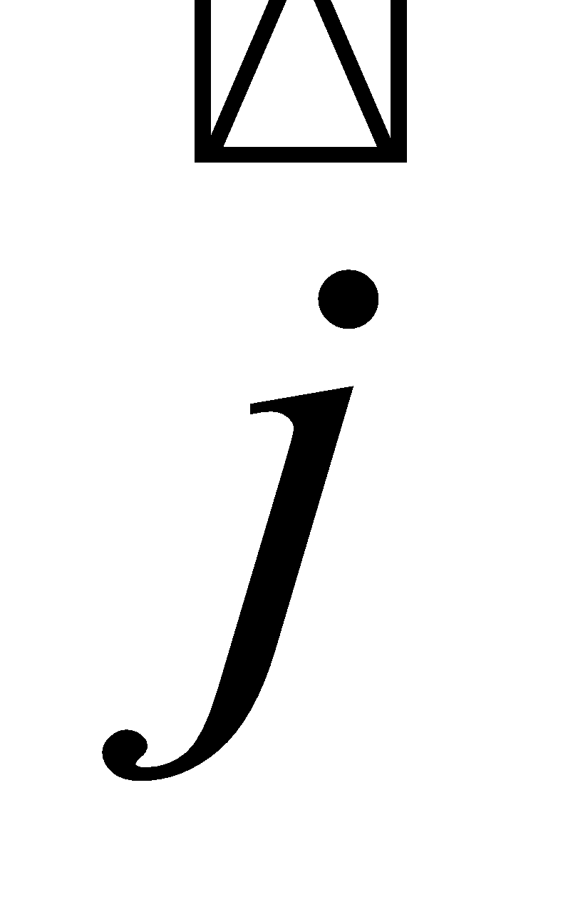) m/s and the velocity of B is 2 m/s where and are unit perpendicular vectors in the plane of the table and lies along the line of centres at impact.
If the collision is perfectly elastic find the velocity of A and the velocity of B immediately afterwards.
Perfectly elastic: e = 1

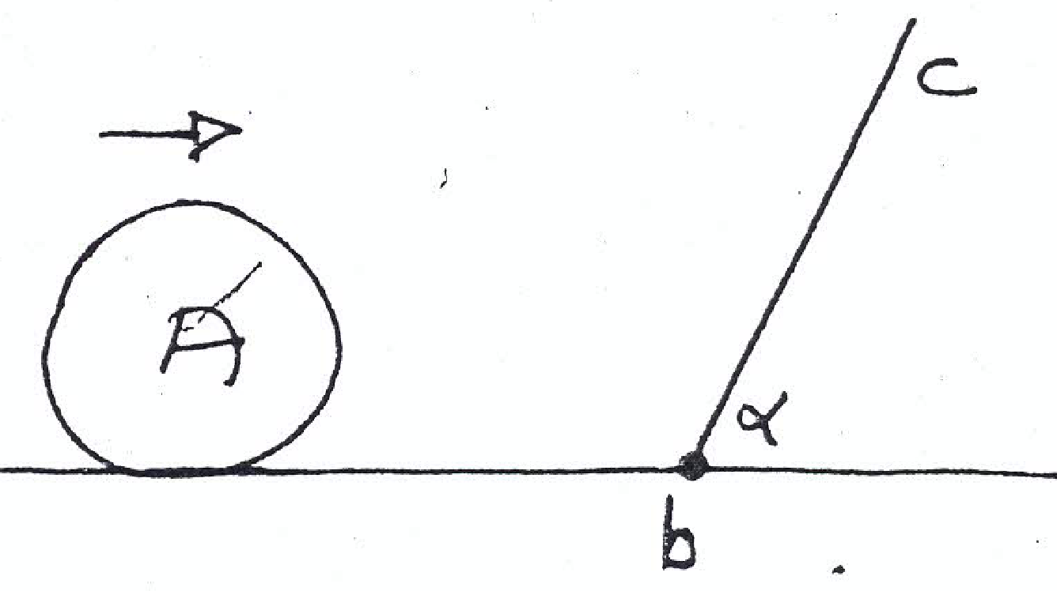
1980 (b)
A sphere A of mass m kg moving with a speed u m/s on a smooth on a smooth horizontal table impinges on a smooth plane bc.
This plane is inclined to the table at an angle α and the line of intersection of it with the table is at right angles to the direction of motion of the sphere.
Write down the components of the velocity of A perpendicular to the plane and parallel to the plane before impact and show that eusinα is the velocity of A perpendicular to the plane after impact when e is the coefficient of restitution between the sphere and the plane.
Find the magnitude of the impulse due to the impact.

1973 (full question)
A perfectly elastic particle falls vertically with sped u on to a smooth plane inclined at an angle 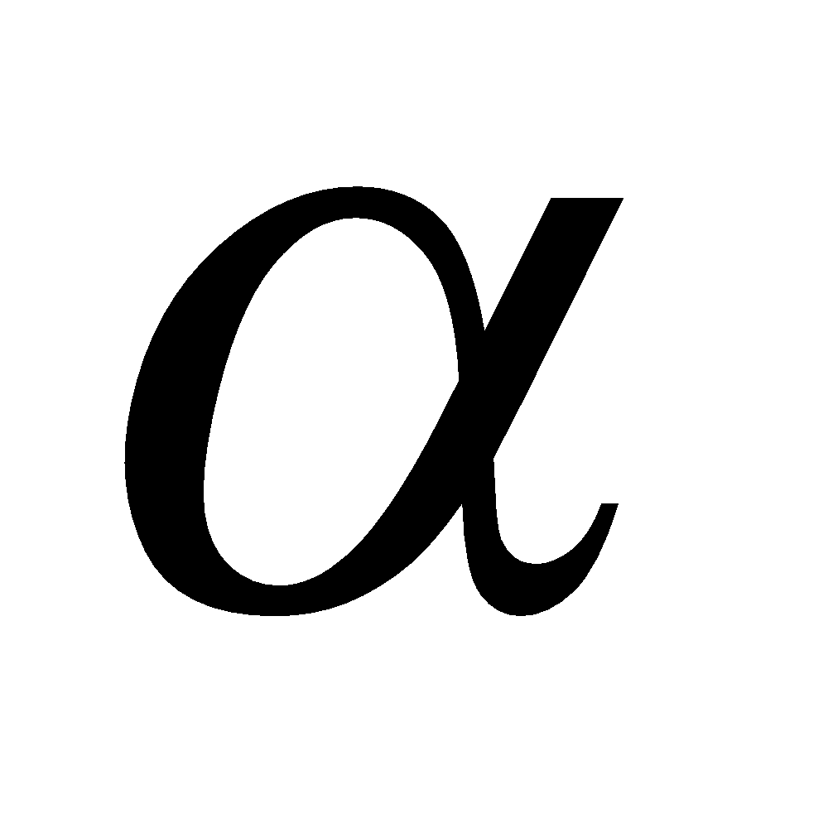 to the horizontal, and rebounds, hopping down the plane.
Write down its displacement 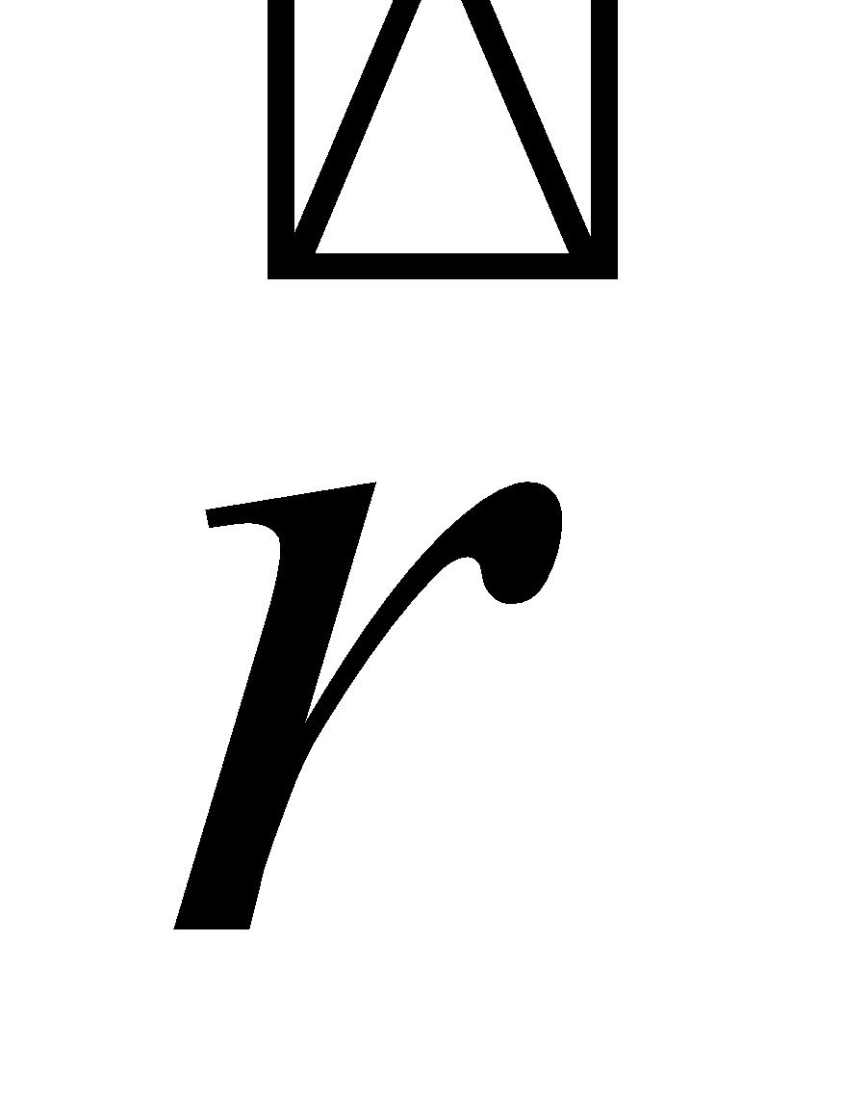from the point of contact after time t in terms of and , where is drawn directly down the plane.
Show that the length of the first hop is 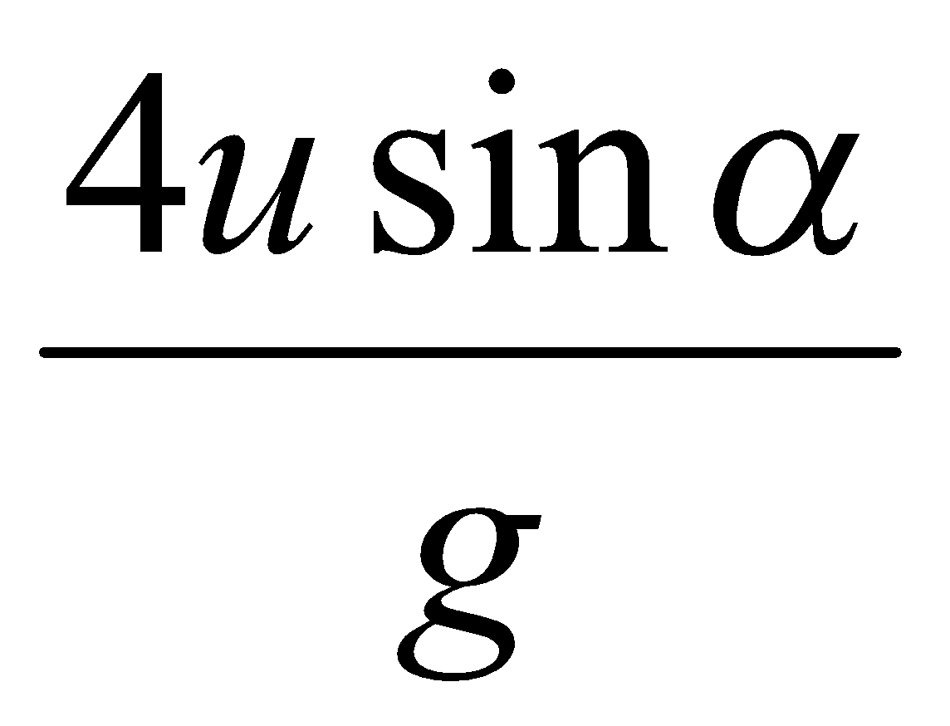 and that the length of the second hop is double this.

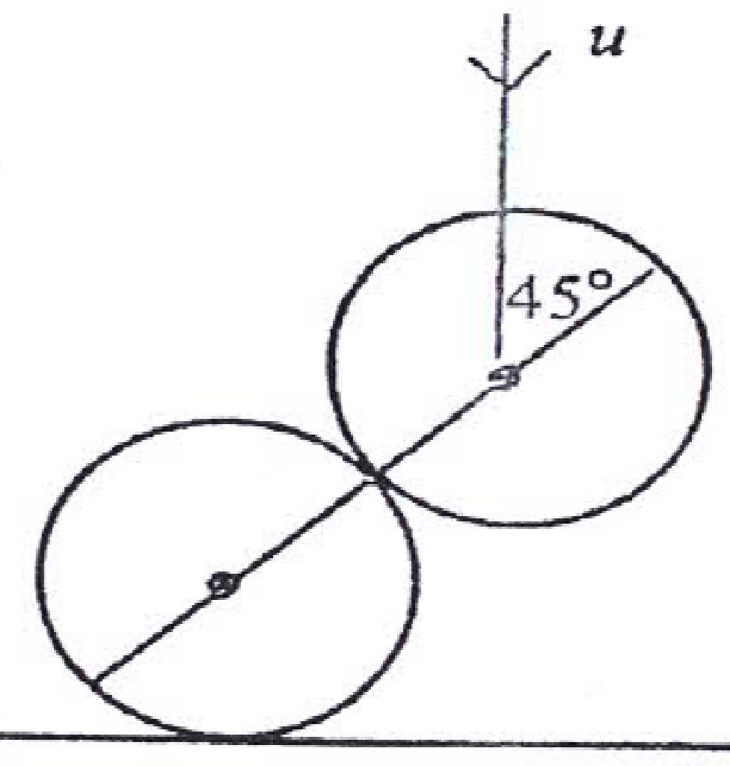
1990 (full question)
State the laws governing the oblique collision of two smooth elastic spheres.

A smooth elastic sphere of mass 6 kg rests on a smooth horizontal table.
A second smooth elastic sphere of mass 4 kg falls vertically on it.
At the moment of impact the line of centres makes an angle of 45⁰ with the vertical, and the velocity of the falling sphere is u.
The 6kg sphere moves horizontally after the collision.

- Explain why the principle of conservation of momentum may be applied horizontally.
- Hence, or otherwise, prove that the speed of the 6kg mass after impact is 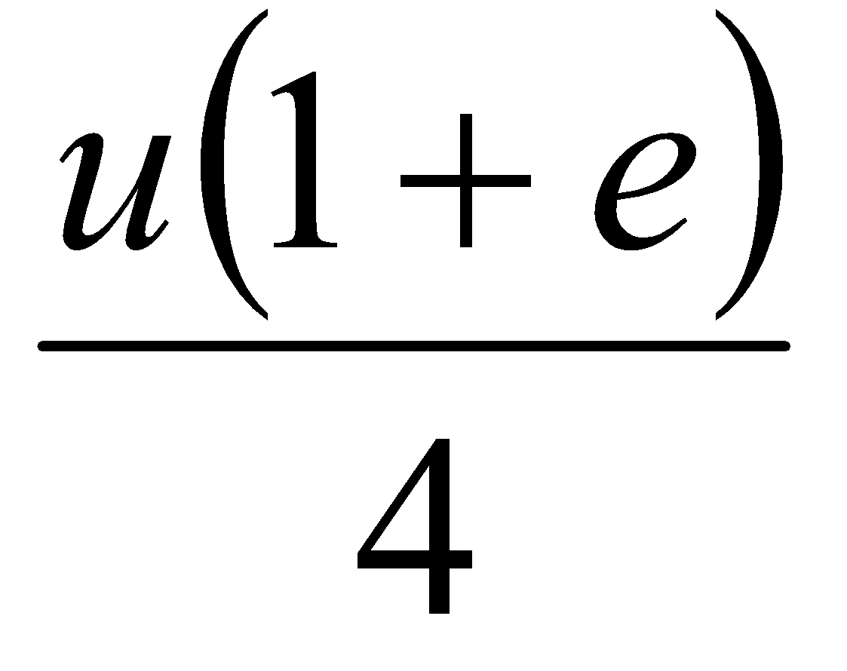where e is the coefficient of restitution between the two spheres.
- If e = , prove that the loss of kinetic energy due to the impact is 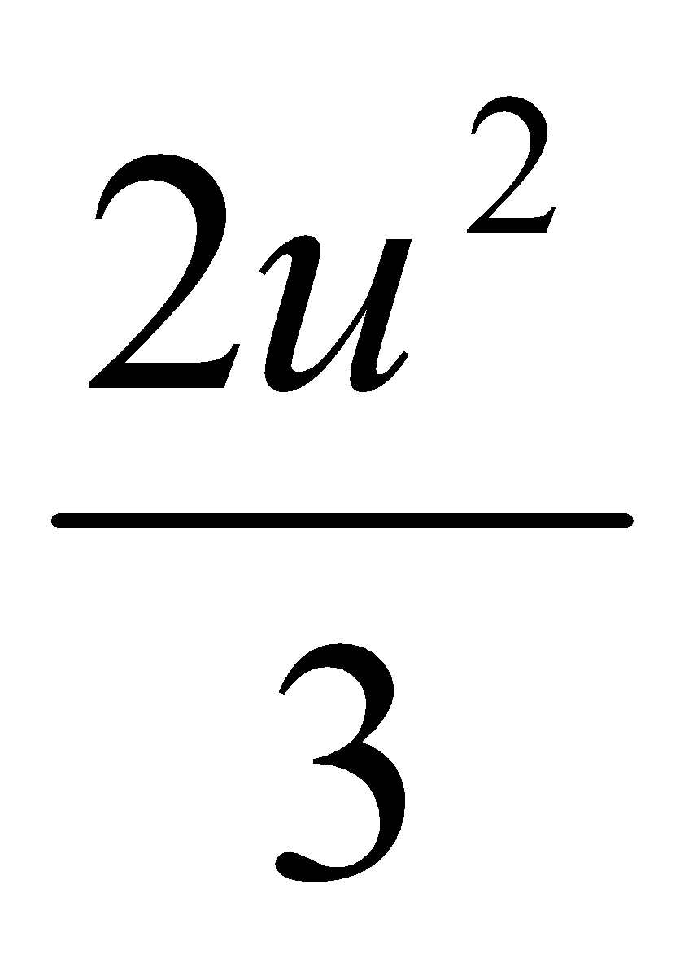.

Guide to answering exam questions
2010 (a)
- Straightforward. v₁ = u(1-3e)/4, v₂ = u(1+e)/4
- Straightforward. The percentage loss in kinetic energy = 70.3 %

2010 (b)
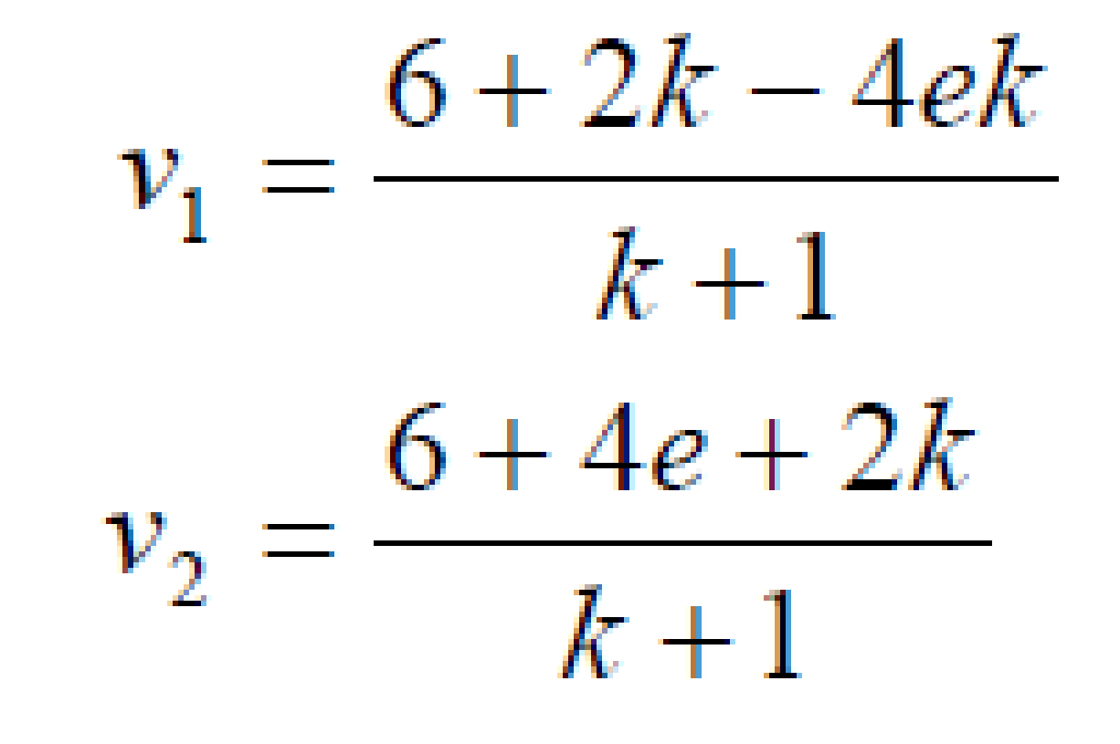
- First get v1 and v2; the method is the usual one but the algebra is a little more complex than normal and may not ‘look right’ when you get an answer for them:
Now if the slopes are parallel then the j component divided by the i component will be the same for both particles. So equate and solve for e.
Answer: e = (3+k)/(2+4k)
- Use the fact that e is less than or equal to 1 to get the required answer.

2009 (a)
- Straightforward. v₁ = u(4-2e)/3, v₂ = u(4+e)/3
- Straightforward. The speed of Q increases because it (v₂) is greater than u. How can we verify this? Well, v₂ = u(4+e)/3 and (4 + e)/3 must be positive since e < 0, therefore v₂ > u.
- Straightforward. e = 1/3

2009 (b)
- Nice when you see the answer, but rather tricky if you haven’t. Complete the triangle using the arrow as one side, a line from the centre of A to the centre of B as another side (which is of length 2r), and a third side from the centre of B to the intersection between tangent and sphere (this is of length r and the angle between this side and the tangent is 90 degrees. So sin ⟨ = r/2r ⇒ r = 30⁰. (It would appear that in this case a picture only paints 71 words).
- This question is tricky because we are used to spheres travelling ‘across the page’ which means that the j-components don’t change. Here we have two options; either turn the page on its side so that the line joining the centres is again the i-axis, in which case the j-components still don’t change, or alternatively take the diagram as is, in which case the line joining the centres is now the j-axis and it is the i-components which don’t change. The marking scheme takes the latter option. Note that if you go with the first option your i and j components will be reversed in the final answer.
Direction of A = tan⁻¹ (√3/10), direction of B = along line of centres
- Straightforward, but as always care is needed with the fractions. Percentage K.E. lost = 13.5 %

2008 (a)
- Straightforward. Ans: 1-e, ½ (1-e²), ½ (1+e²)
- The only other possible collision would be between the first and second sphere, this will only happen if
1-e > ½ (1-e²). Follow this through to get e < 1, which is correct therefore there will be a collision.

2008 (b)
Straightforward. Get v₁ and v₂ as normal and then use tan (⟨ + 45) = v_{j}/v_{i} to get the required expression.

2007 (a)
- Straightforward. Ans: v₁ = 6-3e, v₂ = 6+2e
- Easy peasy once you remember that Impulse = change of momentum

2007 (b)
- Straightforward, remember that speed means magnitude. Ans: v₁ = usin ⟨, v₂ = ½ uCos ⟨.
- Draw a diagram and it becomes obvious that the 4 kg sphere gets deflected by an angle of 90 -⟨.
- Straightforward, just be careful with the algebra.
Ans: u²Cos²⟨.

2006 (a)
- Straightforward. Ans: v₁ = (7-5e)/2, v₂ = (7 + 3e)/2
- Straightforward, just be careful with the algebra. Ans: k = 15.

2006 (b)
- This seems very different from the standard question but if you approach it in the same way you get v₁ = u/2 (1-e) and v₂ = u/2 (1+e). Then get the magnitude of each (using Pythagoras) to get a value for the speed of each. Then by equating the expressions for the speed of each you end up with e = -1, which can’t be true therefore the two spheres could not have the same speeds.
- Straightforward angle of deflection question.

2005 (a)
Straightforward. After the first set of collisions v₁ is 1/4 and v₂ is 7/32, so P will strike Q a second time.

2005 (b)
- Straightforward. Ans: v₁ = -eu/√2, v₂ = eu/√2, so speed of A = u√(1+e²)/√2, speed of B = u√(1+e²)/√2
- Work out ⟨ for each in the usual way, then draw a diagram to represent the velocity of each after the collsion, which shows that the angle between them afterwards = 180 - 2⟨, where ⟨ represents the angle of each sphere after the collision and can be found in the usual way, i.e. Tan ⟨ = v_{j}/v_{i}

2004 (a)
- Straightforward: v₁ = u(3 -5e)/8 and v₂ = 3u(1+ e)/8.
- Straightforward. We know that v₂ is always positive so if the spheres move in opposite directions then v₁will have to be negative, i.e. 3 – 5e < 0. Work with this to get an answer of e > 3/5.

2004 (b)
- Unusual in that you had to do part (ii) first. When you get e, sub it in to Tan ⎝ = v_{j}/v_{i} to get ⎝ = 60⁰.
- Difficult question. You had to notice that the part of the question which was in bold was necessary, i.e. the speeds afterwards are equal. This means you need to get the magnitude of each velocity afterwards and equate.
Ans: e = 1/3
2003 (a)
- Straightforward. Ans: v₁ = u (3 -13e) /16 and v₂ = 3u (1+ e)/16.
- Straightforward. there will be a second collision if the velocity of the sphere coming back off the wall is greater than the velocity of the first sphere (also moving to the left). i.e. if ev₂ > - v₁
Ans: 0 < e < 1/3

2003 (b)
- Tough question. Find v₁ and v₂ as usual: v₁ = u Cos ⟨ (1 -2e) /3 and v₂ = u Cos ⟨ (1+ e)/3. Now for the angle of the velocity after you need to notice that the angle is (90 - ⟨), and that if Tan (90 -⟨) = v_{j}/v_{i}, then Tan ⟨ = Tan v_{i}/v_{j} (prove this to yourself by investigating a right-angled triangle with sides 3, 4 and 5. Begin with this and work through to get the required expression at the end.
- Easy peasy. Impulse = change in momentum. Ans: e = ½.
2002 (a)
Straightforward. Just be careful with the algebra. Ans: e = 0.58

2002 (b)
Straightforward. The angle associated with the velocity afterwards is in the form Tan (⎝ + ⟨) so to get Tan ⎝ on its own you need to refer to page 9 of the log-tables.

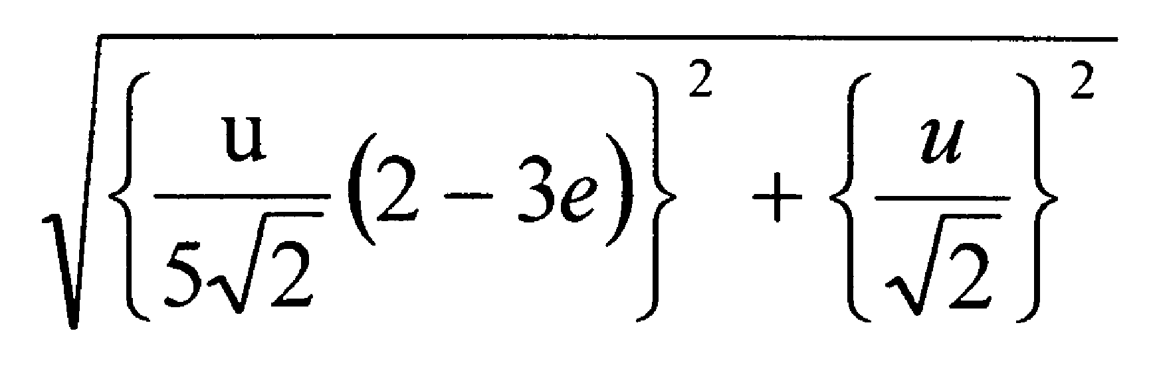
2001 (a)
- Straightforward. Remember speed means ‘magnitude’. Ans: speed of the first sphere is and speed of the second sphere is u (2 + 2e)/5√2.
- Straightforward. Ans: e = ½.

2001 (b)
- Tricky. You need to remember that if u is the magnitude of the relative velocity between the spheres then this means that you take the velocity of the first sphere to be u and the velocity of the second sphere to be 0. From this it is straightforward to show that v₁ = u/2 (1 -e) and v₂ = u/2 (1+ e) and from there to show that the impulse is ½ mu(1+e).
- Straightforward, take care with the algebra.

2000 (a)
Straightforward.
To show that the spheres will move in opposite directions you must first look at both velocities. Note that v2 is always going to be positive, while v1 could be positive or negative, depending on the value of e. For the spheres to move in opposite directions then v1 must be < 0.

2000 (b)
Straightforward.

1999 (a)
- Straightforward if you’ve seen it before, almost impossible if you haven’t.
Finding the velocity of each sphere after all collisions is fine, it’s calculating an expression for d that’s the tricky bit. For this you must use the following method.
Time for A to travel distance (y-d) at velocity V1 = time for B to travel distance y (at velocity V2)
            - plus
            - time for B to travel distance d (at velocity eV2)
Use time = distance/velocity in each case.
Note that because we are looking at time we can take the positive value of eV2.

- Straightforward. e = 1 ⇒ d = y ⇒ A stops dead after the first collision and the second collision between the spheres occurs at a distance y from the cushion (and yes I did read the marking scheme).

1999 (b)
All the complex notation would suggest that this is a difficult question but it is actually remarkably straightforward once you set up your table in the usual fashion and equate the j components.
Answer: Magnitude = 4.32 and direction = 23.23⁰.

1998 (a)
Straightforward. First get a value for v in the usual manner (be careful with the table; read the question a number of times and check the sign of each variable). To show that 3m₁ > 2m₂ note that v must be > 0 and 3m₁ and 2m₂ are both on the top of the expression for v.
This part is trickier. Go back and work out a value for e (e = v + u/4u), then use the fact that e < 1 (subbing in the value for v obtained above) and solve to get the required expression.

1998 (b)
Straightforward. Use conservation of energy to calculate the velocity of the pendulum at the bottom, then use the standard procedure to calculate the speed of the box after impact.
Answer: v = 1.99 m/s

1997 (a)
- Straightforward. You actually only need to use the PCM equation to solve.
Answer: Q = 2u
- Straightforward once you know where to go, but it’s not obvious. Get an expression for e, then let e < 1 and solve.
1997 (b)
- Straightforward (but the diagram is confusing because the 60⁰ is only relevant for the second part of the question, whereas the temptation is to use it in part (i).
Answer: V1 = (√3/4)u(1-e) i + u/2 j, V2 = (√3/4)u(1+e) i + 0 j
- Straightforward. Just algebra to take care of.
Answer: e = 1/3

1996 (a)
Straightforward, just requires a little playing around with algebra.

1996 (b)
Tricky. Because it gives you the speed of P after impact as u/2, you can make the angle after impact ⎞, and because velocity in the j direction does not change it means u sin ® = u/2 sin ⎞. From this you can work out cos ⎞.
The rest of it is now straightforward.

Answers to ordinary level exam questions
2017 (a)
- v₁ = 7 m s⁻¹, v₂ = 1 m s⁻¹
- KE lost = 24 J
- I = 12 N s

2017 (b)
- v = 9 m s⁻¹
- Yes it does

2016 (b)
- v = 8 m s⁻¹
- e = 0.75 m

2015 (a)
- v₁ = 1 m s⁻¹, v₂ = 6 m s⁻¹
- KE lost = 15 J
- I = 30 N s

2015 (b)
- v = 8 m s⁻¹
- h = 1.152 m

2014
- v₂ = 3 m s⁻¹
- v₁ = 1.5 m s⁻¹
- e = ¾
- Loss in KE = 1.5 J

2013
- v₁ = -3/2 m s⁻¹, v₂ = 4 m s⁻¹
- KE lost = 7.5 J
- I = 6 N s

2012
- v₁ = 3 m s⁻¹, v₂ = 3.5 m s⁻¹
- KE lost = 6.25 J
- I = 5 N s

2011
- v₁ = 3 m s⁻¹, v₂ = 4 m s⁻¹
- KE lost = 18 J
- I = 6 N s

2010
- v₁ = 4 m s⁻¹, v₂ = 14/3 m s⁻¹
- KE lost = 9 J
- I = 2 N s

2009
- v₁ = -1 m s⁻¹, v₂ = 5 m s⁻¹
- KE lost = 20 J
- Impulse = 20 N s

2008
- v₁ = 1 m s⁻¹, v₂ = 1.6 m s⁻¹
- KE lost = 48.6 J
- Impulse = 18 Ns
2007
- v₁ = 2 m s⁻¹, v₂ = 4 m s⁻¹
- KE lost = 3 J
- Impulse = 6 Ns

2006
- v₁ = 0.8 m s⁻¹, v₂ = 1.8 m s⁻¹
- KE lost = 8.4 J
- Impulse = 8.4 N s

2005
- v₁ = 5.5 m s⁻¹
- e = 0.5
- Fraction of KE lost = 9/110
- Impulse = 9 N s

2004 (a)
- u = 14/9 m s⁻¹
- v₂ = 16/9 m s⁻¹

2004 (b)
v = 5 m s⁻¹
h = 0.8 m

2003
- v₂ = 1 m s⁻¹
- e = 0.25
- Fraction = 6/7 %

2002
- v₁ = m s⁻¹, v₂ = 5 m s⁻¹
- KE lost = 2 J

2001
- v₁ = 2/9 m s⁻¹, v₂ = 14/9 m s⁻¹
- e = ½

2000
- e = ½
- loss in KE = 40.5 J

Collisions questions from 2023 and Sample Paper: Ordinary level and Higher level

Sample paper Ordinary Level Question 5 (a)
A small smooth sphere, 𝑃, of mass 𝑚, travels along a horizontal surface at a constant speed of 8 m s^{–1}. It collides with another small smooth sphere, 𝑄, of mass 3𝑚, which is at rest.
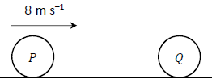
The coefficient of restitution between the spheres is $\frac{3}{8}$.

- Calculate the velocity of 𝑃 and the velocity of 𝑄 after impact.
- Calculate, in terms of 𝑚, the loss in kinetic energy due to the impact.

2023 OL Question 7
A small smooth sphere, 𝑆₁, of mass 6 kg is projected with a velocity of 3 m s^{–1} along a smooth horizontal surface and collides with second small smooth sphere, 𝑆₂, of mass 4 kg travelling in the same direction with a velocity of 1.5 m s^{–1}.
The coefficient of restitution between the spheres is $\frac{2}{3}$.

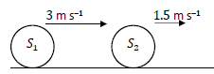

- Calculate the velocity of 𝑆₁ and the velocity of 𝑆₂ after impact.
- Calculate the total kinetic energy of the system before impact.
- Calculate the loss in kinetic energy as a result of the impact.

After the collision, 𝑆₂ travels a distance of 80 cm at constant velocity before it decelerates to rest while travelling a further distance of 50 cm.
- Calculate the time interval between the collision and when 𝑆₂ comes to rest.

2023 HL Question 2 (b)
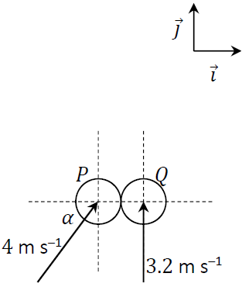
Two smooth spheres, 𝑃 and 𝑄, have equal radius and are of mass 𝑚 and 2𝑚 respectively.
𝑃 and 𝑄 collide obliquely.
The line joining their centres at the point of impact lies along the 𝚤⃗ axis.
Before the collision, sphere 𝑃 moves with a velocity of 4 m s^{–1} at an angle 𝛼 with the 𝚤⃗ axis, where $\sin{α}=\frac{4}{5}$.
Before the collision, sphere 𝑄 moves with a velocity of 3.2 m s^{–1} perpendicular to the 𝚤⃗ axis.
The coefficient of restitution between the spheres is 𝑒, where
0 ≥ 𝑒 ≤ 1.
Calculate, in terms of 𝑒, the velocity of each sphere immediately after they collide.

Sample Paper HL Question 4 (b)
Two identical smooth spheres, 𝑃 and 𝑄, each moving with speed 𝑢, collide obliquely.
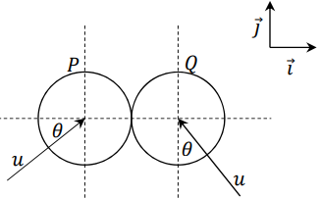
The line joining their centres at the point of impact is along the 𝚤⃗ axis.
Before the collision, the velocity of sphere 𝑃 makes an angle 𝜃 with the 𝚤⃗ axis and the velocity of sphere 𝑄 makes an angle 𝜃 with the 𝚥⃗ axis, as shown in the diagram.
The coefficient of restitution between the spheres is 𝑒, where 0 ≤ 𝑒 ≤1.

After the collision sphere 𝑄 moves off parallel to the 𝚥⃗ axis.
(i) Show that $e=\frac{\tan{θ-1}}{\tan{θ+1}}$

(i) If 25% of the spheres’ total kinetic energy is lost during the collision, calculate 𝜃 and 𝑒.

